|  |  |  |  |  |  |  |  |
| --- | --- | --- | --- | --- | --- | --- | --- |
| **طرح نگهداشت و افزایش تولید 27 مخزن** | | | | | | | |
| **Surface Preparation and Painting Procedure**  **نگهداشت و افزایش تولید میدان نفتی بینک** | | | | | | | |
| V01 | Oct.2023 | | IFR | Beh Koosh Vista | M.Fakharian | S. Faramazpour |  |
| V00 | Aug.2023 | | IFR | Beh Koosh Vista | M.Fakharian | A.M.Mohseni |  |
| **Rev.** | **Date** | | **Purpose of Issue/Status** | **Prepared by:** | **Checked by:** | **Approved by:** | **CLIENT Approval** |
|  | | |  | | | | |
| **Status:** | | |  | | --- | | **IFA: Issued for Approval**  **IFR: Issued for Review**  **IFI: Issued for Information**  **AFC: Approved for Construction** | | | | | | |

# Revision Record Sheet

|  |  |  |  |  |  |  |  |  |
| --- | --- | --- | --- | --- | --- | --- | --- | --- |
| **SHEET** | **V00** | **V01** | **V02** | **V03** | **V04** | **V05** | **V06** | **V07** |
| 1 | X | X |  |  |  |  |  |  |
| 2 | X | X |  |  |  |  |  |  |
| 3 | X |  |  |  |  |  |  |  |
| 4 | X | X |  |  |  |  |  |  |
| 5 | X | X |  |  |  |  |  |  |
| 6 | X | X |  |  |  |  |  |  |
| 7 | X |  |  |  |  |  |  |  |
| 8 | X | X |  |  |  |  |  |  |
| 9 | X |  |  |  |  |  |  |  |
| 10 | X |  |  |  |  |  |  |  |
| 11 | X |  |  |  |  |  |  |  |
| 12 | X | X |  |  |  |  |  |  |
| 13 | X | X |  |  |  |  |  |  |
| 14 |  | X |  |  |  |  |  |  |
| 15 |  | X |  |  |  |  |  |  |
| 16 |  | X |  |  |  |  |  |  |
| 17 |  | X |  |  |  |  |  |  |
| 18 |  | X |  |  |  |  |  |  |
| 19 |  | X |  |  |  |  |  |  |
| 20 |  | X |  |  |  |  |  |  |
| 21 |  |  |  |  |  |  |  |  |
| 22 |  |  |  |  |  |  |  |  |
| 23 |  |  |  |  |  |  |  |  |
| 24 |  |  |  |  |  |  |  |  |
| 25 |  |  |  |  |  |  |  |  |
| 26 |  |  |  |  |  |  |  |  |
| 27 |  |  |  |  |  |  |  |  |
| 28 |  |  |  |  |  |  |  |  |
| 29 |  |  |  |  |  |  |  |  |
| 30 |  |  |  |  |  |  |  |  |
| 31 |  |  |  |  |  |  |  |  |
| 32 |  |  |  |  |  |  |  |  |
| 33 |  |  |  |  |  |  |  |  |
| 34 |  |  |  |  |  |  |  |  |
| 35 |  |  |  |  |  |  |  |  |
| 36 |  |  |  |  |  |  |  |  |
| 37 |  |  |  |  |  |  |  |  |
| 38 |  |  |  |  |  |  |  |  |
| 39 |  |  |  |  |  |  |  |  |
| 40 |  |  |  |  |  |  |  |  |
| 41 |  |  |  |  |  |  |  |  |
| 42 |  |  |  |  |  |  |  |  |
| 43 |  |  |  |  |  |  |  |  |
| 44 |  |  |  |  |  |  |  |  |
| 45 |  |  |  |  |  |  |  |  |
| 46 |  |  |  |  |  |  |  |  |
| 47 |  |  |  |  |  |  |  |  |
| 48 |  |  |  |  |  |  |  |  |
| 49 |  |  |  |  |  |  |  |  |
| 50 |  |  |  |  |  |  |  |  |

|  |  |  |  |  |  |  |  |  |
| --- | --- | --- | --- | --- | --- | --- | --- | --- |
| **SHEET** | **V00** | **V01** | **V02** | **V03** | **V04** | **V05** | **V06** | **V07** |
| 51 |  |  |  |  |  |  |  |  |
| 52 |  |  |  |  |  |  |  |  |
| 53 |  |  |  |  |  |  |  |  |
| 54 |  |  |  |  |  |  |  |  |
| 55 |  |  |  |  |  |  |  |  |
| 56 |  |  |  |  |  |  |  |  |
| 57 |  |  |  |  |  |  |  |  |
| 58 |  |  |  |  |  |  |  |  |
| 59 |  |  |  |  |  |  |  |  |
| 60 |  |  |  |  |  |  |  |  |
| 61 |  |  |  |  |  |  |  |  |
| 62 |  |  |  |  |  |  |  |  |
| 63 |  |  |  |  |  |  |  |  |
| 64 |  |  |  |  |  |  |  |  |
| 65 |  |  |  |  |  |  |  |  |
| 66 |  |  |  |  |  |  |  |  |
| 67 |  |  |  |  |  |  |  |  |
| 68 |  |  |  |  |  |  |  |  |
| 69 |  |  |  |  |  |  |  |  |
| 70 |  |  |  |  |  |  |  |  |
| 71 |  |  |  |  |  |  |  |  |
| 72 |  |  |  |  |  |  |  |  |
| 73 |  |  |  |  |  |  |  |  |
| 74 |  |  |  |  |  |  |  |  |
| 75 |  |  |  |  |  |  |  |  |
| 76 |  |  |  |  |  |  |  |  |
| 77 |  |  |  |  |  |  |  |  |
| 78 |  |  |  |  |  |  |  |  |
| 79 |  |  |  |  |  |  |  |  |
| 80 |  |  |  |  |  |  |  |  |
| 81 |  |  |  |  |  |  |  |  |
| 82 |  |  |  |  |  |  |  |  |
| 83 |  |  |  |  |  |  |  |  |
| 84 |  |  |  |  |  |  |  |  |
| 85 |  |  |  |  |  |  |  |  |
| 86 |  |  |  |  |  |  |  |  |
| 87 |  |  |  |  |  |  |  |  |
| 88 |  |  |  |  |  |  |  |  |
| 89 |  |  |  |  |  |  |  |  |
| 90 |  |  |  |  |  |  |  |  |
| 91 |  |  |  |  |  |  |  |  |
| 92 |  |  |  |  |  |  |  |  |
| 93 |  |  |  |  |  |  |  |  |
| 94 |  |  |  |  |  |  |  |  |
| 95 |  |  |  |  |  |  |  |  |
| 96 |  |  |  |  |  |  |  |  |
| 97 |  |  |  |  |  |  |  |  |
| 98 |  |  |  |  |  |  |  |  |
| 99 |  |  |  |  |  |  |  |  |
| 100 |  |  |  |  |  |  |  |  |

Table of Contents

Revision Record Sheet 2

1 Introduction 4

2 Reference Documents 4

2.1 International Standard 4

2.2 Iranian Petroleum Standard (IPS) 4

2.3 Project specification 5

3 GENERAL 5

3.1 Non-Painted Surface 5

3.2 Machined Surface 5

3.3 Friction Surface 5

3.4 Bolting 5

4 4- SURFACE PREPARATION 5

4.1 Preparation before Blast Cleaning 5

4.2 Required Cleanliness 6

4.3 Required Roughness 6

4.4 Precautions 7

4.5 Stainless Steel 7

5 STORAGE, MIXING AND THINNING OF PROCEDURE 7

5.1 Storage Condition 7

5.2 Mixing 8

5.3 Tinning 8

6 APPLICATION OF PAINT 9

6.1 Paint System 9

6.2 Application 9

6.3 Drying Painted Surfaces 11

7 REPAIR OF DAMAGED PAINT AREAS 11

8 INSPECTION 12

8.1 Previous Approval 12

8.2 Inspection Results 13

9 CODES AND STANDARDS 13

10 Data sheet of paints 14

11 Appendix-1 Painting Test Report Sample 20

# Introduction

This specification covers the minimum requirements for the protection by painting of Pressure Vessels and Pipeline Equipment.

**GENERAL DEFINITION**

The following terms shall be used in this document.

|  |  |
| --- | --- |
| Client: | * National Iranian South Oilfields Company (NISOC) |
| Project: | * Binak Oilfield Development – Manufacturing (w/Engineering & Material Supply) of Pig traps |
| EPD/EPC Contractor (GC): | * Petro Iran Development Company (PEDCO) |
| EPC Contractor/Purchaser: | * Joint Venture of: Hirgan Energy – Design & Inspection(D&I) Companies |
| Vendor: | * Nam Avaran Beh Koosh Vista |
| Executor: | * Executor is the party which carries out all or part of construction and/or commissioning for the project. |
| TPI: | * Third Party Inspector |

# Reference Documents

## International Standard

* SSPC-P A1 Paint Application Specification No.1: Shop, Field and Maintenance Painting.
* SSPC-PA2 Paint Application Specification No.2: Measurement of Dry Paint Thickness with Magnetic Gauges.
* SSPC-P A3 Paint Application Guide No.3: A Guide to Safety in Paint Application
* SSPC-SP COM Surface Preparation Specification Outfaces Preparation Commentary.
* SSPC-SP 3 Surface Preparation Specifications No.3: Power Tool Cleaning
* Swedish standard SIS 05 5900
* SSPC SP-10 / NACE No.2

## Iranian Petroleum Standard (IPS)

* IPS-E-TP-100 Engineering Standard for Paint
* IPS-C-TP-101 Construction Standard for Surface Preparation
* IPS-C-TP-102 Construction Standard for Surface Painting
* IPS-M-TP-130 Material and Equipment Standard for Coloured Alkyd Paint for Top Coat (Finish) Except White
* PS-M-TP-168 Material standard for Acrylic Silicon Finish Paint for Temperature Application up to 200°C
* IPS-M-TP-175 Material and Equipment Standard for Silicone Alkyd Paint (White or Colored) as Top Coat (Finish)
* IPS-M-TP-205 Material & Equipment Standard for Zinc Rich Epoxy as Primer, Intermediate & Top Coat
* IPS-M-TP-210 Material & Equipment Standard for Zinc silicate paint As Primer, Intermediate & Top Coat
* IPS-M-TP-235 Material & Equipment Standard for Two Pack Poly Urethane Paint as Top Coat
* IPS-M-TP-220 Material & Equipment Standard for Epoxy Polyamide Intermediate Paint
* IPS-M-TP-225 Material and Equipment Standard for Epoxy Polyamide Paint as Top Coat

## Project specification

* BK-PPL-PEDCO-320-ME-SP-0001-D04

# GENERAL

## Non-Painted Surface

Painting of the following surfaces is not required:

3.1.1 - Non-ferrous materials (90-10 and 70-30 Copper-Nickel, Monel, Aluminium bronze), high grade stainless steels.

However, low grade stainless steels such as AISI 302, 304, 304L, 321, 347, 316, 316 L, 317, 317 L shall be painted.

3.1.2 - Plastic materials or materials coated with ultra violet ray resistant plastic.

## Machined Surface

Machined and threaded surfaces shall be protected with temporary rust preventive paint.

## Friction Surface

Friction surfaces of assemblies using friction shall be protected by suitable means against corrosion.

## Bolting

Carbon steel bolting and low-grade stainless-steel bolting (see § 4.1.1) shall be painted with the paint system used for painting after tightening.

The bolting which is to be unscrewed frequently, say up to once a year may be coated with a coat of a rust preventive primer such as VIGOR EP 167, then with a coat of a lanolin based soft coating such as EUREKA Fluid Film Gel B.

# 4- SURFACE PREPARATION

## Preparation before Blast Cleaning

### – All mill-scale, rust scale, paint marks or foreign matter shall be removed by shot-blasting, grit blasting, or sandblasting

### All rough-edged cuts and, indentations, all surfaces and protrusions must be ground to smooth out the contour before the surface is prepared for painting. Any grinding performed after blast cleaning, must be re-blasted to required roughness.

4.1.2 - All bolt holes shall be drilled and blunted before blasting.

4.1.3 - Prior to surface preparation, the surface shall be inspected for spotting oil and grease deposits or pollution on the surface. If any, the deposits of oil or grease shall be removed from the surface by solvent cleaning prior to further surface preparation.

****Deleted

4.1.4- Abrasive material for blasting:

1) The abrasive is recovered and re-used shall be copper slag (grain size is 0.5 to 1.68 mm) able to produce the required surface profile. The abrasive shall be replenished using new and worn abrasive, so as to produce a consistent profile height and standard of surface cleanliness. The abrasive mixture shall be kept free of dust (including metallic particles) and debris. Abrasive cleaning employing sand shall not be permitted.

2) Expendable abrasive used for blast-cleaning shall be free of contaminants such as chlorides and other soluble salts and shall not contain metallic copper or more than 2% by weights of copper oxide. Expendable abrasives shall not be recycled. Sand shall not be used for blast-cleaning.

3) Sand or other non-metallic abrasives with free silica shall not be used.

4-1-5 Blast cleaning

Blasting operations shall never be allowed in the vicinity of painting work or near to a wet paint surface or anywhere that blast abrasive, grit or fall-out shall impinge on a freshly painted surface, or on any uncovered primed surface.

Blast cleaning operations shall not be

conducted on surfaces that will be wet after

blasting and before coating, when the surfaces temperature is less than 3°C above the dew point, when the relative humidity of the air is greater than 85%, or when the ambient temperature is below 3°C.

               NOTE: Only GRIT BLASTING/SHOT BLASTING IS PERMITTED.

2) Blast cleaning operations shall not be conducted on surfaces that will be wet after blasting and before coating, when the surfaces temperature is less than 3ºC above the dew point, when the relative humidity of the air is greater than 80%, or when the ambient temperature is below 5ºC.

3) The maximum particle size of the abrasives used in blast cleaning shall not be larger than that passing through a 14-mesh screen B.S. Sieve Series. All abrasives shall be free from dust, moisture and salt. Blasting shall be continued till a uniform white metal surface is achieved.

4) Blast cleaning is permitted only during the day light.

5) Where rectification has been necessary on blast-cleaned surface, the particular area shall be re-blasted to remove all rust and slag, and to provide adequate paint adhesion.

6) Blast cleaning shall overlap by a minimum of 25 mm into any adjacent coated areas. Any steel work not primed and/or wetted by rain or moisture shall be re-blasted prior to being painted if rust develops.

7) Steel may be blast-cleaned either before or after fabrication. Sometimes it may be necessary both before and after.

Where steel is cleaned before fabrication it shall be protected with a suitable blast-primer to avoid rusting before fabrication is completed. During fabrication, the blast-primer will inevitably be destroyed or damaged in places, e.g. by welding. Such areas shall be cleaned and re-primed as soon as possible.

Where steel cleaned after fabrication it may still be necessary to apply a blast-primer, but often the first coat of the full protective system can be applied.

8) The roughness of prepared surface results from primary roughness already present in the initial state and which is exposed by the mechanical preparation methods, in particular by blasting. The roughness parameters (the peak-to valley height) give some basis for determining the minimum coat thickness necessary for satisfactory embedment and covering of roughness peaks.

The surface roughness of steel work shall be within 0.1 mm to 0.03 ± 0.005 mm for painting, coating and lining.

## Required Cleanliness

All surfaces prepared for coatings shall satisfy:

- SA 2 1/2 of the Swedish standard SIS 05 5900.

SSPC SP-10 / NACE No.2.

## Required Roughness

4.3.1 - All surfaces shall be blast cleaned to obtain a total angular roughness RT included:

Blast-cleaning produces a roughened surface and the profile size is important. The surface roughness (average peak-to valley height) achieved for each qualities of surface finish, depends mainly upon the type and grade of abrasive used. Unless otherwise specified by the company the amplitude of surface roughness of steel work shall be within 100to 30 micron for painting, coating and lining. Table 3 IPS C-tp-101 gives the range of maximum and average maximum profile heights of some abrasive to be expected under normal good operation conditions (wheel and nozzle). If excessively high air pressure or wheel speed is used, the profile may be significantly higher.

- Between 30 and 50 microns when total thickness of the coats of paint applied is less than 400 microns,

- Between 50 and 80 microns when total thickness of the coats of the paint applied is greater than 400 microns.

4.3.2 - Only dry blasting techniques are allowed. Compressed air for abrasive blasting shall not contain any trace of oil or water. Blasting nozzle pressure shall not be less than 7 barg (100 psi).

## Precautions

4.4.1 - Surface preparation by dry blasting techniques shall not be performed if:

- The surface is likely to be humid after surface preparation and before painting,

- The surface temperature is less than 3°C above the surrounding air's dew point,

- The air's relative humidity is greater than 85 %.

If the air's relative humidity exceeds 80 %, the Applicator must obtain permission from the Company to proceed with or continue with surface preparation. The

Applicator must provide a hygrometer to measure the air's relative humidity.

4.4.2 - Surface preparation operations shall be terminated early enough during the day to permit application of the adopted primer on the prepared surface before the sun sets and rust sets in.

If, exceptionally, surface preparation is authorized at night, the prepared surfaces shall be wiped the next morning. They shall be freshened with light sand blasting before the primer is applied.

4.4.3 - During surface preparation, care shall be taken not to damage or alter identification plates, machined surfaces and parts coated in the factory. These parts shall be properly protected.

4.4.4 - Oil, grease 2000 shall be cleaned before blasting.

4.4.5 - Any oil, grease, dust or foreign body present on the surface after surface preparation operations shall be removed before painting. If rust reappears on the surface, the surface shall be re blasted as per paragraphs 5.2 and 5.3.

## Stainless Steel

Before painting, stainless steel surfaces shall be cleaned degreased and blast cleaned with a nonmetallic abrasive. Total roughness shall be in the 25-micron range.

# STORAGE, MIXING AND THINNING OF PROCEDURE

## Storage Condition

5.1.1 - All paint and thinner containers shall be kept closed before use and stored under shelter.

The painting and thinner materials must be stored in a well-ventilated place free from excessive heat or direct rays of sun and according to Manufacturer’s Instruction Manuals.

• The painting materials for which the shelf life is expired shall not be used and paint shall not be used if it has gelled or if it has thickened to such extent that more than 5% by volume (10 percent by volume of priming paints of the correct thinner is required to bring it to brushing consistency. Also, the painting materials shall be used in rotation of receipt. Paints shall not be stored in open containers.

All containers of paint shall be clearly marked or labelled to show paint identification, date of manufacture, batch number, all legible at the time of use." No Smoking "and other warning signs such as " No Open Flames", "Danger ", "Storage of Inflammable Material ", etc., shall be posted around storage shed".

5.1.2 - With condition as the same as manufacturer constructions. Any paint which has gelled or settled during storage shall not be used.

5.1.3 - Any paint for which the shelf life is expired shall not be used.

## Mixing

5.2.1 - All the ingredients in each container shall be thoroughly mixed and homogenized. Mechanical mixing shall be such that all pigments or other agents are held in solution during application. Manual mixers are not authorized.

5.2.2 - Paint mixed in the original container shall not be transferred until all settled particles have been remixed with the medium. This does not imply temporary removal of part of the medium to facilitate mixing.

5.2.3 - Paint shall not be mixed or held in solution with air bubbles.

5.2.4 - If a skin has formed in the container, it shall be cut and removed. If the skin is thicker than 1 mm, the paint shall not be used.

5.2.5 - All pigmented products shall be strained after mixing unless applicator equipment is provided with adequate strainers.

Strainers must allow all pigments to pass through, but not any skin.

5.2.6 - Products with unlimited pot life or which do not alter on standing may be mixed at any time; however, if they have set, they must be mixed immediately before use. Paint shall not be kept in the spray equipment pots overnight, but shall be put back into a closed container and remixed before re-use. Containers must be marked with the involved paint's pot-life.

## Tinning

5.3.1 - No thinners are to be added unless necessary for proper application. Thinning must never exceed Manufacturer recommendations.

5.3.2 - Thinners used must be those suggested by the Manufacturer.

5.3.3 - When use of thinner is authorized by the Manufacturer, it shall be added during mixing. Applicators shall not add thinner after the paint has been thinned to the proper consistency. Thinners must be added under the guidance of a specialist who is thoroughly familiar with the quantity and type of the added thinner.

# APPLICATION OF PAINT

## Paint System

|  |  |  |  |  |  |  |  |  |  |  |
| --- | --- | --- | --- | --- | --- | --- | --- | --- | --- | --- |
| **No.** | **Item** | **Surface Preparation Grade** | **Design**  **Temperature**  **C°** | **Coat** | **Paint** | **Recoat Interval** | **Minimum Dry Film Thickness (µ)** | | **Product No.** |  |
| **Every**  **Layer** | **Total** | **RAL** |
| 1 | PIG LAUNCHER & RECEIVER TRAP | SA 2 1/2 |  | PRIMER | Zinc Rich Epoxy  (IPS-M-TP-205) | Min.: 24 hrs. at 20°C. | 75 | 205 | RAF3-6007 | - |
| 85 | MID. COAT | Epoxy Polyamide  (IPS-M-TP-220) | Max.: 7 days at 20°C. | 80 | RAF2-6000 | 1014 |
|  | TOP COAT | Two-pack Aliphatic Polyurethane  (IPS-M-TP-235) | Min.: 24 hrs. at 20°C. | 50 | RAFIS-7000 | 7047 |

## Application

6.2.1 - Paint shall not be applied to surfaces:

- During rain, snow, fog or when dust is in suspension in the air, when wind velocity exceeds 7 m/s.

- In areas where harmful particles are in suspension,

- When surface temperature is less than 3°C above the surrounding air's dew point,

- When relative humidity is greater than 85 % (95 % when applying inorganic zinc silicate),

- When temperature is below 5°C.

- When surface temperature is greater than 35°C.

6.2.2 - Blast cleaned surfaces shall be primed as quickly as possible and at the latest during the day they shall be blast cleaned. The primer coat shall end 5 cm from a surface to be prepared on the same panel.

6.2.3 - As far as possible, each coat of paint shall be applied in a continuous, even coat free of holiday. Any area which has not been properly coated or missed shall be repainted.

6.2.4 - Each coat must cure or dry properly before application of the next coat. The applicator shall follow Manufacturer's instructions.

6.2.5 - When several coats of the same type of paint have been specified, alternate coats of paint shall be tinted as much as possible to make sure that the surface is completely covered. If a colorant is added, it shall be compatible with the paint and not alter its service life.

6.2.6 - Application by Airless Spray Gun

Application by pneumatic spray gun must satisfy the following conditions:

a) Equipment used shall be capable of spraying the paint properly. It shall be fitted with pressure indicators and regulators adapted to service. Nozzles and needles shall be those recommended by the equipment manufacturer for the paint being used. Equipment shall be maintained in good working order.

b) Traps shall be installed to trap oil or water condensed in the air.

Traps shall be of adequate capacity and drained regularly. Air from the spray gun impinging against the surface shall not deposit any oil or condensed water.

c) Continuous mechanical agitation shall keep paint mixture in spray pots or containers at proper consistency.

d) Pressure on the product in the spray pot and air in the gun shall be adjusted to obtain optimum atomization. Pressure on the product in the pot shall be set, if necessary, to accommodate gun height with respect to the can height. Air pressure in the gun shall be high enough to atomise paint without forming excessive mist or causing excessive evaporation of solvent.

e) Spray equipment shall be kept clean so that dust, dry paint or other foreign matter are not deposited in the coat of paint.

Any solvent left in the spray equipment shall be completely removed before applying the paint to the surface.

f) Paint shall be applied in uniform coats with total spray pattern coverage.

Spray patterns shall be such that paint is evenly applied.

g) Drips or excess thickness shall be removed with a brush or the surface cleaned and repainted.

h) Surfaces inaccessible by spray gun shall be brush painted. If they are inaccessible by brush, a sheep skin shall be used. Brushes shall be used to work paint into cracks, crevices or other areas not properly coated by spraying.

i) Special precautions shall be taken when inorganic zinc is applied. These are given in the Manufacturer's instructions.

6.2.7 - All identification plates, machined surfaces, instrument glass, bearing surfaces of flange, control valve shafts and other similar material shall be masked. If paint gets on these surfaces they shall be cleaned and returned to their original condition.

Spray guns shall be held perpendicular to the surface being coated at a maximum distance of 300mm from the surface and no closer than 200mm to the surface.

6.2.8 - Structural steel section edges and irregular surfaces shall be coated first and an additional coat shall be applied at a later stage.

6.2.9 - All equipment and component contact surfaces (skid bases, equipment bottoms, etc...) shall be painted.

6.2.10 - Fresh paint shall be protected against dust and other foreign matter.

The applicator shall maintain the necessary instruments to test and inspect

surface preparation, coating application, and the fully cured coating for his

quality control. These instruments shall include:

• Thermometer

• Psychrometer (or Hygrometer)

• Roughness gauge

• Digital thermometer for pipe surface temperature

• Dry film thickness gauge

• Sharp knife

• Holiday Detector

• Blast nozzle pressure checking

• Porosity checking

## Drying Painted Surfaces

6.3.1 - An additional coat of paint shall not be applied until the previous coat is dry and may be painted. Read Manufacturer's instructions for drying times with respect to ambient temperature and humidity.

6.3.2 - Paint shall not be dried under conditions that may cause wrinkling, blistering, pore formation or other injurious defects.

6.3.3 - No drier shall be added to paint.

6.3.4 - Paint shall be protected from rain, condensation, snow or freezing until it is completely dry (refer to Manufacturer's technical data sheet).

6.3.5 - Next layer shall be applied before interval time coating.

# REPAIR OF DAMAGED PAINT AREAS

Touch-up coating of metal surfaces

The following areas shall receive a field touch-up for corrosion protection after fabrication or installation work:

Surface where the shop coat of paint has been marred, scratched, or otherwise damaged, due to transportation, handling, erection, installation or weathering. In this case, surface preparation shall be as per SSPC-SP2 or SSPC-SP3 standards.

Heads of field bolts and nuts, and adjacent surfaces left unpainted in the shop. Surfaces of any ferrous fasteners not otherwise protected.

Weld seams of hanger and support If sand blasting is not applicable for any reason to be agreed upon by Consortium or Inspector, zinc silicate primer shall not be used for touch-up repairs. Zinc rich 2 components epoxy or an approved epoxy primer should be used instead.

Remedial work

Pinholes, skips, and area less than the specified dry film thickness shall be touch-up or re- coated to specification.

Unacceptable runs, sags, dry over-spray, orange peel, and embedded dust shall be removed by sanding. The surface shall be vacuumed or blown off with compressed air and touch-up or recoated as per related specification.

When factory painted or painted surfaces have been marked in handling, the damaged paint and non-adherent paint shall be removed and the surface thoroughly cleaned in accordance to paragraph 5. The edges of the damaged area shall be smoothed. Surface preparation shall extend approximately 5 cm into the sound coat.

NOTE: if sand blasting is not applicable for any reason to be agreed upon by Company or Inspector, zinc silicate primer shall not be used for touch up repairs.

Zinc rich 2 components epoxy primer or an approved epoxy primer formulated for application on hand or mechanically brushed surfaces should be used instead.

The touch up primer shall be compatible with the paint system.

# INSPECTION

Painting works achieved in accordance with this specification, shall be inspected by a Company representative.

## Previous Approval

Approval shall be obtained for each stage, indicated below, before going on to the next stage.

### Location of the painting work, products and painted equipment storage conditions.

### Equipment.

### Surface preparation & roughness check.

### Primer or prime coat.

### Dry film thickness checks after each coat of paint: (Procedure to Measure Dry Film Thickness of Nonmagnetic Coatings over Magnetic Substrates is Fixed Probe. Spot

### Reading = 3 gage readings in 1.5-inch circle, 5 Spot Readings per 9.3 sq meter)

### X-Cut tape test:

Apparatus and Materials

Cutting Tool—Sharp razor blade, scalpel, knife or other cutting devices. It is of particular importance that the cutting edges be in good condition.

Cutting Guide—Steel or other hard metal straightedge to ensure straight cuts.

Tape—One-inch (25-mm) wide semitransparent pressure-sensitive tape with an adhesion strength agreed upon by the supplier and the user is needed7. Because of the variability in adhesion strength from batch-to-batch and with time, it is essential that tape from the same batch be used when tests are to be run in different laboratories. If this is not possible the test method should be used only for ranking a series of test coatings.

Rubber Eraser, on the end of a pencil.

Illumination—A light source is helpful in determining whether the cuts have been made through the film to the substrate.

The above test shall be performed for all layer of paints.

Humidity and temperature check:

Operations shall not commence until relative humidity and ambient and surface temperatures are within the limits.

Measuring times of relative humidity:

Min. 6 times a day whence two times before commencement of work

Measuring times of moisture on surface

****On time before beginning surface preparation operation or applying a coat of paint

Dust test:

According to BS EN ISO 8502-3 with permissible limit max. class 2 is necessary.

## Inspection Results

All quality control results shall be written up into reports. All reports shall be submitted to the Company during provisional acceptance of the paint.

# CODES AND STANDARDS

|  |  |  |
| --- | --- | --- |
| IPS-C-TP-101 | Construction Standard for Surface Preparation |  |
| IPS-C-TP-102 | Construction Standard for Painting |  |
| IPS-E-TP-100 | Engineering Standard for Paints |  |
| SSPC-PA2 | Procedure for Determining Conformance to Dry Coating Thickness Requirements |  |
| ASTM D4285-83 | Test Method for Indicating Oil or Water in Compressed Air | --- |
| ASTM D 4417-93 | Test Method for Field Measurement of Surface Profile of Blast Cleaned Steel | --- |
| ASTM E 337-84 | Tests for Relative Humidity by Wet-and-Dry-Bulb Psychrometer | --- |
| ASTM D3359 | Standard test method for measuring adhesion by tape test | --- |
| ASTM D3951 | Standard practice for commercial packaging | --- |
| ASTM D4752 | Standard Test Method for Measuring MEK Resistance of  Ethyl Silicate (Inorganic) Zinc-Rich Primers by Solvent Rub | --- |
| SSPC SP1 | Surface Preparation Standard No. 1-Solvent Cleaning | --- |
| SSPC SP3 | Surface Preparation Standard No. 3- Power Tool Cleaning | --- |
| SSPC Paint 20 | Zinc Rich Coating Type I- Inorganic & Type II-Organic | --- |
| SSPCSP-10/NACE No.2 | Joint Surface Preparation Standard-Near White Metal Blast Cleaning | Sa 2 ½ |
| SSPC VIS 1 | Guide and Reference Photographs for Steel Surfaces Prepared by Dry Abrasive Blast Cleaning | --- |
| Swedish standard SIS 05 5900 | Pictorial Surface Preparation Standards for Painting Steel Surface |  |

This procedure according to following standards, referenced used.

# Data sheet of paints

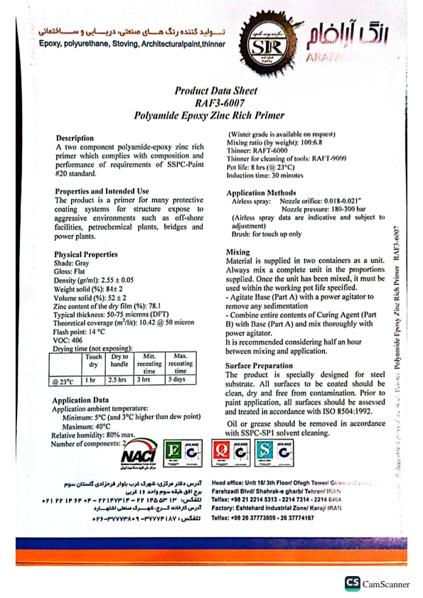

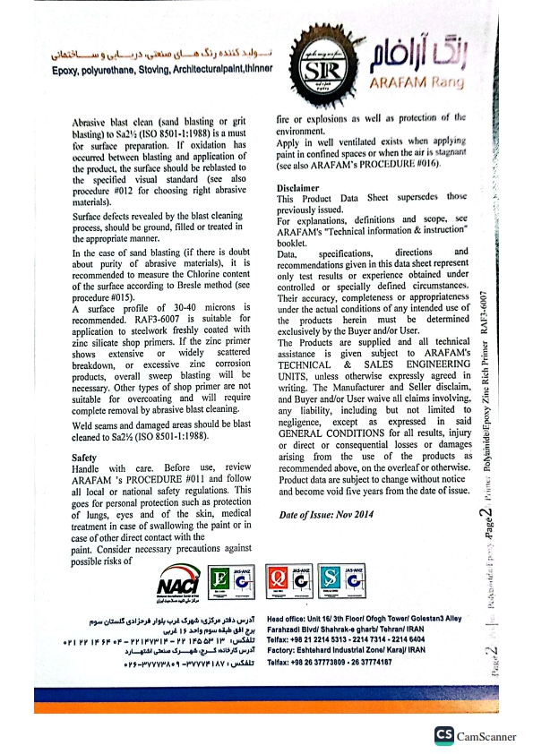

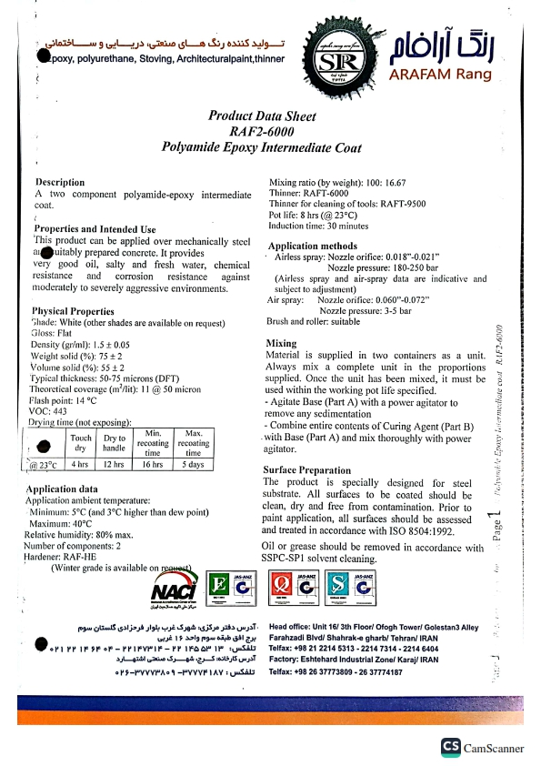

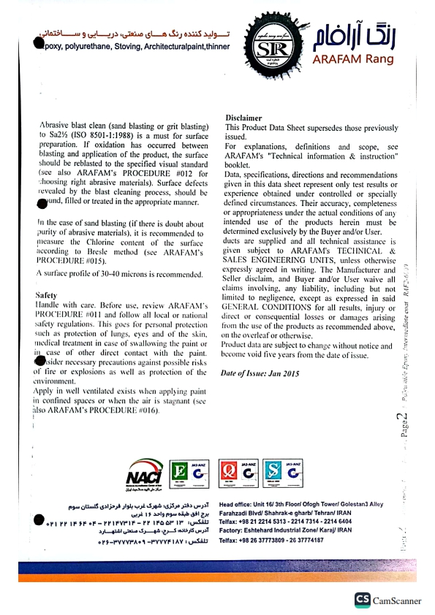

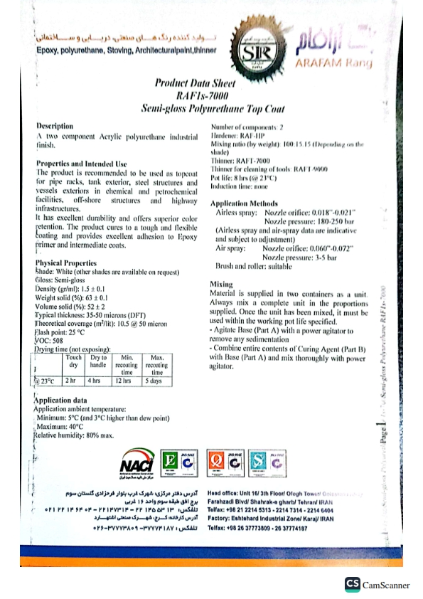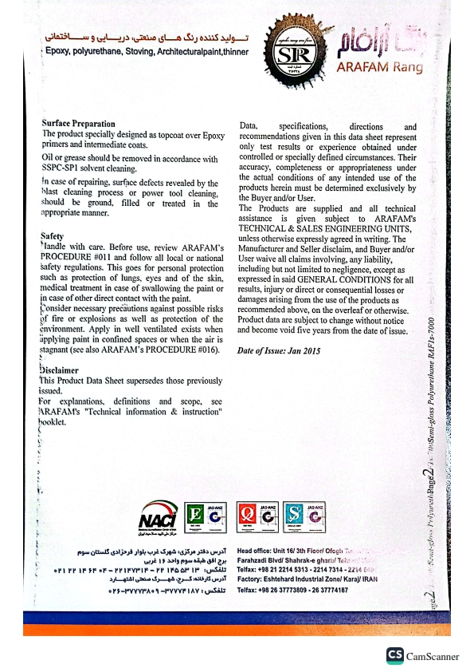

# Appendix-1 Painting Test Report Sample