|  |  |  |  |  |  |  |  |
| --- | --- | --- | --- | --- | --- | --- | --- |
| **طرح نگهداشت و افزایش تولید 27 مخزن** | | | | | | | |
| **Post Weld Heat Treatment (PWHT) Procedure**  **نگهداشت و افزایش تولید میدان نفتی بینک** | | | | | | | |
| V01 | Oct.2023 | | AFC | Beh Koosh Vista | M.Fakharian | S.Faramarzpour |  |
| V00 | Aug.2023 | | IFR | Beh Koosh Vista | M.Fakharian | A.M.Mohseni |  |
| **Rev.** | **Date** | | **Purpose of Issue/Status** | **Prepared by:** | **Checked by:** | **Approved by:** | **CLIENT Approval** |
|  | | |  | | | | |
| **Status:** | | |  | | --- | | **IFA: Issued for Approval**  **IFR: Issued for Review**  **IFI: Issued for Information**  **AFC: Approved for Construction** | | | | | | |

# Revision Record Sheet

|  |  |  |  |  |  |  |  |  |
| --- | --- | --- | --- | --- | --- | --- | --- | --- |
| **SHEET** | **V00** | **V01** | **V02** | **V03** | **V04** | **V05** | **V06** | **V07** |
| 1 | X | x |  |  |  |  |  |  |
| 2 | X | x |  |  |  |  |  |  |
| 3 | X |  |  |  |  |  |  |  |
| 4 | X | X |  |  |  |  |  |  |
| 5 | X | X |  |  |  |  |  |  |
| 6 | X | X |  |  |  |  |  |  |
| 7 | X |  |  |  |  |  |  |  |
| 8 | X | X |  |  |  |  |  |  |
| 9 | X | X |  |  |  |  |  |  |
| 10 |  | X |  |  |  |  |  |  |
| 11 |  | X |  |  |  |  |  |  |
| 12 |  | X |  |  |  |  |  |  |
| 13 |  |  |  |  |  |  |  |  |
| 14 |  |  |  |  |  |  |  |  |
| 15 |  |  |  |  |  |  |  |  |
| 16 |  |  |  |  |  |  |  |  |
| 17 |  |  |  |  |  |  |  |  |
| 18 |  |  |  |  |  |  |  |  |
| 19 |  |  |  |  |  |  |  |  |
| 20 |  |  |  |  |  |  |  |  |
| 21 |  |  |  |  |  |  |  |  |
| 22 |  |  |  |  |  |  |  |  |
| 23 |  |  |  |  |  |  |  |  |
| 24 |  |  |  |  |  |  |  |  |
| 25 |  |  |  |  |  |  |  |  |
| 26 |  |  |  |  |  |  |  |  |
| 27 |  |  |  |  |  |  |  |  |
| 28 |  |  |  |  |  |  |  |  |
| 29 |  |  |  |  |  |  |  |  |
| 30 |  |  |  |  |  |  |  |  |
| 31 |  |  |  |  |  |  |  |  |
| 32 |  |  |  |  |  |  |  |  |
| 33 |  |  |  |  |  |  |  |  |
| 34 |  |  |  |  |  |  |  |  |
| 35 |  |  |  |  |  |  |  |  |
| 36 |  |  |  |  |  |  |  |  |
| 37 |  |  |  |  |  |  |  |  |
| 38 |  |  |  |  |  |  |  |  |
| 39 |  |  |  |  |  |  |  |  |
| 40 |  |  |  |  |  |  |  |  |
| 41 |  |  |  |  |  |  |  |  |
| 42 |  |  |  |  |  |  |  |  |
| 43 |  |  |  |  |  |  |  |  |
| 44 |  |  |  |  |  |  |  |  |
| 45 |  |  |  |  |  |  |  |  |
| 46 |  |  |  |  |  |  |  |  |
| 47 |  |  |  |  |  |  |  |  |
| 48 |  |  |  |  |  |  |  |  |
| 49 |  |  |  |  |  |  |  |  |
| 50 |  |  |  |  |  |  |  |  |

|  |  |  |  |  |  |  |  |  |
| --- | --- | --- | --- | --- | --- | --- | --- | --- |
| **SHEET** | **V00** | **V01** | **V02** | **V03** | **V04** | **V05** | **V06** | **V07** |
| 51 |  |  |  |  |  |  |  |  |
| 52 |  |  |  |  |  |  |  |  |
| 53 |  |  |  |  |  |  |  |  |
| 54 |  |  |  |  |  |  |  |  |
| 55 |  |  |  |  |  |  |  |  |
| 56 |  |  |  |  |  |  |  |  |
| 57 |  |  |  |  |  |  |  |  |
| 58 |  |  |  |  |  |  |  |  |
| 59 |  |  |  |  |  |  |  |  |
| 60 |  |  |  |  |  |  |  |  |
| 61 |  |  |  |  |  |  |  |  |
| 62 |  |  |  |  |  |  |  |  |
| 63 |  |  |  |  |  |  |  |  |
| 64 |  |  |  |  |  |  |  |  |
| 65 |  |  |  |  |  |  |  |  |
| 66 |  |  |  |  |  |  |  |  |
| 67 |  |  |  |  |  |  |  |  |
| 68 |  |  |  |  |  |  |  |  |
| 69 |  |  |  |  |  |  |  |  |
| 70 |  |  |  |  |  |  |  |  |
| 71 |  |  |  |  |  |  |  |  |
| 72 |  |  |  |  |  |  |  |  |
| 73 |  |  |  |  |  |  |  |  |
| 74 |  |  |  |  |  |  |  |  |
| 75 |  |  |  |  |  |  |  |  |
| 76 |  |  |  |  |  |  |  |  |
| 77 |  |  |  |  |  |  |  |  |
| 78 |  |  |  |  |  |  |  |  |
| 79 |  |  |  |  |  |  |  |  |
| 80 |  |  |  |  |  |  |  |  |
| 81 |  |  |  |  |  |  |  |  |
| 82 |  |  |  |  |  |  |  |  |
| 83 |  |  |  |  |  |  |  |  |
| 84 |  |  |  |  |  |  |  |  |
| 85 |  |  |  |  |  |  |  |  |
| 86 |  |  |  |  |  |  |  |  |
| 87 |  |  |  |  |  |  |  |  |
| 88 |  |  |  |  |  |  |  |  |
| 89 |  |  |  |  |  |  |  |  |
| 90 |  |  |  |  |  |  |  |  |
| 91 |  |  |  |  |  |  |  |  |
| 92 |  |  |  |  |  |  |  |  |
| 93 |  |  |  |  |  |  |  |  |
| 94 |  |  |  |  |  |  |  |  |
| 95 |  |  |  |  |  |  |  |  |
| 96 |  |  |  |  |  |  |  |  |
| 97 |  |  |  |  |  |  |  |  |
| 98 |  |  |  |  |  |  |  |  |
| 99 |  |  |  |  |  |  |  |  |
| 100 |  |  |  |  |  |  |  |  |

Table of Contents

Revision Record Sheet 2

1 Introduction 4

2 Reference Documents 4

3 Responsibility 4

4 Personal handling the PWHT activities 5

5 Furnace 5

6 Surface Conditions 5

7 Procedure 5

8 Thermocouples 6

9 Temperature Recording 7

10 GENERAL NOTES 7

11 Documentations 8

12 Report & Records 8

13 Appendix-1 PWHT Report Sample 9

14 Appendix-2 Heat Treatment Controller Recorder Certificate 10

# Introduction

This procedure covers the minimum requirements for post weld heat treatment of Pig Launcher and Pig Receiver Trap with item No: PL-3201, PR-3201 which are designed and fabricated by Vista Company.

The following terms shall be used in this document.

|  |  |
| --- | --- |
| Client: | * National Iranian South Oilfields Company (NISOC) |
| Project: | * Binak Oilfield Development – Manufacturing (w/Engineering & Material Supply) of Pig traps |
| EPD/EPC Contractor (GC): | * Petro Iran Development Company (PEDCO) |
| EPC Contractor/Purchaser: | * Joint Venture of: Hirgan Energy – Design & Inspection(D&I) Companies |
| Vendor: | * Nam Avaran Beh Koosh Vista |
| Executor: | * Executor is the party which carries out all or part of construction and/or commissioning for the project. |
| TPI: | * Third Party Inspector |

# Reference Documents

Unless stated otherwise all codes and standards referenced in this procedure shall be of the latest issue (including revisions – addenda and supplements) and the following documents shall be referred to along with this procedure.

|  |  |
| --- | --- |
| a) ASME B31.8-2016 | - Gas transmission and distribution piping system |
| b) ASME Sec. VIII Div. 1-2019 | - Boiler & Pressure Vessels code |
| c) IPS-M-PI-130 -2009 | - Material and equipment standard for pig launching and receiving traps |
| d) NACE MR 0175/ISO 15156-2020 |

# Responsibility

1. General

Required NDE shall be performed after PWHT and before hydrostatic test.

Welding is not permitted on the pressure retaining shell after PWHT.

Anyhow, if repair by welding is required, local heat treatment must be done according to paragraph 6.

1. Vendor's responsibility

Vendor is responsible for the preparation, implementation and control of PWHT works. The Vendor's PWHT QC Engineer is responsible for the inspection of PWHT works and review of the PWHT records. Vendor's welding QC engineer will be appointed to ensure that the procedural requirements are fully complied with project requirements. The vendor's welding QC engineer shall control and be responsible for completion of all documentation. Heat treatment chart shall be submitted to TPI to verify and endorse as per Approved ITP. Vendor shall submit PWHT/Hardness test report including PWHT chart to TPI for review and approval. The vendor is required to get a TPI/COMPANY approval/certification in accordance with Approved ITP. Vendor shall carry out re-calibration for recorder and thermocouple by approved laboratory before expiry date, and shall submit it to TPI for review and approval.

All heat treatment activities shall be performed by qualified group and all relevant equipment must be calibrated & certified before commencement of any heat treatment activity.

Deleted

# Personal handling the PWHT activities

All personals working in the heat treatment shall be trained and cautioned about the possible plungers in PWHT work.

It shall be the responsibility of the employed PWHT operator to ensure personal safety & to ensure whether the facilities with respect to scaffolding, lighting are fully sufficient, before commencement of any job. All cables shall be tied up properly & neatly to avoid damages to cables & personnel injuries to operators.

# Furnace

This procedure applies furnace condition meets the code requirement ASME Sec. VIII, Div. 1, UW-40.

furnace used for heat treatment shall have sufficient size of space to get uniformity of temperature on the heat-treated materials.

Heat treatment is performed in furnace with indirect heating to ensure a uniform temperature distribution and the furnace temperature and atmosphere shall be so controlled as to avoid excessive surface oxidation. Vista furnace dimension is 7x2x1.8 meter. The furnace is insulated with stonewool. Brand of burner torch is “Tanesh Zoda Sanat-model: GB-500000”. Heat treatment controller recorder certificate no. is ELSD65-000. (Appendix-2)

# Surface Conditions

The welds to be heat treated shall be prepared free of greases, lubricants dust and coatings to avoid damage & short circuiting of accessories equipment.

Prior to the start of the PWHT, component shall be checked to ensure that all restrains are removed and the component is free to expand and contract and suitable and sufficient supports are used.

During heat treatment it shall be necessary to protect from oxidation the mechanical surfaces line flange faces, threaded holes, threads by the application of coating such as deoxaluminite or any other suitable coating material.

PWHT shall follow all welding and repairs and whole of grit trap but shall be performed prior to any hydro test or other load test.

Where practicable, open pipe ends of component shall be closed off to prevent the cooling effects associated with draughts (chimney effects).

Heating elements shall be securely fixed in contact with the work piece by stainless steel or mild steel banding to suit the application. Under no circumstances shall galvanized wire or other fixings likely to be detrimental to the pipe material be utilized.

Upon completion of the Post Weld Heat Treatment, the thermocouple shall be removed and the areas of attachment dressed by either grinding or filling before being non-destructively examined using either dye penetrate or magnetic particle inspection methods by Client (if required) Client’s representative will sign and date the column inspection after Heat Treatment.

# Procedure

The procedure for PWHT shall be followed for the various steel grades as mentioned below in furnace:

|  |  |  |  |  |  |  |  |  |  |  |
| --- | --- | --- | --- | --- | --- | --- | --- | --- | --- | --- |
| Base Metal  P-No.  [Note 1] | Weld Metal Analysis  A-No.  [Note 2] | Base Metal Group | Nominal Wall  Thickness  (mm) | Metal Temperature Range | Holding Time per  Nominal Wall  [Note (3)] | | | Maximum Cooling Rate  °C/hr | Maximum Heating Rate  °C/hr | Rockwell  Hardness  (HRC) |
| °C | min/mm | Hr./in | Min. Time,  Hr. |
| 1 | 1 | Carbon steel  P No. 1  Gr. No. 1 &2 | 6.35 / 8.74 / 8.18 / 9.27 | 620±25 | 2.4 | 1 | ½  (30 min.) | 150 | 150 | 22 |

Note:

(1) P-Number from BPV Code, Section IX, QW/QB-422.

(2) A-Number from Section IX, QW-442.

(3) For holding time in SI metric units, use min/mm (minutes per mm thickness). For U.S. units, use hr./in. thickness.

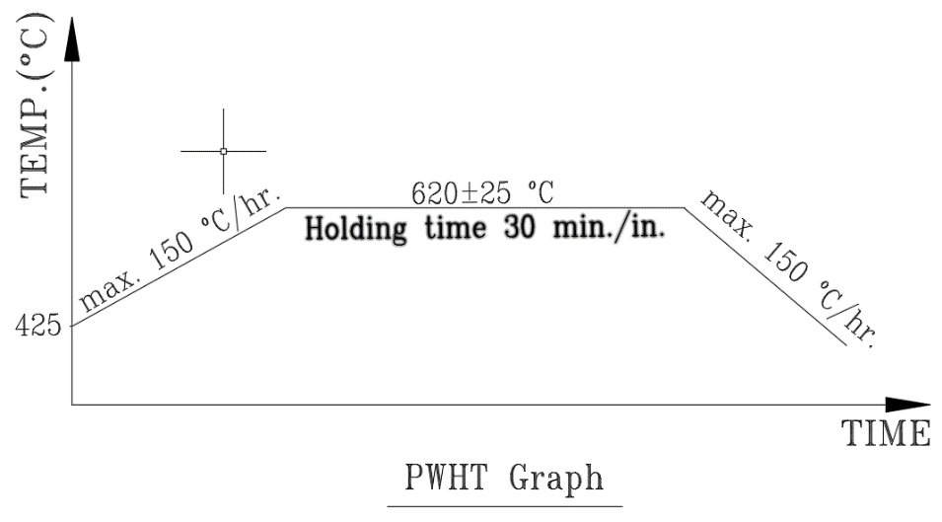

# Thermocouples

1. The thermocouples shall be of the type ‘K’ i.e. nickel-chromium / nickel – aluminum type in accordance with BS 1041. Part – 4. The thermocouples should have initial calibration check. All the thermocouple wires should have valid certificate of conformance with a tolerance of <+/- 0.75% between the temperature ranges 200 C to 700 C.
2. The general ‘K’ type thermocouple wire shall have dimension 1/0.71 mm of Ni-Cr/Ni-A1. The +ve & -ve charges should be marked properly.

Additional Thermocouple will be used if multiple heat control zones are used, in which a control zone is monitored by any of the Primary Thermocouples.

Deleted

The thermocouples are installed outside the equipment and are calibrated.

The thermocouples shall be attached in the following manner.

1. Capacitance discharged direct wire, & the gap between the wires should not be more than 5mm. The junction has to be insulated by using thermocouple high temperature putty in order to protect it from direct heat source.

The thermocouple to extension cable connection shall be minimum of 0.5m outside the heated zone & the acceptable junction temperature should not be more than 800 ºC.

The thermocouples & positions shall be identified on the particular temperature recording chart by number of color / symbols of stamp

1. After the completion of PWHT remove the thermocouples & ground smoothly the area, to clean & achieve sound metal. As per the specification / instruction of the inspector the areas are to be examined by MT or PT after grinding.

Minimum quantity of thermocouples shall be 9 pieces according to following sketch.



# Temperature Recording

1. Temperature recorders shall be calibrated before of PWHT. The calibration certificate should be kept & a sticker should be stuck on the instrument.
2. The speed of the chart should be adjusted at 25mm / hr., recording all monitoring of thermocouples, it should also be giving information’s of the difference in temperatures and the different trends during the heating & cooling cycle.
3. The time temperature chart should be recording the heat treatment of those welds undergoing the same cycle for any particular section.
4. During the holding period shall not be greater difference than 83°C between the highest and invert temperature through the body portion of work piece heated.

# GENERAL NOTES

1. Temperature of any parts during heat treatment shall not be less than values shown herein.
2. Maximum temperature of any part shall not be more than 25°C above the holding temperature shown in graph.
3. The fuel is natural gas.
4. During the heating period there shall not be a greater variation in temperature throughout the portion of the vessel being heated than 140°C within any 4.6m interval of length.
5. During the holding `` there shall not be a greater difference than 83°C between the highest and lowest temperature throughout the portion of the vessel being heated.
6. Heat treatment operator shall witness for controlling of temperature above 425°C.
7. The flame shall not be touched directly on the product.
8. From 425°C the equipment may be cooled in still air.
9. As part of the inspection, thermocouple to be used for heat treatment shall be checked to verify their calibration status. Only calibrated thermocouple shall be used.

# Documentations

1. Procure the approval of the PWHT cycle & assignment for the weld joint to be heat treated. The details to be included in the work sheet are as follows: Material, wall thickness of shell, heating & cooling rates, soaking temperature & time.
2. Inform the client if you notice any deviation in the heat treatment cycle.

# Report & Records

The heat treatment cycle chart shall be treated as the proof & record for any h.t - completion.

A copy of calibration certificate with TPI signature and other involved parties (Acc. to approved ITP) for temperature recorders shall be attached to the report.

ISB technicians will fill out the record sheets of Heat Treatment (sample attached) prior to start of any PWHT and client shall authorize specifications complying with governing code. On completion, the record of the Heat Treatment along with chart will be submitted to the client, as minimum the following information will be provided:

a. Client Identity

b. Contract/Job Identity c. Specification Details

d. Equipment number, diameter and weld numbers e. Material specification

f. Thermocouple locations

g. Heating and Cooling Rate h. Soaking (holding) time

i. Operator name

j. Location map of particular vessels k. Date and Chart speed

Deleted

# Appendix-1 PWHT Report Sample

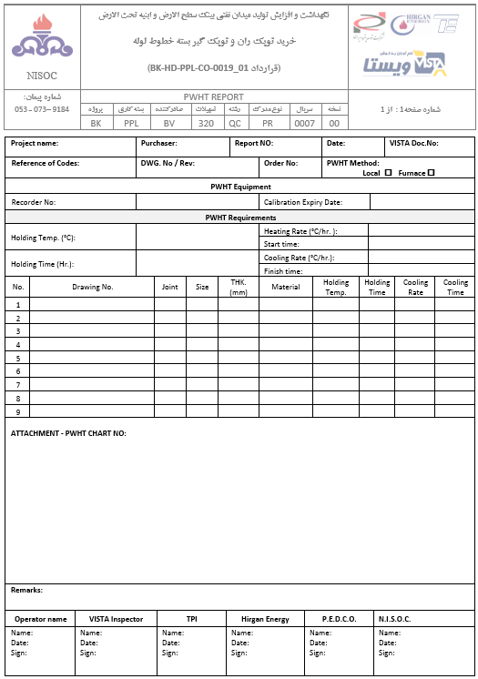

# Appendix-2 Heat Treatment Controller Recorder Certificate

