|  |  |  |  |  |  |  |
| --- | --- | --- | --- | --- | --- | --- |
| **طرح نگهداشت و افزایش تولید 27 مخزن** | | | | | | |
| **Packing, Marking and Shipping Procedure**  **نگهداشت و افزایش تولید میدان نفتی بینک** | | | | | | |
| V01 | Oct.2023 | IFI | Beh Koosh Vista | M.Fakharian | S.Faramrz.pour |  |
| V00 | Aug.2023 | IFI | Beh Koosh Vista | M.Fakharian | A.M.Mohseni |  |
| **Rev.** | **Date** | **Purpose of Issue/Status** | **Prepared by:** | **Checked by:** | **Approved by:** | **CLIENT Approval** |
|  | |  | | | | |
| **Status:** | |  | | --- | | **IFA: Issued for Approval**  **IFR: Issued for Review**  **IFI: Issued for Information**  **AFC: Approved for Construction** | | | | | | |

# Revision Record Sheet

|  |  |  |  |  |  |  |  |  |
| --- | --- | --- | --- | --- | --- | --- | --- | --- |
| **SHEET** | **V00** | **V01** | **V02** | **V03** | **V04** | **V05** | **V06** | **V07** |
| 1 | X | X |  |  |  |  |  |  |
| 2 | X | X |  |  |  |  |  |  |
| 3 | X | X |  |  |  |  |  |  |
| 4 | X | X |  |  |  |  |  |  |
| 5 | X | X |  |  |  |  |  |  |
| 6 | X | X |  |  |  |  |  |  |
| 7 | X | X |  |  |  |  |  |  |
| 8 |  | X |  |  |  |  |  |  |
| 9 |  |  |  |  |  |  |  |  |
| 10 |  |  |  |  |  |  |  |  |
| 11 |  |  |  |  |  |  |  |  |
| 12 |  |  |  |  |  |  |  |  |
| 13 |  |  |  |  |  |  |  |  |
| 14 |  |  |  |  |  |  |  |  |
| 15 |  |  |  |  |  |  |  |  |
| 16 |  |  |  |  |  |  |  |  |
| 17 |  |  |  |  |  |  |  |  |
| 18 |  |  |  |  |  |  |  |  |
| 19 |  |  |  |  |  |  |  |  |
| 20 |  |  |  |  |  |  |  |  |
| 21 |  |  |  |  |  |  |  |  |
| 22 |  |  |  |  |  |  |  |  |
| 23 |  |  |  |  |  |  |  |  |
| 24 |  |  |  |  |  |  |  |  |
| 25 |  |  |  |  |  |  |  |  |
| 26 |  |  |  |  |  |  |  |  |
| 27 |  |  |  |  |  |  |  |  |
| 28 |  |  |  |  |  |  |  |  |
| 29 |  |  |  |  |  |  |  |  |
| 30 |  |  |  |  |  |  |  |  |
| 31 |  |  |  |  |  |  |  |  |
| 32 |  |  |  |  |  |  |  |  |
| 33 |  |  |  |  |  |  |  |  |
| 34 |  |  |  |  |  |  |  |  |
| 35 |  |  |  |  |  |  |  |  |
| 36 |  |  |  |  |  |  |  |  |
| 37 |  |  |  |  |  |  |  |  |
| 38 |  |  |  |  |  |  |  |  |
| 39 |  |  |  |  |  |  |  |  |
| 40 |  |  |  |  |  |  |  |  |
| 41 |  |  |  |  |  |  |  |  |
| 42 |  |  |  |  |  |  |  |  |
| 43 |  |  |  |  |  |  |  |  |
| 44 |  |  |  |  |  |  |  |  |
| 45 |  |  |  |  |  |  |  |  |
| 46 |  |  |  |  |  |  |  |  |
| 47 |  |  |  |  |  |  |  |  |
| 48 |  |  |  |  |  |  |  |  |
| 49 |  |  |  |  |  |  |  |  |
| 50 |  |  |  |  |  |  |  |  |

|  |  |  |  |  |  |  |  |  |
| --- | --- | --- | --- | --- | --- | --- | --- | --- |
| **SHEET** | **V00** | **V01** | **V02** | **V03** | **V04** | **V05** | **V06** | **V07** |
| 51 |  |  |  |  |  |  |  |  |
| 52 |  |  |  |  |  |  |  |  |
| 53 |  |  |  |  |  |  |  |  |
| 54 |  |  |  |  |  |  |  |  |
| 55 |  |  |  |  |  |  |  |  |
| 56 |  |  |  |  |  |  |  |  |
| 57 |  |  |  |  |  |  |  |  |
| 58 |  |  |  |  |  |  |  |  |
| 59 |  |  |  |  |  |  |  |  |
| 60 |  |  |  |  |  |  |  |  |
| 61 |  |  |  |  |  |  |  |  |
| 62 |  |  |  |  |  |  |  |  |
| 63 |  |  |  |  |  |  |  |  |
| 64 |  |  |  |  |  |  |  |  |
| 65 |  |  |  |  |  |  |  |  |
| 66 |  |  |  |  |  |  |  |  |
| 67 |  |  |  |  |  |  |  |  |
| 68 |  |  |  |  |  |  |  |  |
| 69 |  |  |  |  |  |  |  |  |
| 70 |  |  |  |  |  |  |  |  |
| 71 |  |  |  |  |  |  |  |  |
| 72 |  |  |  |  |  |  |  |  |
| 73 |  |  |  |  |  |  |  |  |
| 74 |  |  |  |  |  |  |  |  |
| 75 |  |  |  |  |  |  |  |  |
| 76 |  |  |  |  |  |  |  |  |
| 77 |  |  |  |  |  |  |  |  |
| 78 |  |  |  |  |  |  |  |  |
| 79 |  |  |  |  |  |  |  |  |
| 80 |  |  |  |  |  |  |  |  |
| 81 |  |  |  |  |  |  |  |  |
| 82 |  |  |  |  |  |  |  |  |
| 83 |  |  |  |  |  |  |  |  |
| 84 |  |  |  |  |  |  |  |  |
| 85 |  |  |  |  |  |  |  |  |
| 86 |  |  |  |  |  |  |  |  |
| 87 |  |  |  |  |  |  |  |  |
| 88 |  |  |  |  |  |  |  |  |
| 89 |  |  |  |  |  |  |  |  |
| 90 |  |  |  |  |  |  |  |  |
| 91 |  |  |  |  |  |  |  |  |
| 92 |  |  |  |  |  |  |  |  |
| 93 |  |  |  |  |  |  |  |  |
| 94 |  |  |  |  |  |  |  |  |
| 95 |  |  |  |  |  |  |  |  |
| 96 |  |  |  |  |  |  |  |  |
| 97 |  |  |  |  |  |  |  |  |
| 98 |  |  |  |  |  |  |  |  |
| 99 |  |  |  |  |  |  |  |  |
| 100 |  |  |  |  |  |  |  |  |

Table of Contents

Revision Record Sheet 2

1 Introduction 4

2 Reference 4

3 Packing Description 4

4 Marking Instruction 5

5 Lifting Sketch 6

6 Care Mark 7

7 Appendix1: Packing List 8

# Introduction

The PACKING AND MARKING PROCEDURE specifies the preparation, packing, and marking of Pig Launcher and Pig Receiver Trap with item No: PL-3201, PR-3201 which are designed and fabricated by Vista Company.

In all circumstances, the packing will be calculated in order to support any strain exerted on the GOODS during transportation. They must be carried out specifically, in order to permit the delivery of GOODS to the jobsite by sea, road or air in good condition.

Equipment must be carefully protected and packed against all damages or defects during transit to destination and shall be in accordance with any special provision contained in the specification or purchase order. Special attention must be given for protection against corrosion during transit.Ancillary items forming an integral part of the equipment should be packed preferably in a separate container if the equipment is normally cased or crated.Alternatively, the ancillary items should be fixed securely to the equipment and adequate precaution should be taken to ensure that items do not come loose in transit or be otherwise damaged.

The following terms shall be used in this document.

|  |  |
| --- | --- |
| Client: | * National Iranian South Oilfields Company (NISOC) |
| Project: | * Binak Oilfield Development – Manufacturing (w/Engineering & Material Supply) of Pig traps |
| EPD/EPC Contractor (GC): | * Petro Iran Development Company (PEDCO) |
| EPC Contractor/Purchaser: | * Joint Venture of: Hirgan Energy – Design & Inspection(D&I) Companies |
| Vendor: | * Nam Avaran Beh Koosh Vista |
| Executor: | * Executor is the party which carries out all or part of construction and/or commissioning for the project. |
| TPI: | * Third Party Inspector |

# Reference

|  |  |
| --- | --- |
| a) IPS-M-PI-130 -2014 | * Material and equipment standard for pig launching and receiving traps |
| b) BS-1133 -2016 | * Packing code |
| c) IPS-G-GN-210 -1997 | * General standard for packing & packages |
| d) BK-GNRAL-PEDCO-000-QC-PR-0045-D00 | * Packing, Marking and Transportation Procedure |

# Packing Description

The pig trap is placed upright on its saddles and fastened with a strap.

All flanges, machined working surfaces and threaded parts of all equipment shall be suitably protected.

All flanged connections of traps shall be protected by wooden or plastic caps suitably secured in position.

All valves and fittings (pipe elbows, flanges, etc.) shall be suitably protected and their method of shipment shall be:

1. All valves and fittings shall be suitably packed and shipped in metal strapped or wood re‐ enforced waterproof wooden cases with metal corner protection.
2. All treaded fittings shall be greased and provided with plastic caps.
3. All equipment internals and items not installed by the VENDOR at works including accessories such as small parts, bolts, nuts, gaskets, valves and etc. shall be packed in wooden cases separately for each vessel or equipment (apparatus) and marked with the same item number as the vessel/apparatus in order to protect all parts from loss, damage or pilferage in transit.

Internals, bolts and gaskets for service/ testing operations shall be supplied with the equipment/items by the VENDOR and all internals, boxed separately and marked according to marking procedures. Each item shall be supplied correctly and identified for field installation by others.

BS 1133, IPS-G-GN-210 and IPS-M-PI-130 standards are followed according to the scope of work as per purchase order.

# Marking Instruction

All equipment will be clearly marked with their equipment number, purchaser job number and order number. This marking is additional to manufacturers name plate.

The package marking must allow a sure identification of the items (for example n° of order, destination place etc.) and give useful information to carry out the lifting, transport and storage operations correctly (for example gross weight, guaranteed superimposition load, environmental conditions that are tolerated etc.). The marking information is written in the "Purchase Conditions" that are enclosed with the Order.

Units or parts belonging to main equipment but separately packed shall be clearly marked for easy identification with the main equipment to which they relate.

The package marking must be clear, indelible and proportionate to the package dimensions. It can be executed directly on the package by black characters on light background, or indirectly on A4-size plastic-coated signboards (mm 210x297) filled in by black characters on white background.

On each case, apparatus on saddles the gross weight, the center of gravity and the lifting or forking points (symmetrical and adequately spaced out from the load barycenter) must be clearly marked.

for the apparatuses that are positioned on saddles, the marking can be executed directly on the apparatus or on the saddles.

Delete

All cost whatever resulting from inadequate or insufficient packing shall be fully compensated by the VENDOR. The preparation shall be suitable for at least one years of outdoor storage from the time of shipment in a manner requiring no disassembly prior to operation.

All materials shipped in separate crates shall be suitably identified with securely affixed corrosion resistant metal tags indicating the items and serial number of the equipment for which it is intended.

The greatest care must be taken to ensure that shipping description of packages for custom release are accompanied with the shipment.

|  |  |  |
| --- | --- | --- |
| **Namavaran Behkoosh VISTA** |  | **N.I.S.O.C** |
|  | | VENDOR/SUPPLIER: |
|  | | Project |
|  | | Manufacture |
|  | | JOB No. |
|  | | Tag No. |
|  | | Serial No. |
| KGs |  | Net Weight |
| KGs |  | Gross Weight |
| In MMs |  | Dimensions L x W x H |

It shall be capable of multiple handling and storage under favorable conditions for a minimum of 2 years.

The requirements of above items shall not relieve the supplier/contractor of any of his responsibilities and his obligations for delivery of equipment in a sound undamaged and operable conditions at site.

# Lifting Sketch

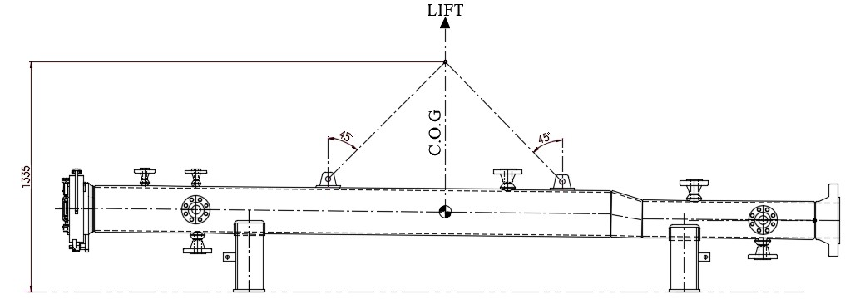

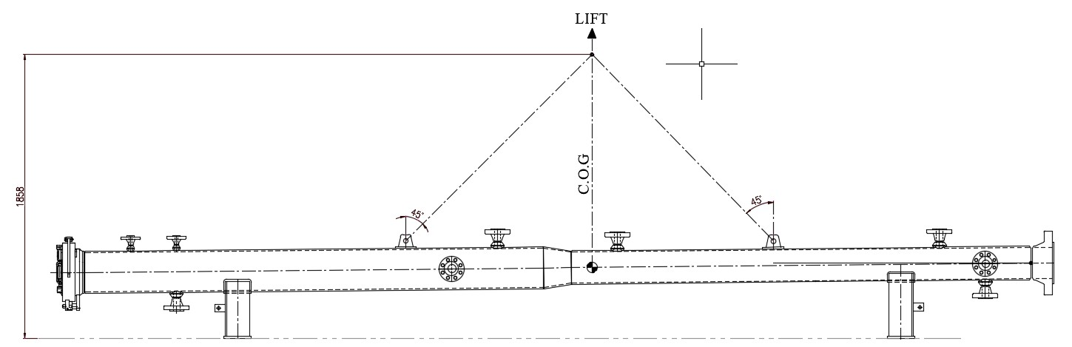

# Care Mark

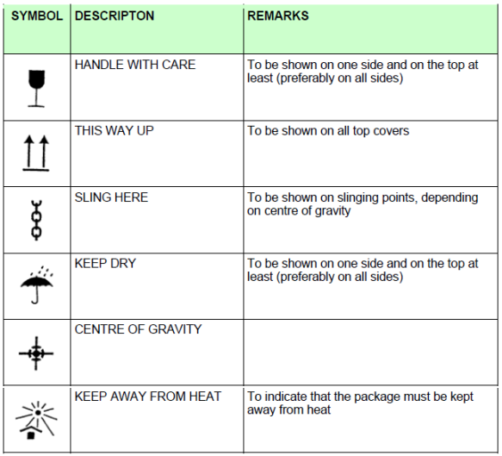

# Appendix1: Packing List

