|  |  |  |  |  |  |  |
| --- | --- | --- | --- | --- | --- | --- |
| **طرح نگهداشت و افزایش تولید 27 مخزن** | | | | | | |
| **Packing, Marking And Shipping Procedure**  **نگهداشت و افزایش تولید میدان نفتی بینک** | | | | | | |
|  |  |  |  |  |  |  |
|  |  |  |  |  |  |  |
|  |  |  |  |  |  |  |
| V01 | Apr. 2025 | IFA | IGK | M.Fakharian | S.Faramarzpour |  |
| V00 | Mar. 2025 | IFA | IGK | M.Fakharian | S.Faramarzpour |  |
| **Rev.** | **Date** | **Purpose of Issue/Status** | **Prepared by:** | **Checked by:** | **Approved by:** | **CLIENT Approval** |
|  | | | | | | |
| **Status:** | **IFA: Issued for Approval**  **IFI: Issued for Information**  **AFC: Approved for Construction** | | | | | |

**REVISION RECORD SHEET**

|  |  |  |  |  |  |  |  |  |  |  |  |  |
| --- | --- | --- | --- | --- | --- | --- | --- | --- | --- | --- | --- | --- |
| **PAGE** | **V00** | **V01** | **V02** | **V03** | **V04** |  | **PAGE** | **V00** | **V01** | **V02** | **V03** | **V04** |
| **1** | X | X |  |  |  | **66** |  |  |  |  |  |
| **2** | X | X |  |  |  | **67** |  |  |  |  |  |
| **3** | X |  |  |  |  | **68** |  |  |  |  |  |
| **4** | X | X |  |  |  | **69** |  |  |  |  |  |
| **5** | X |  |  |  |  | **70** |  |  |  |  |  |
| **6** | X | X  X  X |  |  |  | **71** |  |  |  |  |  |
| **7** | X | X  X  X |  |  |  | **72** |  |  |  |  |  |
| **8** | X |  |  |  |  | **73** |  |  |  |  |  |
| **9** | X |  |  |  |  | **74** |  |  |  |  |  |
| **10** | X | X  X  X |  |  |  | **75** |  |  |  |  |  |
| **11** | X |  |  |  |  | **76** |  |  |  |  |  |
| **12** | X |  |  |  |  | **77** |  |  |  |  |  |
| **13** | X |  |  |  |  | **78** |  |  |  |  |  |
| **14** | X |  |  |  |  | **79** |  |  |  |  |  |
| **15** | X |  |  |  |  | **80** |  |  |  |  |  |
| **16** | X |  |  |  |  | **81** |  |  |  |  |  |
| **17** |  |  |  |  |  | **82** |  |  |  |  |  |
| **18** |  |  |  |  |  | **83** |  |  |  |  |  |
| **19** |  |  |  |  |  | **84** |  |  |  |  |  |
| **20** |  |  |  |  |  | **85** |  |  |  |  |  |
| **21** |  |  |  |  |  | **86** |  |  |  |  |  |
| **22** |  |  |  |  |  | **87** |  |  |  |  |  |
| **23** |  |  |  |  |  | **88** |  |  |  |  |  |
| **24** |  |  |  |  |  | **89** |  |  |  |  |  |
| **25** |  |  |  |  |  | **90** |  |  |  |  |  |
| **26** |  |  |  |  |  | **91** |  |  |  |  |  |
| **27** |  |  |  |  |  | **92** |  |  |  |  |  |
| **28** |  |  |  |  |  | **93** |  |  |  |  |  |
| **29** |  |  |  |  |  | **94** |  |  |  |  |  |
| **30** |  |  |  |  |  | **95** |  |  |  |  |  |
| **31** |  |  |  |  |  | **96** |  |  |  |  |  |
| **32** |  |  |  |  |  | **97** |  |  |  |  |  |
| **33** |  |  |  |  |  | **98** |  |  |  |  |  |
| **34** |  |  |  |  |  | **99** |  |  |  |  |  |
| **35** |  |  |  |  |  | **100** |  |  |  |  |  |
| **36** |  |  |  |  |  | **101** |  |  |  |  |  |
| **37** |  |  |  |  |  | **102** |  |  |  |  |  |
| **38** |  |  |  |  |  | **103** |  |  |  |  |  |
| **39** |  |  |  |  |  | **104** |  |  |  |  |  |
| **40** |  |  |  |  |  | **105** |  |  |  |  |  |
| **41** |  |  |  |  |  | **106** |  |  |  |  |  |
| **42** |  |  |  |  |  | **107** |  |  |  |  |  |
| **43** |  |  |  |  |  | **108** |  |  |  |  |  |
| **44** |  |  |  |  |  | **109** |  |  |  |  |  |
| **45** |  |  |  |  |  | **110** |  |  |  |  |  |
| **46** |  |  |  |  |  | **111** |  |  |  |  |  |
| **47** |  |  |  |  |  | **112** |  |  |  |  |  |
| **48** |  |  |  |  |  | **113** |  |  |  |  |  |
| **49** |  |  |  |  |  | **114** |  |  |  |  |  |
| **50** |  |  |  |  |  | **115** |  |  |  |  |  |
| **51** |  |  |  |  |  | **116** |  |  |  |  |  |
| **52** |  |  |  |  |  | **117** |  |  |  |  |  |
| **53** |  |  |  |  |  | **118** |  |  |  |  |  |
| **54** |  |  |  |  |  | **119** |  |  |  |  |  |
| **55** |  |  |  |  |  | **120** |  |  |  |  |  |
| **56** |  |  |  |  |  | **121** |  |  |  |  |  |
| **57** |  |  |  |  |  | **122** |  |  |  |  |  |
| **58** |  |  |  |  |  | **123** |  |  |  |  |  |
| **59** |  |  |  |  |  | **124** |  |  |  |  |  |
| **60** |  |  |  |  |  | **125** |  |  |  |  |  |
| **61** |  |  |  |  |  | **126** |  |  |  |  |  |
| **62** |  |  |  |  |  | **127** |  |  |  |  |  |
| **63** |  |  |  |  |  | **128** |  |  |  |  |  |
| **64** |  |  |  |  |  | **129** |  |  |  |  |  |
| **65** |  |  |  |  |  | **130** |  |  |  |  |  |

**TABLE OF CONTENTS**

1. Introduction 4

1.2 REFERENCES: 4

1.3 ABBREVIATIONS: 4

1.4 Purpose and definition of packing 5

1.5 Scope Covered 5

2. Packing Material and Assembly 6

3. Packing Procedure 10

4. PRE-CAUTION WHILE LOADING/ SHIPMENT 12

7. Handling 13

7.1 General 13

7.2 Handling of packed equipment 13

7.3 Handling without Packing 13

8. Transportation 14

9. Installation of Equipment 14

10.Site Utilization 15

11.Long Term Storage 15

12.Storage and Preservation 15

12.1 Storage Condition 15

12.2 Location of Storage 15

12.3 Storage Environment 16

12.4 Storage of Pack Equipment 16

12.5 Storage of Unpack Equipment 16

12.6 Stores keeping 16

12.7 Protection of material 16

# Introduction

This procedure specifies the packing, marking, transportation, storage and unpacking conditions which are essential for the smooth and safe movement of IGK components by road, air and sea. This procedure for packing, shipping and storage noted here are applicable in all cases unless overriding packing directions are received from the Customer.

**1.1 GENERAL DEFINITION**

The following terms shall be used in this document.

|  |  |
| --- | --- |
| CLIENT: | National Iranian South Oilfields Company **(NISOC)** |
| PROJECT: | DCS and ESD Control System of Binak Gas Booster Station. |
| EPD/EPC CONTRACTOR (GC): | Petro Iran Development Company **(PEDCO)** |
| EPC CONTRACTOR/PURCAHSER: | Joint Venture of: Hirgan Energy – Design & Inspection Companies **(HE/DI)** |
| VENDOR: | IDEH GLOBAL KISH (IGK) |
| EXECUTOR: | Executor is the party which carries out all or part of construction and/or commissioning for the project. |
| TPI: | IS Tehran company |
| SHALL: | Is used where a provision is mandatory. |
| SHOULD: | Is used where a provision is advisory only. |
| MAY: | Is used where a provision is completely discretionary. |

### **1.2 REFERENCES:**

PACKING , MARKING , TRANSPORTATION PROCEDURE BK-GNRAL-PEDCO-000-QC-PR-0045_D00

### **1.3 ABBREVIATIONS:**

ESD : Emergency Shutdown



DCS : Distributed Control System

VCI: Volatile Corrosion Inhibitor

OEM: Original Equipment Manufacturer

Every IGK component must be packed with careful consideration of the following:

* The special characteristics of each product or component
* The method of transportation and handling conditions
* The weather conditions entire route to the destination and the time period after arrival until it is unpacked.
* Protection against above-lying cargo pressure in a warehouse or ship’s hold
* Prevention of quality impairment, deterioration, or rusting, etc. caused by submersion and moisture absorption
* Measures against theft and prevention from dropping

### **1.4 Purpose and definition of packing**

The purpose of packing is to protect the value and condition of products or components when they are transported or stored. Hence, suitable packing materials and containers must be used with products and parts. These packing materials are divided into the following three groups: Item packing, inner packaging, and outer packaging.

* Item Packaging

Packing of individual goods. Techniques or conditions in which, to raise the merchandise value of goods or to protect them, appropriate packing materials or containers are used with the goods.

* Inner Packaging

Inner packaging of cargo. Techniques or conditions in which appropriate packing materials or containers are used with goods taking into account the effects of water, moisture, light, heat, vibration or shock, etc. on the goods.

* Outer Packaging

Outer packaging of cargo. Techniques or conditions for placing goods in containers such as boxes, bags, barrels, and cans, or tying and bundling the goods without a container, and labelling them with symbols or marks.

### **1.5 Scope Covered**

This packing procedure scope covers the following products and components.

This procedure shall be followed for all IGK executed project materials and shall include the followings:

* System Cabinets DCS, ESD
* Marshalling Cabinets DCS, ESD
* Auxiliary Consoles
* Network Cabinet
* Supervisory (Station,Prineter,…)
* Operator Desk

# Packing Material and Assembly

All components packing shall be in the form of wooden base with batten plywood as side/ end/ top walls unless otherwise specific method provided by IGK customers. In some cases components shall be packed in standard factory packing which is provided by the manufacturer; this is applicable to those components are being sent separately as spare/ commissioning items which doesn’t require wooden packing while shipment.

The packing shall be in common standard practice in IGK for type of shipments and shall be followed for all modes of shipments such as Road, Air and Sea. The batten plywood packing shall comprise of the following as minimum requirements.



* Wooden Skid Base
* Batten plywood Side walls (Prefabricated Structural Members)
* Batten plywood Ends walls (Prefabricated Structural Members)
* Batten plywood Top Cover
* The Wooden Skid Base shall be made of:
* Skids or Runners

The Skids or Runners shall be lengthwise wooden members of the foundations or the base and serve to support the load of the contents in combination with the load bearing floor members. The sizes of the runners shall vary from component to component based on the type of the components. Sling points shall be provided at the ends of the skids for cabinets to ease the loading / unloading activity by crane / hoist. Wooden material for skid base shall be with 100mm X 100mm size and the length shall be based on the size of the components.

* Load bearing floor members

These Load bearing floor members shall be of timber with almost 24mm thickness; screwed and or nailed on to the runners making provision for the “ENDS” to sit on the runner. The size of the load bearing floor members shall be as per the actual component size and type.

* Locking Members.

These are members of wood nailed on to the skid base and at different location in a packing case for restriction of movement of the component during transit and handling. The size, position and number of these locking members vary depending upon the type of component.

The sides of locking battens at the bottom are not faced with the felt material to avoid slippage during jolts in transportation. They will be firmly butted to the base channel of the component.

* Batten plywood Side walls (Prefabricated Structural Members)

These are prefabricated wooden structural members, which covers the item getting packed from the left and right sides of the skid base. This will form as mechanical protection on left and right sides for the components which is being packed. The size of the side walls shall vary based on the actual component size and type.

Side wall plywood thickness shall be with minimum 24mm thickness. Battens size shall be 50mm (D) X 60mm (W). Batten shall be fixed with plywood with nails or screws as applicable.

For cubicles minimum 5 no. battens shall be used including the top and bottom battens in some cases 3 no. batten shall be provided including top and bottom battens depending on the size and type of the packing.

For consoles and other miscellaneous items minimum 3 no. battens shall be used including the top and bottom battens; in some cases additional battens shall be provided depending on the size and type of the packing as applicable.



* Batten plywood Ends walls (Prefabricated Structural Members)

These are prefabricated wooden structural members, which covers the item getting packed from the front and rear sides of the skid base. This will form as mechanical protection on front and rear sides for the components which is being packed. The size of the end walls shall vary based on the actual component size and type.

End wall timber thickness shall be with minimum 24mm thickness. Battens size shall be 50mm (D) X 60mm (W). Batten shall be fixed with timber with nails or screws as applicable. The length of the batten shall be as per the actual component size/ type.

For cabinets minimum 5 no. battens shall be used including the top and bottom battens; in some cases 3 no. batten shall be provided including top and bottom battens depending on the size and type of the component.

For consoles and other miscellaneous items minimum 3 no. battens shall be used including the top and bottom battens; in some cases additional battens shall be provided depending on the size and type of the packing as applicable.

These are also prefabricated structural members, which covers the item being packed from the front and rear side of the skid base. Construction wise this is also same as side walls.

* Batten plywood Top Cover

These Top covers are prefabricated wooden structural members, which covers the item getting packed and covered at top side. This will form as mechanical protection on top side for the component which is being packed. The size of the top cover shall be similar size to the skid base and shall vary based on the actual component size and type.

Top cover plywood thickness shall be with minimum 24mm thickness. Battens size shall be 50mm (D) X 60mm (W). Batten shall be fixed with plywood with nails or screws as applicable. The length of the batten shall be as per the actual component size/ type.

Assembly shall be done in such a way that the end walls are positioned on the top of the skid at the extreme ends and bolted with GI nut/ bolts diagonally on to the runners.

Subsequently the side walls are placed on both sides of the skid base butting to the runners at the bottom, to end walls vertically and bolted with GI nut/ bolts on from outside to the runners of the skid base at the bottom and to the end walls vertically. Finally the case shall be closed with a top cover.

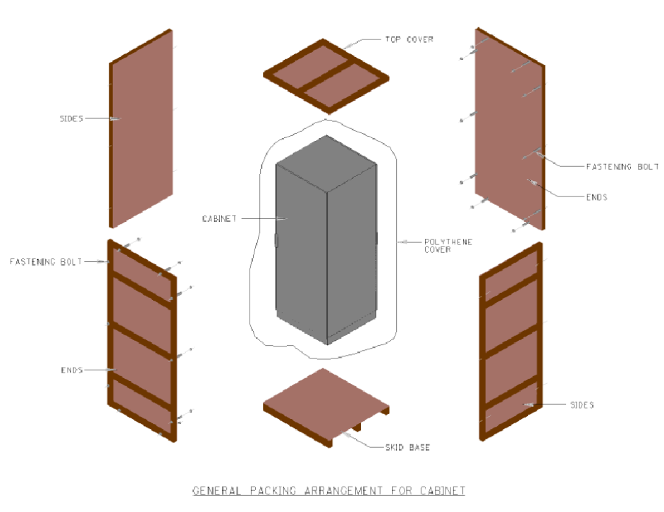

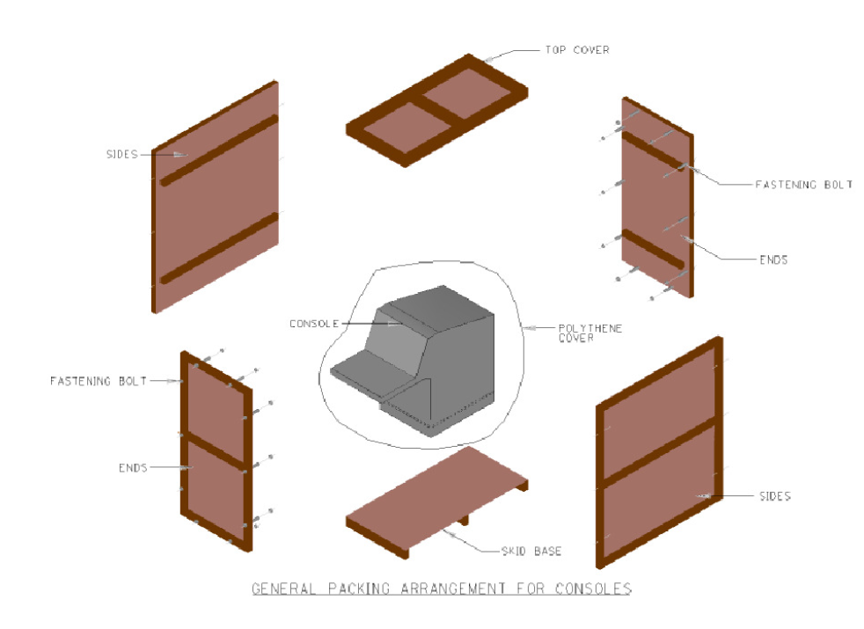

# Packing Procedure

Packing materials and assembly shall be arranged as detailed in the section 2. The component/ materials which are ready for packing shall be placed on the skid base with suitable bottom sheet as applicable.

Prior to start of packing the components shall be cleaned with suitable hand-held vacuum cleaner for dust and other foreign particles. Loose component parts, falling objects, loose cables etc shall be properly tied and kept safely inside the component to avoid any transportation damages. Any loose unconnected wires shall be tied properly and kept safely. Any opening on the components shall be closed on temporarily. Any sensitive electronic parts shall be removed from the component and packed in separate boxes.

Items like system cables, printers, color hard copy units, consumables, spares, field instruments will undergo a preliminary packing in corrugated board boxes or its original OEM packing boxes prior to final case packing. Cabinets shall be fixed with skid base with nut bolts to avoid vertical & horizontal movement of cabinets.

All parts with in the component shall be fixed rigidly by tightening the screw/ nut bolts.

Cabinets / Consoles which are to be packed shall be covered with suitable packing Aluminium foil pockets, heat sealed at the bottom after removing the atmospheric air concealed inside. This packing Aluminum foils as a barrier in avoiding ingression of atmospheric moisture and there by prevents oxidation of metallic parts. Also desiccants packets consisting of Silica gel shall be used in the packages prior to final close in order to absorb the moisture traces within the packing case. After heat sealing the cover at the bottom, the stretch film shall be tightly wound at the sides / ends of the cabinets.

The Aluminum foil with vacuum packing shall be applied for all packing which is being transported by any mode and or the components being stored for longer duration (more than 3-months) at customer facility.

Few small components such as cables, spare hardware, printers etc, being transported as separate items shall be packed in the OEM (Original Equipment Manufacturer) packing and few cases packing shall be done with VCI covers when the components are packed in cartoon boxes.

Additionally desiccants packets consisting of Silica gel shall be used in the packages after the vacuum pack with Aluminum foil prior to close by top cover while packing in order to absorb the moisture traces within the packing case.

Cabinets with glass on front door shall be cover with Bubble plastic shock absorber .



NOTE: All spare parts will be packaged separately and appropriately labeled.

* **The below sequential activities shall be followed for the packing:**
* Place the skid base pallet on the ground.
* Spread the Aluminum foil, and air bubble sheet over the pallet and position the component on the skid base pallet.
* Clean the equipment for dust and finger marks with clean cotton waste.
* Cover the equipment with air bubble sheet.
* Drop the aluminium foil cover with thermal stitching machine and seal all the sides except leaving a small opening for evacuating the air accumulated inside the cover/ cabinet.
* Evacuate the air inside the aluminum foil cover using a vacuum pump. While evacuating the air ensure the cabinet side cover/ door not deflecting inside due to more vacuum.
* Seal the small opening after evacuating the air inside the Aluminium foil cover and ensure proper sealing without leak.
* Stretch wrap with minimum thickness of 25 microns around the Aluminium foil and place the paper tonnage around the packed component. This wrap shall be made minimum 3-layers and additionally minimum one layer after placing the paper tonnage.
* Lock the equipment by using locking battens.
* Build the side walls and fix with GI Nut bolts rigidly.
* Place the end walls, fix and lock the side walls with nut and bolts.
* Place the top cover on the sides and fix with nut bolts.
* Handling marks shall be provided as follows on wooden cases/ boxes as applicable.
* In addition Delivery Address with contact person name, shipping marks (as per customer requested form) shall be provided in either side of the wooden case. Any color code from customer requirements shall also be followed.

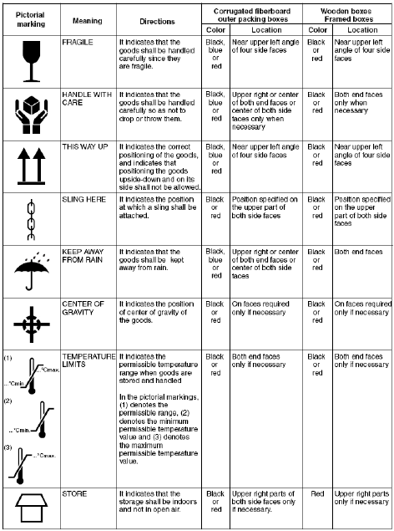

# PRE-CAUTION WHILE LOADING/ SHIPMENT

* Do not load crates on top of others.
* Keep all crates upright.
* Secure loaded crates using ropes, and cover them completely with water proof coverings.
* Do not load crates outdoors when it is raining.
* Cargos contain precision instruments. Selecting a company specializing in the transportation of Engineering, Electronics and precision instruments. Keep all products upright during movement by truck transport. When transporting by surface transport, drive at low speed to avoid vibration and impact. Also, slow down to the limit on a bad road. Vehicle selection & placement as per Logistics Planning. Almost in all cases anti-vibration air-suspension type trucks shall be used while transporting the cases having sensitive electronic components.
* Documents of Vehicles are verified to ensure Vehicle is insured and SAFE for transit.
* After completing the above formalities Loading activity will commence
* Loading of truck by using Forklift / hoist / trolley.
* Do not transport equipment through areas where there may be corrosive gas or intensive electric or magnetic field. Handle with utmost care, strictly avoid transhipment.
* While transportation ensure that equipment is not vibrating much. As much as possible avoid transporting in jagged roads.
* Notify the transporter about the sensitive electronic equipment are available inside and they should take more care while transportation.

1. **UNLOADING / UNPACKING PROCEDURE**

Prepare special equipment for unloading. Avoid unloading outdoor in case of rain.

To select a location for safe unloading, check that:

* There is ample space for crane and forklift manoeuvring.
* Ground is solid.
* The handrails of scaffold can be removed.
* There is enough working space for unpacking.
* There is a height of at least 3000 mm under the roof.
* Outdoor-indoor temperature difference should be less than 10 °C

1. **Admissible Conditions for Transportation and Storage**

* Temperature: -20 C to +60 C
* Temperature Fluctuation: within 20°C/hour
* Relative humidity: 10 to 90 % RH non-condensing
* Vibration for Cabinets, Horizontal: 2.9 m/s2 or less & Vertical: 4.9 m/s2 or less

# Handling

## 7.1 General

This chapter defines the handling procedure for the Control and Safety System equipment to be installed on the Binak Gas Booster Station.

## 7.2 Handling of packed equipment

Handling operation of packed equipment shall be performed taking into account the graphic symbols shown on each box without any restriction.

Ensure that the cabinets are adequately supported during periods that they are suspended or supported by lifting equipment. Opening of cabinet doors or the movement of any loose equipment in the cabinets may cause center of gravity shifts. This constitutes a hazard to personnel and may cause serious injury or death. Ensure that the swing panels, cabinets’ doors and all panel modules are secured before lifting commences.

The cabinets are fitted with eyebolts on the top of each cabinet to facilitate lifting by using overhead lifting equipment. When there is insufficient height to use overhead lifting equipment the cabinets may be moved by lifting from below, protection shall be employed to prevent damage to the plinths of the cabinets. Care should be taken when lifting the cabinets to ensure safety of the operators and to prevent damage to the equipment. The eyebolts can be removed and replaced by blanking plugs to gain extra height clearance.

The cabinets are separated for shipping and protective panels are secured to the exposed ends.

These protective panels must be removed and the fasteners retained for securing the cabinets to each other after the cabinets have been secured to the floor.

## 7.3 Handling without Packing

Ensure that all the following inside devices are fixed before transportation:

* Chassis
* Termination panels
* Covers for termination panel
* Terminals
* Transformers
* Earth bus
* Breakers and fuses
* Ensure that all wires are connected
* Ensure that all the doors are locked and ensure that the keys are in your possession.
* Ensure that all the system cabinets are correctly wound up.
* Ensure that the monitors are properly protected.

Each equipment can be moved either by **forklift truck or by crane**, as follows:

**Forklift:**

* Each equipment is placed on a pallet.
* The transportation is made possible with a forklift truck.
* One equipment at a time shall be moved by the forklift truck.
* Each equipment is separate to ease the handling operation.
* Cabinets must be moved only vertically.
* The transportation must not be done by one person alone.
* The cabinet must be kept vertical by another person.
* Do not move the cabinet without protection (packing).
* The front glass door for the system cabinet must be protected.
* The operator station should not be move without protection.

**Crane:**

* Each cabinet is equipped by four lifting eyes at the top. The cabinets can be handled by a crane through the lifting eyes.
* In view of the system cabinet’s heavy weight, also attach the cranes strap at the bottom of the system cabinet.
* Ensure that the fixations are solid.
* Cabinets must be moved only vertically.
* Do not move the cabinet without protection (packing).
* The front glass door for the system must be protected.
* The operator stations can be handle by crane only in their original wooden packing.

# Transportation

Cargoes contain precision instruments. Select a company specializing in the transportation of computers and precision instruments.

Keep all products upright during air transport, freightage, or truck transport. When transporting by track, drive at low speed to avoid vibration and impact. Also, slow down to the limit on a bad road.

# Installation of Equipment

The hereafter conditions are the maximum acceptable conditions to be supported by the equipment

During installation period.

* Temperature: 0 to +50°C,
* Temperature Fluctuation : within 10°C/hour,
* Relative humidity : 10 to 90 % RH non-condensing
* Vibrations
* Continuous Vibrations: Total amplitude: 0.5mm or less (1 to 14Hz)
* Acceleration: 2 m/s2 or less
* Brief Vibrations: Total amplitude: 5mm or less (1 to 7Hz)
* Acceleration: 5 m/s2 or less

As soon as packing is removed equipment has to be installed in their final location within the Cabinet Room, Engineering Room and CCR which shall be air-conditioned.

Electronic modules contain components that may be sensitive for static electricity; it should be transported and stored in its original packaging material.

A humidity and temperature recorder has to be installed to control that climatically conditions here above mentioned are observed.

IDEHGLOBAL accepts no liability for damage to the equipment resulting to a non-respect of the recommendations.

# Site Utilization

After delivery on site, if the packing has been removed, the climatically conditions have to be observed within the technical control rooms by running the air conditioning.

It has to be noted that:

* Above-mentioned rooms are restricted areas limited to working personnel and CONTRACTOR’s or COMPANY’s people,
* For items with delicate mechanical content e.g.; disk units, line printers, etc., check with IDEHGLOBAL if mechanism should be exercised (e.g. disk spindles rotated) regularly during long dormant periods,
* Magnetic media, hard disc, etc. containing useful data must be copied and held separately on at least 3 different areas under controlled temperature and humidity.
* Monitor tubes shall not be let permanently powered up during dormant period.
* Spare parts related to electronic equipment to be kept in air-conditioned room.
* When prolonged storage is expected, electronic cards should be sealed with a desiccant, into plastic bags and double wrapped for protection.

IDEHGLOBAL accepts no liability for damage to the equipment resulting to a non-respect of the recommendations.

# Long Term Storage

If a long-term storage takes place, IDEHGLOBAL strongly recommend below:

* To avoid any unpacking.
* To store the wooden packing boxes in a dry and cool area.

IDEHGLOBAL accepts no liability for damage to the equipment resulting to a non-respect of the recommendations.

# Storage and Preservation

Avoid storing products more than two months in non-air conditioned location. If long-term storage cannot be avoided, these items must be stored preferably in an air-conditioned room or in an indoor location with necessary waterproofing, condensation prevention, and dust proofing measures as well as periodical inspections.

## 12.1 Storage Condition

To store products without unpacking, be sure to confirm that the package is not damaged. To store them after unpacking, be sure to take the precautions described below. IDEHGLOBAL recommends to keep the Aluminum sealing cover in which the equipment arrived in place as long as possible.

## 12.2 Location of Storage

Store products in an indoor location, preferably in air-conditioned room never store in an open-air

location.

## 12.3 Storage Environment

* Avoid direct sunlight.
* Prevent condensation.
* Do not store products where corrosive gas or salty air may be present.

## 12.4 Storage of Pack Equipment

* Avoid direct sunlight.
* Prevent condensation.
* Do not store products where corrosive gas or salty air may be present.

## 12.5 Storage of Unpack Equipment

To store unpacked products without power connection, recommended to store inside the air conditioned environment. If stored in a non-air-conditioned room, cover them with polyethylene or other sheets for protection against dust and moisture. For moisture-proofing, place a sufficient amount of Silica gel or other desiccating agent inside the covering and inspect regular basis and replace the silica gel from time to time.

## 12.6 Stores keeping

Materials and equipment shall be stored according to category, classification and size. Easy handling, access and proper identification should provide.

## 12.7 Protection of material

The stored materials shall be protected from fire, deterioration and pilferage. Sufficient number of fire extinguishers shall be used. All warehouse personnel shall be trained in the use of fire extinguishers.

Smoking shall be strictly prohibited, except in designated/and approved smoking shelters.

These materials shall never be exposed to salty water or be directly in contact with the ground. All precision instruments shall be protected from dust, rain, moisture and against rust. The products which could be damaged through exposure from sunlight shall be protected by adequate cover or stored indoors. All precautions shall be taken to avoid the pilferage of materials by means necessary:

* Light and fence the outdoor store area.
* Lock warehouse & fence store area when necessary.
* Prohibit unauthorized personnel from entering the store area.