طرح نگهداشت و افزایش تولید 27 مخزن
Grounding Plan & Earthing Diagram Principle
نگهداشت و افزایش تولید میدان نفتی بینک
V00 | Apr. 2025 | IFA | IGK | M.Fakharian | S.Faramarzpour
Rev. | Date | Purpose of Issue/Status | Prepared by: | Checked by: | Approved by: | CLIENT Approval
Status: | IFA: Issued For Approval  AFC: Approved For Construction  IFI: Issued For Information

PAGE | V00 | V01 | V02 | V03 | V04 |  | PAGE | V00 | V01 | V02 | V03 | V04
1 | X |  |  |  |  |  | 61
2 | X |  |  |  |  |  | 62
3 | X |  |  |  |  |  | 63
4 | X |  |  |  |  |  | 64
5 | X |  |  |  |  |  | 65
6 | X |  |  |  |  |  | 66
7 | X |  |  |  |  |  | 67
8 | X |  |  |  |  |  | 68
9 | X |  |  |  |  |  | 69
10 | X |  |  |  |  |  | 70
11 | X |  |  |  |  |  | 71
12 | X |  |  |  |  |  | 72
13 | X |  |  |  |  |  | 73
14 | X |  |  |  |  |  | 74
15 | X |  |  |  |  |  | 75
16 | X |  |  |  |  |  | 76
17 | X |  |  |  |  |  | 77
18 | X |  |  |  |  |  | 78
19 | X |  |  |  |  |  | 79
20 | X |  |  |  |  |  | 80
21 | X |  |  |  |  |  | 81
22 | X |  |  |  |  |  | 82
23 | X |  |  |  |  |  | 83
24 | X |  |  |  |  |  | 84
25 | X |  |  |  |  |  | 85
26 | X |  |  |  |  |  | 86
27 | X |  |  |  |  |  | 87
28 |  |  |  |  |  |  | 88
29 |  |  |  |  |  |  | 89
30 |  |  |  |  |  |  | 90
31 |  |  |  |  |  |  | 91
32 |  |  |  |  |  |  | 92
33 |  |  |  |  |  |  | 93
34 |  |  |  |  |  |  | 94
35 |  |  |  |  |  |  | 95
36 |  |  |  |  |  |  | 96
37 |  |  |  |  |  |  | 97
38 |  |  |  |  |  |  | 98
39 |  |  |  |  |  |  | 99
40 |  |  |  |  |  |  | 100
41 |  |  |  |  |  |  | 101
42 |  |  |  |  |  |  | 102
43 |  |  |  |  |  |  | 103
44 |  |  |  |  |  |  | 104
45 |  |  |  |  |  |  | 105
46 |  |  |  |  |  |  | 106
47 |  |  |  |  |  |  | 107
48 |  |  |  |  |  |  | 108
49 |  |  |  |  |  |  | 109
50 |  |  |  |  |  |  | 110
51 |  |  |  |  |  |  | 111
52 |  |  |  |  |  |  | 112
53 |  |  |  |  |  |  | 113
54 |  |  |  |  |  |  | 114
55 |  |  |  |  |  |  | 115
56 |  |  |  |  |  |  | 116
57 |  |  |  |  |  |  | 117
58 |  |  |  |  |  |  | 118
59 |  |  |  |  |  |  | 119
60 |  |  |  |  |  |  | 120

Purpose
The purpose of this document is to describe the earthing principles to be used for the system cabinets of the control and safety systems & the Honeywell EXPERION earthing systems for Binak Gas Booster Station.

DEFINITIONS AND ABBREVIATIONS:
The following terms and abbreviations will be used in this document:
CCR: Central Control Room
IE: Electric Ground (Instrument Earth)
IPE: Primary Earth Ground (Instrument Protective Earth)
IS: Intrinsic Safety
ISE: IS Electronic Ground (Intrinsically Safe Earth)
JB: Junction Box
LP: Local Panel for main equipment (heater, compressor)
MC: Marshalling Cabinet
PE: Plant Earth Loop
CR: Cabinet Room
NIS: Non Intrinsically Safe

REFERENCE DOCUMENT
- Instrument Earthing Typical Diagram BK-GCS-PEDCO-120-IN-DG-0001
- Honeywell Experion PKS manuals
- Delta V Power and Grounding

Honeywell GROUNDING REQUIREMENTS:
Note: All description in this section(4) is according to recommend Honeywell grounding requirements.

The implementation of correct grounding for Experion PKS is imperative to protect the system from excessive noise, static, lighting strikes, and voltage spikes. This section discusses required ground systems, their design, and their connections.

Grounding guidelines:
Guidelines
General
Install grounding in accordance with the appropriate electrical code for the system.
All earth-ground connections must be permanent and provide a continuous low impedance path to earth
Install grounding in accordance with the appropriate electrical code for the system.
ground for induced noise currents and fault currents.
For safe operation of your equipment, a high-integrity grounding system must be installed as part of the building's wiring system.
Electrical outlets for workstations and any other higher-level computer connected to the ControlNet communications network must be on a separate AC circuit from its peripherals.
If the existing installation does not have an equipment grounding cond consult your Honeywell Account Manager. Consult local codes for ground wiring.
Female receptacles or connectors.
An equipment ground wire must be enclosed with the circuit conductors (phase and neutral wires).
The isolated ground wire must run directly from the outlet to the power source.
The size of the ground conductor must be the same as, or larger, than the circuit conductors
supplying the equipment.
The ground conductor must be securely bonded to the building-ground electrode.
Grounding provisions must be in accordance with the NEC, CEC, and any other local codes.

Types of grounding:
The following grounding systems are used for distributed control areas and are briefly described in this section. See also the 'Series C Hardware Configuration' section in the Control Hardware Planning Guide for specific grounding information about controller hardware.
- AC Safety Ground
- Lightning Ground
- Supplementary Ground
- Master Reference Ground

About Master reference ground in Experion:

The Master Reference Ground (MRG) is not used with Experion systems.
The MRG serves as the reference point for all signals. All common leads terminate at this point. Bus bars and wire shields are all connected to this ground. To maintain system reliability and electric integrity, the resistance to true earth should be less than 5 ohms for general purpose area installations. The master reference ground rods or grid are isolated from the safety and lightning ground rods to eliminate any noise at the signal reference point.
About supplementary ground :
In accordance with NEC section 250.54, supplementary grounding electrodes can be used to connect to equipment grounding conductors. The supplementary ground can serve as the termination point for all common leads.
Using spark gap devices for more than one grounding system:
Electrical codes do allow for both a safety ground and a master reference ground in the same building as long as there are devices that can connect the two grounds to safety in case of a lightning strike.
To connect two types of grounding systems, Honeywell recommends a 'spark gap' device. Spark gaps are preferred for grounds because of their very low voltage drop while conducting a surge. Suitable protectors can be purchased from local or national suppliers. Consult lightning specialists for proper model choice and correct installation.

Cabinet grounding

Each Experion cabinet and station is equipped with a Safety Ground Terminal. Honeywell recommends, and many codes require that, for personnel protection, each cabinet and station be connected to building steel or other designated safety ground before connecting ac power wiring.
Make sure that the safety wire (green or yellow green), if insulated, from the cabinet and station frame ground post is connected to the safety ground terminal block in the control room power panel, dedicated branch circuit power panel, or building steel.

Grounding for PC based nodes:
The ground connection is made through the third wire in the AC power cord.
AC safety ground:
AC safety ground interconnects all metallic structures and enclosures in an area minimizing the voltage that people can come into contact with. For each building power entry, an independent AC safety ground system with an electrode cable is preferred. The following two figures provide examples of an independent ground system.
Safety ground system - upper view
Safety ground system - lower view

Safety ground requirements:
Safety grounding requires electrode systems that provide grounding resistances between 0.1 and 5.0 ohms. The required performance varies according to the following circumstances:
- When a facility has neither Zener barriers nor lightning problems, AC safety ground must only meet the minimum grounding requirements specified in the local electrical code. Usually, codes require a grounding resistance of 5.0 ohms maximum to true earth.
- When a facility uses Zener barriers for intrinsic safety, AC safety ground should be less than 0.1 ohms to true earth.

IEC standards:
Following are additional requirements according to IEC standards:
- Zener ground and equipment logic ground must be connected together.
- Zener ground and logic ground must have a resistance to safety ground of less than 1.0 ohm.

Lightning ground:
Lightning ground safely disperses lightning charges that may be picked up by the facility metallic structure and electrical system to protect personnel, the process control equipment, and the building.
Lightning is intercepted by air terminals and/or the building's frame and conducted through a dedicated 5.2 mm (#4 AWG) wire to the lightning-ground rods or grid.

Lightning ground requirements:
Lightning grounds must conform to applicable codes and design construction criteria.
Typically, a lightning-ground system consists of 10-foot (3-meter) ground rods bonded (connected) to vertical structural members every 100 feet (30 meters) along the building's perimeter. If possible, locate the rods near wet areas, and allow enough space for future access to existing rods or for expansion.
Normally, the ac safety ground (main) rod is connected to the lightning ground-rod system. A lightning-ground resistance of 0.1 ohms to true earth maximum is recommended.
NFPA No. 78 (ANSI), IEEE Std 142-1972, Code LP1-175, and other local codes. When a facility is subject to lightning, each lightning rod should be grounded at the base with a maximum resistance of 0.1 ohms to earth. A 100 kA lightning strike into a 0.1 ohm ground generates 10 kV. Experience has shown that 10 kV does not cause sparking inside of wiring trays or across terminal blocks.
Notice:In this project, according to the INSTRUMENT EARTHING TYPICAL DIAGRAM and clause 10: "THE RESISTANCE TO EARTH FOR THE INSTRUMENT EARTH AND I.S. EARTH SHALL BE LESS THAN 0.5 OHM INDEPENDENTLY OF SAFETY EARTH", the earth resistance for IE and ISE, similar to PE, must also be less than 0.5 ohms

Use of lightening arresters:
To help ensure the safety of all equipment and personnel, the primary transformers should be protected by lightning arresters. It is highly recommended that similar protection be provided at the service entrance to the building. Arresters reduce the possibilities that excessive voltage and currents caused by lightning strikes will seek an indeterminate, low-impedance path to ground, such as the system power circuits.
Use of spark-gap devices:
There is always the possibility of arcing (flash) to an isolated ground 'systems' when lightning strikes. To prevent this, some electrical codes require all isolated ground systems to be connected to building steel through spark-gap devices. These spark-gap devices can be installed at any convenient location, usually where the ground wire leaves the building.
Twisted pair lightning protection:
When a particular 4-20 mA/1-5 V twisted pair requires lightning protection, use the protection system shown in the following figure. Suitable protectors are available from Joslyn Electronic Systems in Goleta, California,
telephone 805-968-3551. Use model 1669-01 at the transmitter and model 1820-28 in the electronics room.

About lightning grounds;
Lightning grounds must conform to applicable codes such as NFPA No. 78 (ANSI),IEEE Std. 142-1972, Code LPI-175, and other local codes. A typical lightning ground system consists of 10-foot (3-meter) ground rods bonded (connected) to vertical structure members every 100 feet (30 meters)
along the building perimeter.
The mains ground is usually bonded to the lightning ground. Master reference grounds must be isolated from all other grounds. Where ground wires are close in an enclosure, the possibility exists for arcing (flashover) between ground wires when lightning strikes.
To inhibit this hazardous arcing, some codes require all ground wires to be connected through spark gap devices at the building perimeter. The following example shows the master reference (common) ground and the low- level shield grounds connected to a building vertical steel frame structure that is also connected to the lightning ground rod.
Spark gap devices connect all ground wires to avoid an excess voltage difference that may be created by a lightning strike. We recommend 90 Volt, 150KA spark gaps for system grounds.
Grounding design:
Use the following grounding design guidelines for your site:
- Measure the soil resistivity.
- Determine the best electrode configuration for the soil.
- Install and interconnect the electrodes.

Soil resistivity test:
Soil resistivity can vary a great deal, depending upon the water table, chemical content of the soil, and geographical characteristics of the site. The only way to get electrical information about the soil at a given site is to drive electrodes down to the water table and measure resistance. The electrical measurement is done with a commercial tester. A single 3-meter (10-foot) electrode might have a contact resistance of, typically, 5 ohms to earth.

Deep grounding:
Deep grounding minimizes both soil resistivity and seasonal variations. If variations are a potential problem, periodically measure and record the resistance of all ground systems to determine whether the resistance meets specifications.
Lightning ground design:
When the ground is suitably large, no additional lightning protection is required because significant voltage cannot be induced by any kind of strike. If additional lightning protection, which can be expensive, is required the following approach considers both performance and cost:
Ground the facility lightning antennas to an electrode system that has a contact resistance to the earth of 0.1 ohms or less.
Install 150 kA protectors on the system power and grounds. If a strike occurs, it will be present here first.
Install protection on circuit twisted pair wires only as damage occurs.

EARTHING SYSTEMS
A general Plant Earth loop (PE) shall be provided and distributed all around the plant for protection of both personnel and equipment.
For instrumentation, three (3) earthing systems shall be used:
- Primary earth ground,
- Electronic ground,
- IS electronic ground.

PRIMARY EARTH GROUND: IPE (Instrument protective earth)
It shall be used for earthing of:
- Instrument, equipment and enclosures,
- Control system equipment and enclosures,
- Instrument cable armours`. Within the CCR and the cabinet room.
- Field instrument enclosures and cable armours within the field shall be earthed to the PE. Impedance from any instrument earth to the true earth shall be less than 5ohm.

ELECTRONIC GROUND: IE (Instrument earth)
It shall be used for earthing the screens of cables (at the end of each screened cable in CR
Side) except those carrying intrinsically safe signals.
Field instrument cable screen shall be insulated from earth at the field end. Electronic ground shall be a dedicated ground, separate from primary earth ground.
Impedance of IE used less than 1 ohm.

IS ELECTRONIC GROUND: ISE (Intrinsically safe earth)

It shall be used for earthing the screens of cables (CR end of each screened cable) carrying intrinsically safe signals through the isolated barriers bus bar.
Field instrument cable screen shall be insulated from earth at the field end.
Impedance of ISE shall be less than 1 ohm.
Note:
Electrical codes do allow for both a safety ground and a master reference ground in the same building as long as there are devices that can connect the two grounds to safety in case of a lightning strike.
To connect two types of grounding systems, Honeywell recommends a 'spark gap' device. Spark gaps are preferred for grounds because of their very low voltage drop while conducting a surge. Suitable protectors can be purchased from local or national suppliers. Consult lightning specialists for proper model choice and correct installation.

EARTHING PRINCIPLES

PANELS/CABINETS EARTHING

Each indoor instrument panel cabinet shall have:
- A primary earth ground (IPEI bus bar which shall be connected to the specific room),
- Primary Earth loop (IPE loop inside the room),
An electronic ground (IE) bus bar which shall be connected to the specific room Electronic ground.
Each local instrument panel shall have:
- A primary earth ground (IPEI connected to Plant Earth loop),
- An electronic ground (IE) bus bar which shall be connected to the Electronic ground of ITR.
- General earth for metallic parts.
- Separated and isolated earth for electronic circuits.
- All burrs produced around cutouts or bolt hole drillings must be ground smooth.
- The conductive part of instrumentation equipment installed in the ER and CR building shall be connected to a specific earth loop which is connected to the main earth loop through existing earth dispatchers.
- In order to avoid electronic noise and interference, the instrument earth shall remain totally isolated from the electrical protective earth. Instrument earth shall be individually separated for intrinsically safe & none intrinsically safe instruments. The impedance of the instrument earth shall be less than 0.5 ohm.

In addition, each instrument panel cabinet in which intrinsic safety barriers are installed, shall have an IS electronic ground (ISE) bus bar which shall also be connected to the specific room Electronic ground.
Primary earth ground (lPE) Electronic ground (IE) and IS electronic ground (ISE) bus bars shall be mounted on insulated blocks.
Connection to the Plant Earth Loop (PE) shall be 35 mm2 minimum, PVC isolated yellow / green cable”.
Within each instrument panel/cabinet, it shall be possible to isolate one earth from the other(s) without any disturbance to the other (s).
Hinged doors of enclosures, cabinets or panels shall be bonded to the main frame with flexible straps.
IPE, IE and ISE earth bars shall be mounted on insulated blocks.

CABLE SCREEN CONTINUITY

- Cabinets
The individual and overall screen of the multi-pair cables shall be connected to an insulated IE continuity bus bar. Earthing of screen shall be done only in the ITR or at local control cabinet.
Metalic Cable Trays/Ladders and Conduit Earthing
Cable trays shall also be grounded along their length, with a ground wire in the tray attached
to each section and grounded to the plant ground grid.
Conduits shall also be grounded using clamps and brackets attached to the structural steel and
grounded to the plant ground grid.
Metallic cable tray sections shall be connected to each next one by earth straps or flexible
braided (16 mm² green/yellow cable).
Metallic cable trays shall be connected to the PE loop by a 35 mm² Green/Yellow cable.

CONTROL SYSTEMS EARTHING

Series C cabinet safety ground connections
The following illustration and callout table identify typical safety ground connections in the Series C
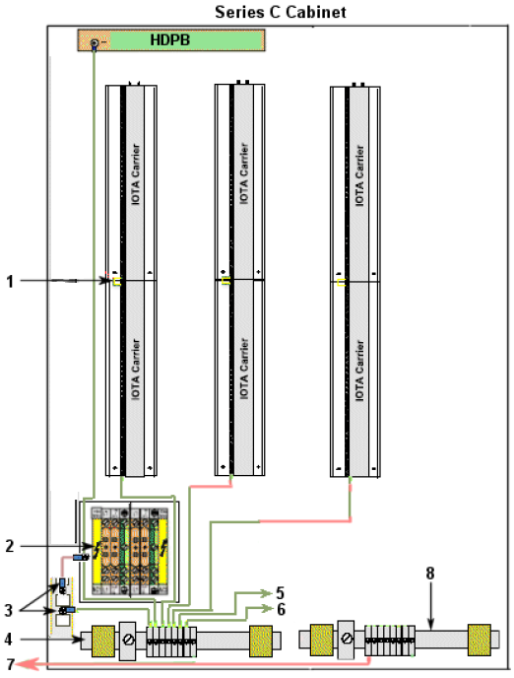

cabinet. For Honeywell assembled cabinets, all power and ground connections within the cabinet are made by Honeywell manufacturing.
-Typical Safety ground connections in Series C cabinet:
Callout | Description
1 | The upper and lower carrier channel assembly shield landing bus bar grounds are jumped together in the center and the lower shield landing bus bar ground is connected to the AC safety ground bar.  Accepts user supplied single or dual AC line power input - Hot (L1), Neutral  (L2), and Ground (AC Safety ground).
2 | The AC terminal block and mounting plate for routing power and making safety ground connections within the cabinet is mounted on the cabinet floor.  See the following figure for details about typical power and ground connections.
3 | The AC safety ground bar and the AC terminal block mounting plate are connected to the cabinet frame.
4 | The AC safety ground bar is mounted to the cabinet frame.
5 | To cabinet front or rear AC safety ground bar if required.
6 | To cabinet complex front or rear AC safety ground bar as required.
7 | To supplementary ground connection, if required.
8 | The Local ground bar is mounted to the cabinet frame, if required.

- FAN, Lighting & Power connected to the IPE bar follow the figure in appendix sections.
- IPE connected to PE
- PE provided and distributed all around the plant for protection of both personnel and equipment.
IPE loop connected to general Plant Earth loop (PE) through earth dispatchers
- General earthing (PE) resistance is less than 0.5 ohm.
- Connections to the IPE is 35 mm².
- Conducting parts such as doors and frames, etc... which are not permanently connected to
safety earth (IPE), connected to the cabinet frame with flexible braided earthing strips
of 6 mm².
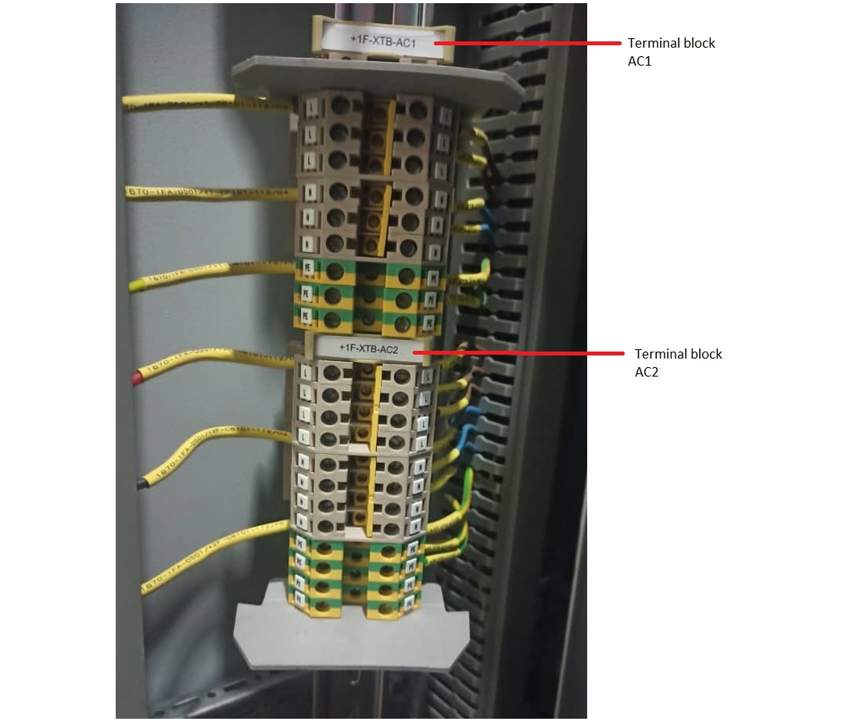
L1 UPS A
L2 UPS B
L2/N UPS A
L2/N UPS B
GND
GND
To power supplies

Grounding guidelines for C300 Controllers with Series C I/0
The following guidelines apply to installations that include C300 and Series C 1/0 components as shown in the following sample quad dual access Series C cabinet complex illustration.
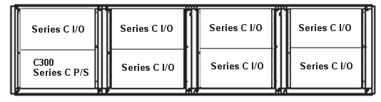
- Connect the system to a single external (safety) ground, like you would install an EC compliant High Performance Process Manager (HPM) system. The Series C power system requires single-point grounding to AC safety ground, as previously described in the Series C cabinet safety ground connections section.
- Any customer wiring shields that must be grounded at the Series C 10TAs is connected to the safety ground shield landing bus bar that is part of the Series C Carrier Channel Assemblies as previously described.
- There are no grounding options for the Series C 1/0 Link connections to the C300 10TA.

DeltaV LOGIC SOLVER earthing philosophy
The following two figures show power configurations for smart logic solvers (SLS). The first figure shows the SLS powered by one 24 VDC feed from a redundant bulk power supply source. This scheme might be used with a smaller system that can accept a safe shutdown on power events. The second figure shows a Logic Solver powered by two independent 24 VDC feeds, one from the primary and one from the secondary bulk power supply source. This eliminates risk of a shutdown due a signal point of failure on the common feed. This method is recommended for added availability. In each case, note that the SIS power supply return, DeltaV power supply return, and system power supply return are grounded at the DC ground bus, as required.
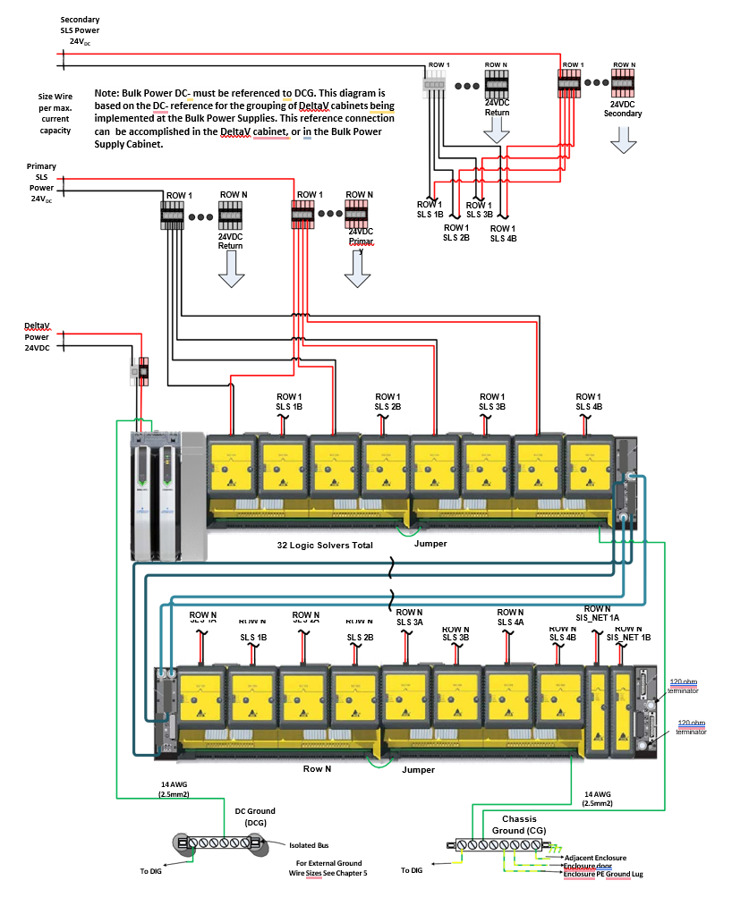
Note: Bulk Power DC- must be referenced to DCG. This diagram is based on the DC- reference for the grouping of DeltaV cabinets being implemented at the Bulk Power Supplies. This reference connection can be accomplished in the DeltaV cabinet, or in the Bulk Power Supply Cabinet.
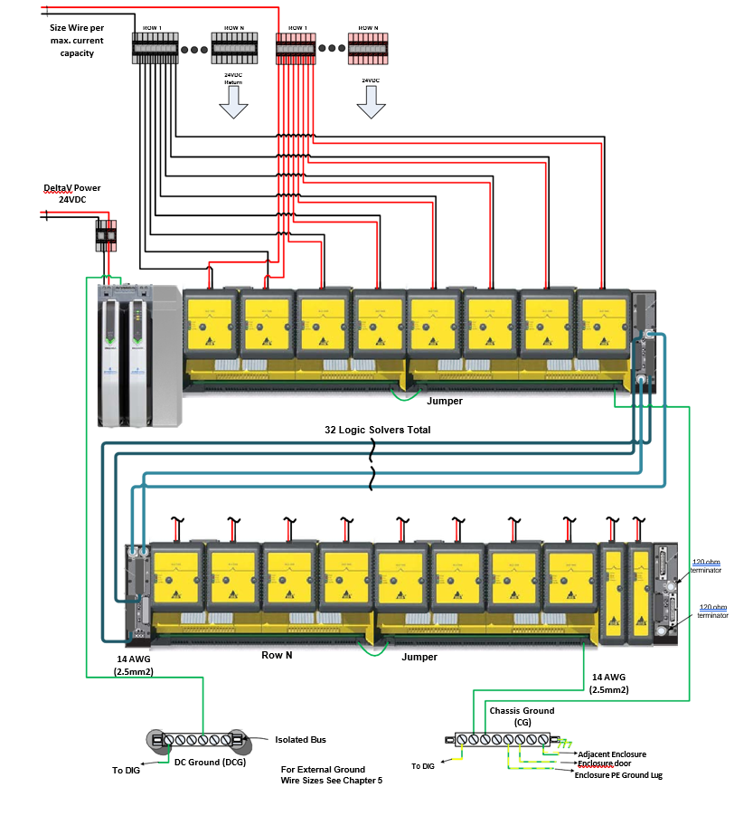

Earthed operation
Earthed operation means that the power supply common (0V) is connected with a single connection to the Instrument Earth bar using a 10 mm:) 2; minimum wire gauge. It is important that both the IO signal shield and IO signals are not earthed/grounded in the field, to avoid creating earth/ground loops. A single earth fault can trigger a system fault reaction

7.5 Galvanically isolated
Galvanically isolated operation means that the power supply common (0V) is galvanically isolated from earth also referred to as floating from earth.
A single earth fault does not cause a system fault reaction and therefore increases system availability and integrity. Any additional earth fault can cause a system fault reaction or an unsafe situation.
Therefore it is important to detect unwanted earth connections or earth faults via an earth leakage detector and correct them.

Power supply group
QUINT POWER circuit breakers magnetically and therefore quickly trip at six times the nominal current, for selective and therefore cost-effective system protection. The high level of system availability is additionally ensured, thanks to preventive function monitoring, as it reports critical operating states before errors occur.
Reliable starting of heavy loads takes place via the static power reserve POWER BOOST. Thanks to the adjustable voltage, all ranges between 5 V DC ... 56 V DC are covered.

Test
The PE loop shall be tested according to the international standards.
Earthing segregation testes shall be performed on all instrument panels/cabinets and preassembled local panels at the vendor premises.
Acceptance tests of instrument earthing system shall be performed at site for:
- Measurement of earthing resistance.
- Checking of earthing segregation.
- Checking of floating power supply.

APPENDIX 1: TYPICAL ESD SYSTEM CABINET GROUNDING:
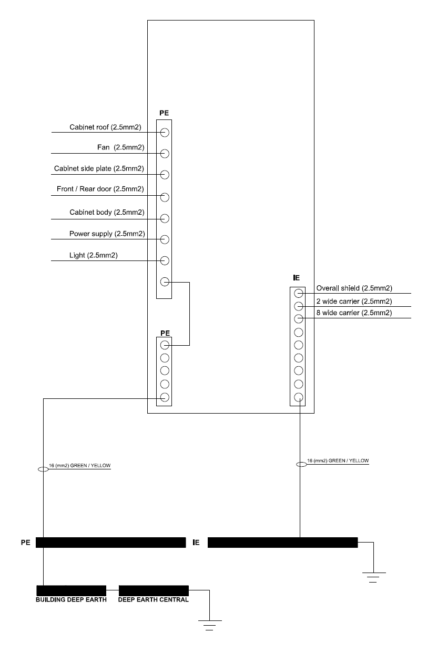

APPENDIX 2: TYPICAL DCS SYSTEM CABINET GROUNDING:

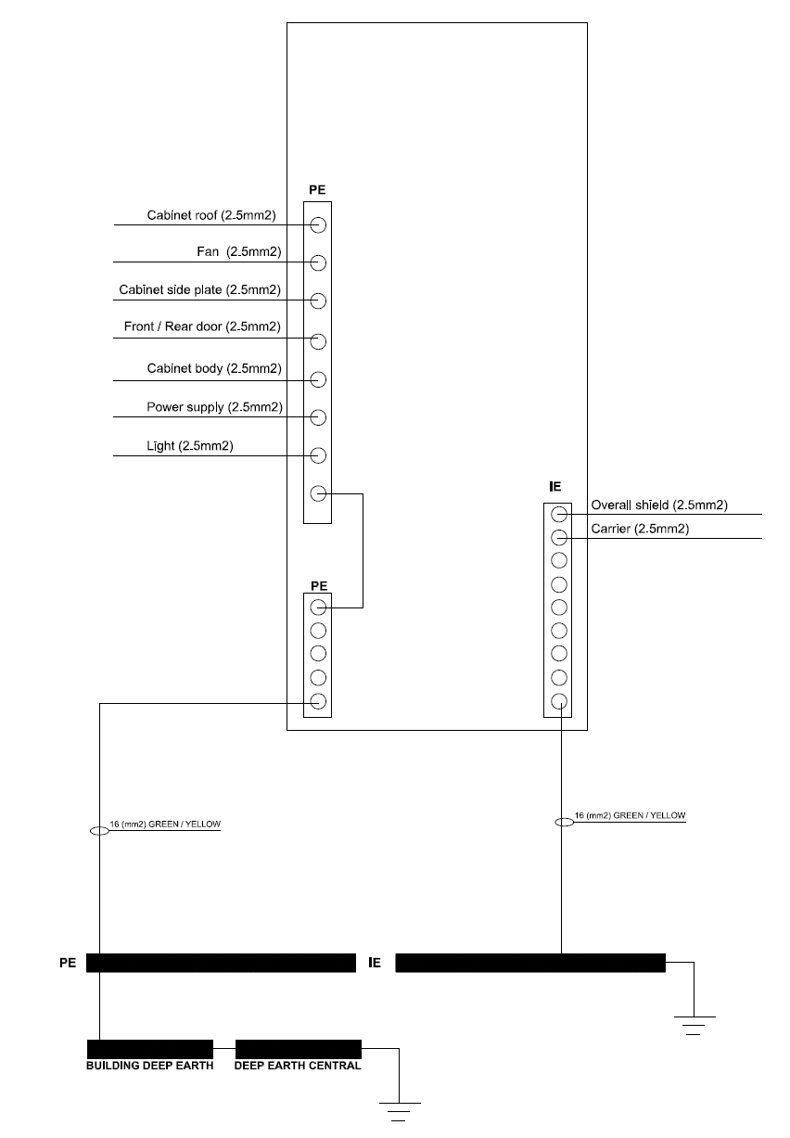

APPENDIX 3: TYPICAL MARSHALLING CABINET GROUNDING:

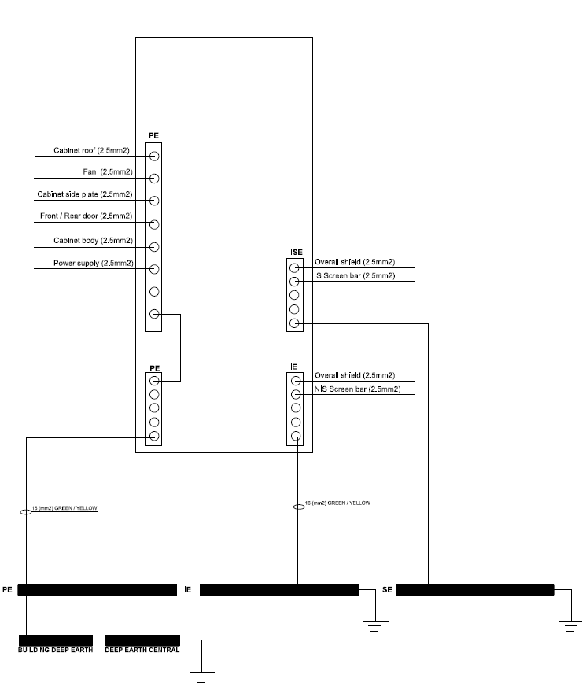

APPENDIX 4: TYPICAL NETWORK CABINET GROUNDING:
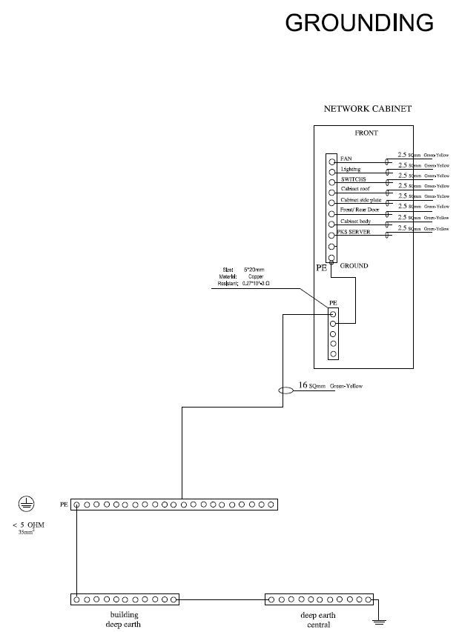

APPENDIX 5: TYPICAL OPERATOR & PRINTER Desk GROUNDING:
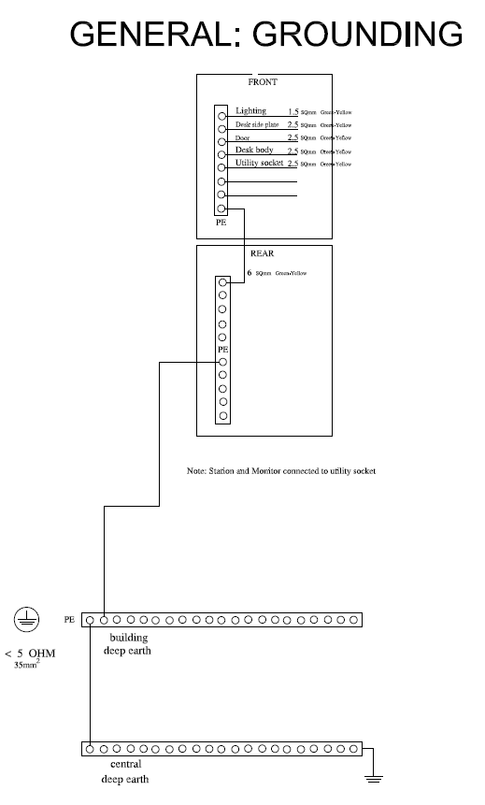

APPENDIX 6: TYPICAL GROUNDING DIAGRAM EXTERNAL FOR TECHNICAL ROOM:
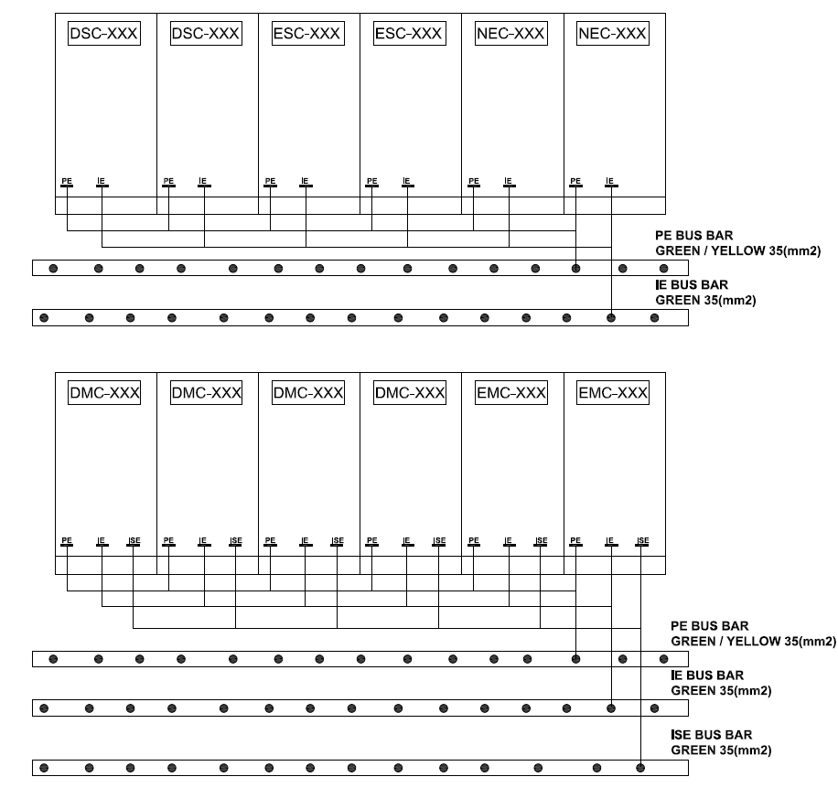

APPENDIX 7: TYPICAL GROUNDING DIAGRAM EXTERNAL FOR CONTROL ROOM:

