|  |  |  |  |  |  |  |  |
| --- | --- | --- | --- | --- | --- | --- | --- |
| **طرح نگهداشت و افزایش تولید 27 مخزن** | | | | | | | |
| **FABRICATION PROCEDURE**  **نگهداشت و افزایش تولید میدان نفتی بینک** | | | | | | | |
|  | |  |  |  |  |  |  |
|  | |  |  |  |  |  |  |
|  | |  |  |  |  |  |  |
|  | |  |  |  |  |  |  |
| V00 | | NOV.2024 | IFI | IDR | M.Fakharian | M.Sadeghian |  |
| **Rev.** | | **Date** | **Purpose of Issue/Status** | **Prepared by:** | **Checked by:** | **Approved by:** | **CLIENT Approval** |
|  | | | | | | | |
| **Status:** | | **IFA: Issued For Approval**  **AFC: Approved For Construction**  **IFI: Issued For Information** | | | | | |

**REVISION RECORD SHEET**

|  |  |  |  |  |  |  |  |  |  |  |  |  |
| --- | --- | --- | --- | --- | --- | --- | --- | --- | --- | --- | --- | --- |
| **PAGE** | **V00** | **V01** | **V02** | **V03** | **V04** |  | **PAGE** | **V00** | **V01** | **V02** | **V03** | **V04** |
| **1** | X |  |  |  |  | **66** |  |  |  |  |  |
| **2** | X |  |  |  |  | **67** |  |  |  |  |  |
| **3** | X |  |  |  |  | **68** |  |  |  |  |  |
| **4** | X |  |  |  |  | **69** |  |  |  |  |  |
| **5** | X |  |  |  |  | **70** |  |  |  |  |  |
| **6** | X |  |  |  |  | **71** |  |  |  |  |  |
| **7** | X |  |  |  |  | **72** |  |  |  |  |  |
| **8** | X |  |  |  |  | **73** |  |  |  |  |  |
| **9** | X |  |  |  |  | **74** |  |  |  |  |  |
| **10** | X |  |  |  |  | **75** |  |  |  |  |  |
| **11** | X |  |  |  |  | **76** |  |  |  |  |  |
| **12** | X |  |  |  |  | **77** |  |  |  |  |  |
| **13** | X |  |  |  |  | **78** |  |  |  |  |  |
| **14** | X |  |  |  |  | **79** |  |  |  |  |  |
| **15** | X |  |  |  |  | **80** |  |  |  |  |  |
| **16** | X |  |  |  |  | **81** |  |  |  |  |  |
| **17** | X |  |  |  |  | **82** |  |  |  |  |  |
| **18** | X |  |  |  |  | **83** |  |  |  |  |  |
| **19** | X |  |  |  |  | **84** |  |  |  |  |  |
| **20** | X |  |  |  |  | **85** |  |  |  |  |  |
| **21** | X |  |  |  |  | **86** |  |  |  |  |  |
| **22** | X |  |  |  |  | **87** |  |  |  |  |  |
| **23** | X |  |  |  |  | **88** |  |  |  |  |  |
| **24** | X |  |  |  |  | **89** |  |  |  |  |  |
| **25** | X |  |  |  |  | **90** |  |  |  |  |  |
| **26** | X |  |  |  |  | **91** |  |  |  |  |  |
| **27** | X |  |  |  |  | **92** |  |  |  |  |  |
| **28** | X |  |  |  |  | **93** |  |  |  |  |  |
| **29** | X |  |  |  |  | **94** |  |  |  |  |  |
| **30** | X |  |  |  |  | **95** |  |  |  |  |  |
| **31** | X |  |  |  |  | **96** |  |  |  |  |  |
| **32** | X |  |  |  |  | **97** |  |  |  |  |  |
| **33** | X |  |  |  |  | **98** |  |  |  |  |  |
| **34** | X |  |  |  |  | **99** |  |  |  |  |  |
| **35** | X |  |  |  |  | **100** |  |  |  |  |  |
| **36** | X |  |  |  |  | **101** |  |  |  |  |  |
| **37** | X |  |  |  |  | **102** |  |  |  |  |  |
| **38** | X |  |  |  |  | **103** |  |  |  |  |  |
| **39** | X |  |  |  |  | **104** |  |  |  |  |  |
| **40** | X |  |  |  |  | **105** |  |  |  |  |  |
| **41** | X |  |  |  |  | **106** |  |  |  |  |  |
| **42** | X |  |  |  |  | **107** |  |  |  |  |  |
| **43** |  |  |  |  |  | **108** |  |  |  |  |  |
| **44** |  |  |  |  |  | **109** |  |  |  |  |  |
| **45** |  |  |  |  |  | **110** |  |  |  |  |  |
| **46** |  |  |  |  |  | **111** |  |  |  |  |  |
| **47** |  |  |  |  |  | **112** |  |  |  |  |  |
| **48** |  |  |  |  |  | **113** |  |  |  |  |  |
| **49** |  |  |  |  |  | **114** |  |  |  |  |  |
| **50** |  |  |  |  |  | **115** |  |  |  |  |  |
| **51** |  |  |  |  |  | **116** |  |  |  |  |  |
| **52** |  |  |  |  |  | **117** |  |  |  |  |  |
| **53** |  |  |  |  |  | **118** |  |  |  |  |  |
| **54** |  |  |  |  |  | **119** |  |  |  |  |  |
| **55** |  |  |  |  |  | **120** |  |  |  |  |  |
| **56** |  |  |  |  |  | **121** |  |  |  |  |  |
| **57** |  |  |  |  |  | **122** |  |  |  |  |  |
| **58** |  |  |  |  |  | **123** |  |  |  |  |  |
| **59** |  |  |  |  |  | **124** |  |  |  |  |  |
| **60** |  |  |  |  |  | **125** |  |  |  |  |  |
| **61** |  |  |  |  |  | **126** |  |  |  |  |  |
| **62** |  |  |  |  |  | **127** |  |  |  |  |  |
| **63** |  |  |  |  |  | **128** |  |  |  |  |  |
| **64** |  |  |  |  |  | **129** |  |  |  |  |  |
| **65** |  |  |  |  |  | **130** |  |  |  |  |  |

**CONTENTS**

1.0 INTRODUCTION 4

2.0 Scope 5

3.0 REFERENCE CODE & STANDARD 5

4.0 General requirements: 5

5.0 RESPONSIBILITY 6

6.0 ENGINEERING 6

7.0 MATERIAL CONTROL 6

8.0 MARKING OF PLATES 7

9.0 CUTTING 7

10.0 HANDLING 7

11.0 ROLLING 8

12.0 PLATE PARTS 8

13.0 NOZZLE PARTS 9

14.0 OTHER PARTS AND CLIPS 9

15.0 SAND BLAST AND PAINTING 9

16.0 PACKING AND SHIPPING to the site 10

17.0 CALIBRATION 10

18.0 ERECTION AND INSTALLATION OF (TK-2102) & (TK-2301A/B) 10

19.0 CONSTRUCTION OF POTABLE TANK BASED ON AWWA D100 (TAG NO.TK-2209) 28

20.0 Quality Control plane & tolerance 33

20.1 material receiving inspection 33

20.2 material traceability 34

20.3 material storage condition 34

20.4 edge preparation and fit-up inspection 34

20.5 welding & visual inspection 35

20.6 nondestructive examination (nde) 36

20.7 dimensional inspection 37

20.8 pressure test 38

20.9 rust prevention / painting inspection. 41

20.10 packing inspection 41

20.11 documentation 41

21 Health, safety & environment 42

1. **INTRODUCTION**

Binak oilfield in Bushehr province is a part of the southern oilfields of Iran, is located 20 km northwest of Genaveh city.

With the aim of increasing production of oil from Binak oilfield, an EPC/EPD Project has been defined by NIOC/NISOC and awarded to Petro Iran Development Company (PEDCO). Also, PEDCO (as General Contractor) has assigned the EPC-packages of the Project to "Hirgan Energy - Design and Inspection" JV.

**GENERAL DEFINITION**

The following terms shall be used in this document.

|  |  |
| --- | --- |
| CLIENT: | National Iranian South Oilfields Company **(NISOC)** |
| PROJECT: | Binak Oilfield Development – Supply Storage Tank |
| EPD/EPC CONTRACTOR (GC): | Petro Iran Development Company **(PEDCO)** |
| EPC CONTRACTOR/PURCAHSER: | Joint Venture of: Hirgan Energy – Design & Inspection Companies **(HE/DI)** |
| VENDOR: | iDrill Middle East **(iDrill M.E)** |
| EXECUTOR: | Executor is the party which carries out all or part of construction and/or commissioning for the project. |
| TPI: | Third-Party Inspector |
| SHALL: | Is used where a provision is mandatory. |
| SHOULD: | Is used where a provision is advisory only. |
| MAY: | Is used where a provision is completely discretionary. |

1. **Scope**

This procedure covers the general technical requirements for Fabrication, Erection & Installation, Inspection and Testing for Storage Tanks, Tag No. TK-2301A/B ,TK-2102 , TK-2209

1. **REFERENCE CODE & STANDARD**

* ASME Section IX: Welding & Brazing Qualification
* ASME Section V: Non-Destructive Examination
* ASME Section II: Part A, Ferrous Material
* ASME Section II: Part C, Welding Material
* ASTM: Materials
* API 650: Welded Tank for Oil Storage
* API 2000: Venting Atmospheric and Pressure Storage Tanks
* BS EN 10204 (3.1): Material Certificates
* ASNT SNT-TC-1A
* IPS-G-ME-100
* AWWA D-100
* Purchaser Specification

1. **General requirements:**

* Unless otherwise specified, parts shall be fabricated, tested and inspected in accordance with project specifications and specified API code in approved data sheet.
* Fabrication procedure shall conform to the requirements specified herein and applicable Construction drawing. When any requirements are stipulated in this specification and drawing call upon the same requirements. If any conflict exists between this specification and the drawings, it shall be reported by Design & construction Department to client in a written letter.
* All materials and equipment delivered to the factory shall be carefully checked for quantity, dimension, production no. or serial No. and other specifications with concerned. All material certificates and shipping documents shall be archived properly by QC. Department.
* All practical tolerances are represented at project specifications and API code.
* 3.3.5All Quality Control activities in each stage shall be according to the approved I.T.P
* 3.3.6All NDT shall be according to the related NDT procedure and NDT drawings.

1. **RESPONSIBILITY**

All activities in regard to the fabrication of parts shall be done according to this procedure and approved ITP and all of them shall be checked by iDrill Middle East Q.C. department.

The accepted activities shall be confirmed in a report by iDrill Middle East Q.C. department and 3rd party inspector as per approved ITP and to be issued for company review.

1. **ENGINEERING**

**6.1** All of engineering activities shall be done according to following steps. (As minimum;)

**6.1.1** Checking document & drawing.

**6.1.2** Checking material take off and compare with received materials.

**6.1.3** Preparation of Shop drawing according to latest revisions of documents.

**6.1.4** Checking or preparing Welding map, NDT dwg, and other QC procedures.

**6.1.5** Issue PQR test coupons sketch according to WPS (if required).

**6.1.6** Issue TQ if required.

**6.1.7** Prepare As built drawing

**6.1.8** All steps shall be subjected to TPA for necessary approval.

1. **MATERIAL CONTROL**
   1. All material control shall be as per project specification.
   2. Upon receipt warehouse keepers checks the documents related to received material signed by third party inspector. And the warehouse keepers will provide the M.R.R. (Material Received Report) and issue to quality control.
   3. The quality control inspector is responsible for conducting a visual and dimensional inspection of incoming material to assure compliance with requirements and with material certificates, and provide a M.I.R. (Material Inspection Report) to record the results of the inspection operation. Final test reports and all of the quality documents shall be sent to third party Inspector and Company for related inspections.
   4. For all materials will ensure that the identification making is traceable to the API or ASME or ASTM specification and project specification.
2. **MARKING OF PLATES**

All plates shall be marked according to the related cutting plan drawing. Marking of shell plates shall be done with respect to the dimensions which are shown in figure 1. With consideration marking, rolling direction.



Figure (1)

1. **CUTTING**
   1. Plates are laid on cutting table and proper nozzle size and cutting speed for machine is chosen to get accurate and smooth edges then cutting slag’s is removed by grinding. Cutting plan provided in order to minimize waste of raw materials and more accuracy and efficiency.
   2. Longitudinal edges for each barrel are left and shall cut after pre-bending (Due to excessive size of flatted.)
   3. After cutting a number code will be given to material for further trace of raw material by Design and Construction department in the cutting plan.
2. **HANDLING**
   1. According to warehouse code specified by warehouse keeper and presented at cutting plan, plates are handled with proper clips and chains respective to estimated weight and laid on level position at marking and cutting shop and the care shall be taken to minimize damage to material.
   2. any temporary attachment for handling shall be with the same P number with base metal.
3. **ROLLING**
   1. Rolling shall be done after cutting of plates and edges preparation as per item. 10 above and approved by TPA.
   2. For rolling shell plate a template with the length of at least 1m is prepared to control the radius of pre bends and ring itself.
   3. As needed the overhead crane is used to support.
   4. In this project because the thickness of plates for rolling plates is 10 mm and under, so is not necessary pre bend for plates (According to rolling machine specification in iDrill Middle East SHOP).
   5. For keeping health, the circularity of rolled ring near joint (L.S) during handling and welding some
   6. restrains are used and tack welded at inside of the ring (as show).



* 1. All activities while rolling parts and after rolling shall be approved by Client Supervisor and TPA.

1. **PLATE PARTS**
   1. Before assembling the surface shall be clean and free of scale, rust, oil, grease, slag, detrimental oxides and other deleterious foreign material. The method and extent of cleaning should be determined based on the material to be welded and the contaminant to be removed. When weld metal is to be deposited over a previously welded surface, all slag shall be removed by a roughing tool, or other suitable means so as to prevent inclusion of impurities in weld metal.
   2. Parts shall be handled by suitable belt avoiding use of welded hooks and shackles.
2. **NOZZLE PARTS**
   1. Preparation of nozzle parts:
      1. Nozzle parts shall be cleaned and free from any oil, grease, rust and any other contamination.
      2. Bevels and root face shall be controlled carefully as per WPS.
      3. Before assembling of nozzle parts W.P.S for welding parts together and the location of nozzle on tanks is reviewed to decide about more accuracy and ease at nozzle assembly on tank.
      4. All steps and activities of montage of nozzles parts before cutting of location of nozzles and installation on tanks shall be approved by client inspector and TPA.
3. **OTHER PARTS AND CLIPS**
   1. Marking & cutting of parts including Structure, pipe, baffle, sup. Roller, …
   2. Before erection, all pre-fabricated spool pieces, pipes, fittings, etc. shall be cleaned internally and externally.
   3. All parts should be prefabricated and tacked in position until making sure that there is no distortion between parts and then welded by small size electrode to reduce the welding temperature. Extra care shall be taken for flange connections to fire tubes, etc. the flange connections to this equipment shall be checked for misalignment excessive gap after final alignment of equipment.
   4. Possibility of internals & externals assembly shall be carefully considered and planned to prevent any problem at tank fabrication.
   5. No deviation from the piping route indicated in drawings shall be permitted without the written approval of the client.
   6. Drill mating pieces with together.
4. **SAND BLAST AND PAINTING**

Sand blast and painting shall be done only for annular and bottom plates in iDrill Middle East Shop according to painting procedure.

1. **PACKING AND SHIPPING to the site**

No material shall be released for shipment until it has been approved by the project's inspector.

For shipping of plates (annular plate, bottom & roof plates, shell course parts) use from Table 1 for Codes in packing and transportation procedure.

The code stamp shall be marked according to Marking Instruction para. 3.1~3.4 packing and transportation procedure.

The parts of plates that rolled (shell plates) packed with transport saddle for save rolling radius in shell plates. (See Sketch)

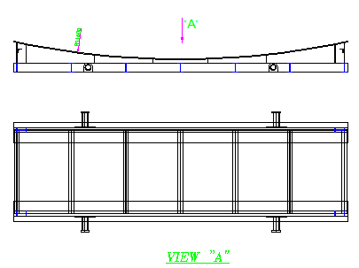

1. **CALIBRATION**

All test gauges and recorder shall be calibrated against a standard dead weight tester or calibrated master gauge method at least every 6 months and at any time is reason to believe they are in error. If insisted by TPA or company recalibration shall be accomplished.

1. **ERECTION AND INSTALLATION OF GLYCOL STORAGE TANK(TK-2102) & FIRE WATER TANK (TK-2301A/B)**

**18.1 Erection & installation**

* Erection & Installation Sequence are as follow:

1. Foundation
2. Material Check up
3. Spreading bottom plates
4. Installing shell plates
5. Arrangement
6. Welding
7. Dimensional tolerances
8. Installing top angles
9. Installing wind girder
10. Protecting against wind
11. Installing sump
12. Installing roof structure
13. Installing roof plates
14. Installing roof nozzles and manhole
15. Installing anchor chair
16. Installing spiral stairway
17. Final visual check
18. Important Note
19. Final cleaning
20. Hydrostatic test
21. Painting
    * 1. **Foundation**

**18.1.1.1** Foundation shall be checked prior to erection work of the tank and after delivered foundation the chipping will be done and then, padding shall be made by grout or by solid shims. The spreading annular plates will be done after approve above activities.

* + - 1. After completion of erection and before hydro test grouting will be done by others.

* + 1. **MATERIAL CHECK UP**
* The plates to be installed should be exactly checked and after being assured of their surface clearness, and the edges prepared as per the relevant WPS, could be transmitted to the site.
* Care should be taken in transportation and installation so that avoiding damage of the plates. In the cases that plates have been formed previously, it should be noted that it mustn’t be deformed during transportation.
  + 1. **Spreading Bottom Plates**
       1. During the work, the foundation mustn’t be damaged.
       2. Spreading is preformed from center to circumference.
       3. Before arranging annular plates, back strips should be attached to underside of them as per the drawing, and then surface and surrounding of the weld should be cleared of weld troubles and other surface troubles as below**.**
       4. Annular plates will be arranged from orientation of 0 º, and after putting the first plate in the place and exact checking, the other ones will be arranged counter clock wisely.

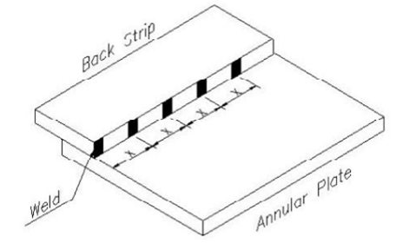

* + - 1. During arrangement of annular plates, it should be noticed that weld joint is conforming to W.P.S.
      2. After that arrangement of annular Plates & checking sequences were accomplished and dimensions were confirmed, joint between back strip and the other annular Plate should be tack welded (as below) These tacks will be removed by grinding before starting the weld.

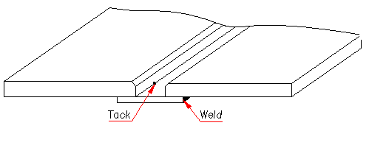

* + - 1. After arrangement of annular plates radial welding of annular plate should be done in 2 steps. First 30 cm of groove between Ann. Plates from the external edge should be welded as per the relevant W.P.S. After installing the fifth shell course the rest of the annular plate should be welded.

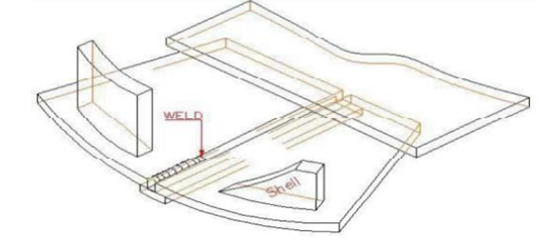

* + - 1. For prevention of welding distortion, the restraint jigs such as reinforcing channel, back piece and strong back can be used.

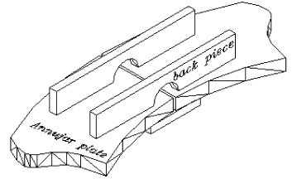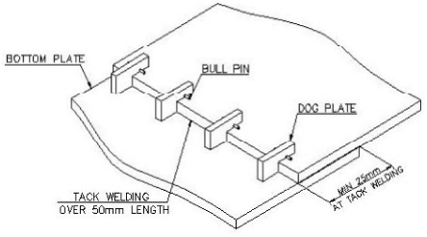

* + - 1. Bottom plates will be arranged from center in one point or every 4 base point as per drawing.
      2. After approval of the arrangement of bottom plates, tack welding was accomplished and welding of bottom plates (except two horizontal & cross length of center plates and annular to bottom plate) could be done from the center of the tanks toward the circumference as below figure.
      3. As arrangement in all of these storages is as per the figure below, welding sequence should follow the shown model from center to sides. It should be noted that welding of bottom plate to annular plates and two horizontal and cross length of center plates will be done after erection of all shell plates.

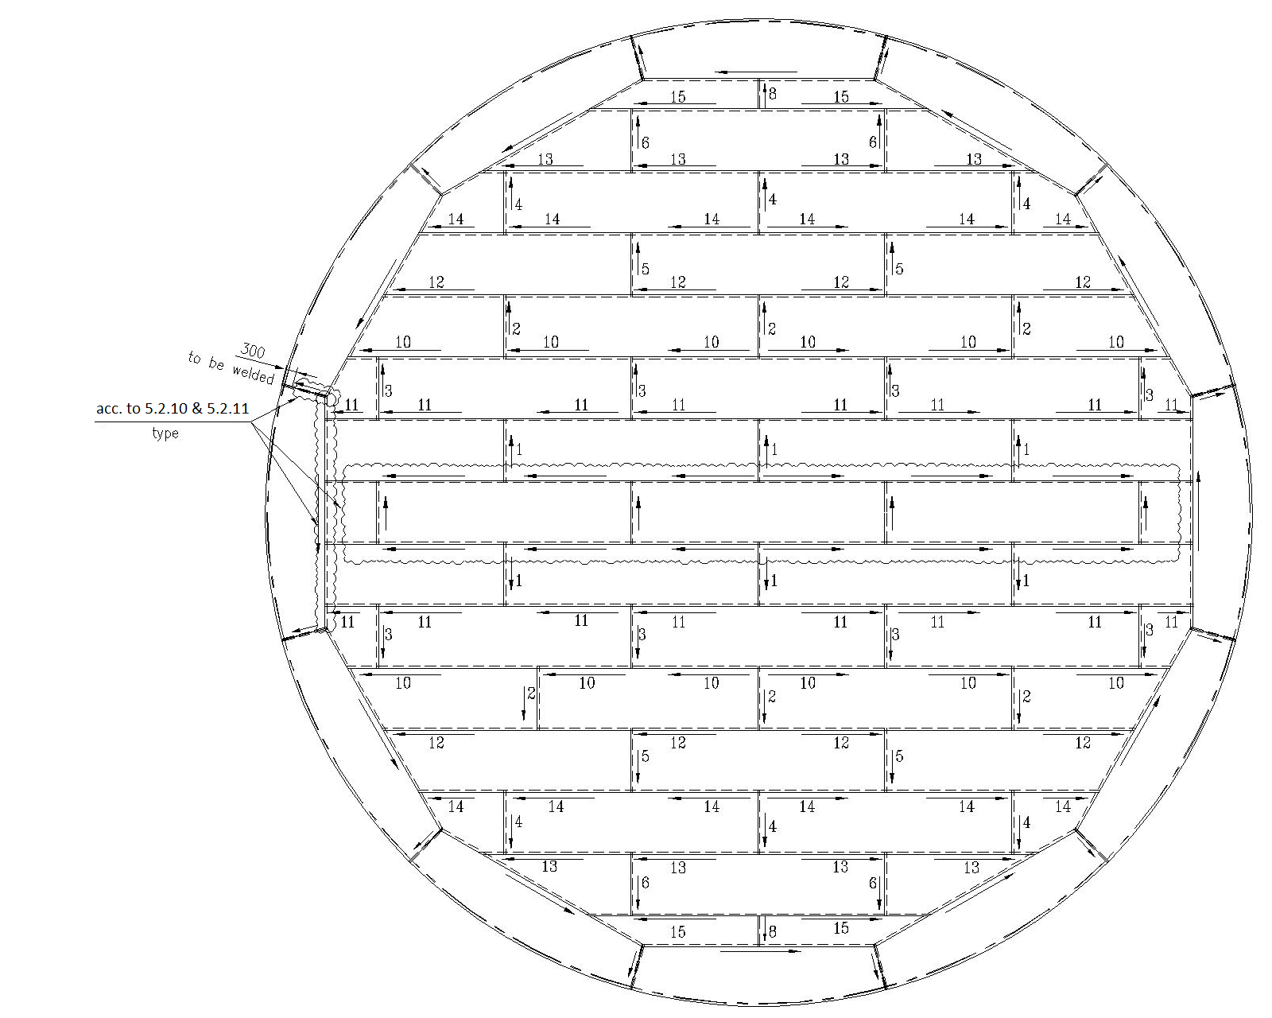

* + - 1. Cutting pattern and fit-up of the three, lap-jointed plates are shown as below.

When the bottom plate corners are cut, take care not to damage the lower bottom plate.

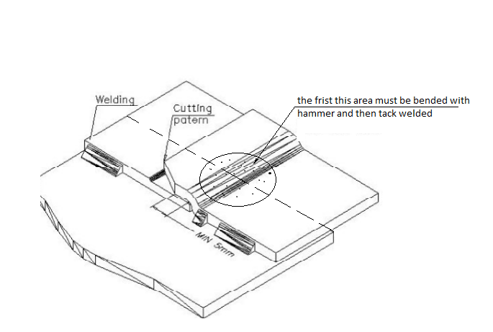

**18.1.3.13** After complete residence of weld, the amount of weld metal that is nodular should be removed by grinding.

* + 1. **Installing Shell Plates**
       1. Prior to the assembly of the shell plates, the shell circular line shall be marked on the bottom annular plate for erection. Then the exact location of shell plates must be marked by drawing and roundness check of shell plate by survey, then shell holders must be installed.
       2. The first shell course shall be erected on the annular plate, adjusting the required gap and plate alignment of vertical joints.
       3. Roundness shall be checked, after installation of the 1st course shell plate.
       4. Verticality shall be checked, prior to welding of the 2nd course shell plate.
       5. Level shall be checked, after installation of the 3rd course shell plate.
       6. Shell plates are located around the foundation of tanks in a sequence so that plates with higher thickness are placed under the plates with lower thickness. Consider that these plates are rolled in expected radius by the manufacturer. They must be stored or carried in a way that their curvatures are preserved.
       7. Prior to the assembly , horse shoes for straight and curved strong back shall be welded temporary on the shell plate. (refer to Fig. below)

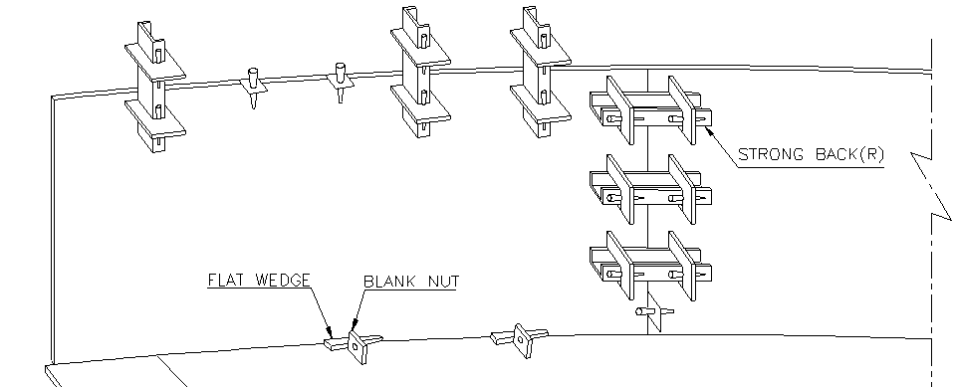

Annular plate

* + 1. **Arrangement** 
       1. **First course:**
* The circle line for erection shall be drawn on the bottom plates and punched equally by the numbers of blank nuts.
* The 1st course shell plate shall be erected on the annular plate, adjusting the required gap and plate alignment of vertical joints.
* Roundness shall be checked, during to fit-up of the 1st course shell plate.
* The shell plates shall be determined in accordance with the drawing and retained in position by spacer, key plates, blank nuts and taper pins it will be ensured that clean out assemblies are installed prior to arranging shell plate (Refer to Fig below).

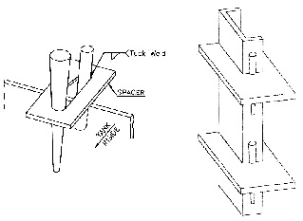

* + - 1. **Second Course:**
* The second course shell plate be erected after fitting-up of the 1st course vertical joints.
* Vertical joints of the second course shall be assembled with the match mark which had stamped on the 1st course accordance with the drawing.
* Vertical joints shall be matched accurately and retained in position with spacers and key plates.
* Horizontal joints between 1st and 2nd course shall be matched to inside of each plate and retained in position with spacer and stiffeners. (refer to below fig.)
* Plumbness, peaking and banding shall be checked, during to fit-up of the 2nd course to 1st course shell plate according to ITP.

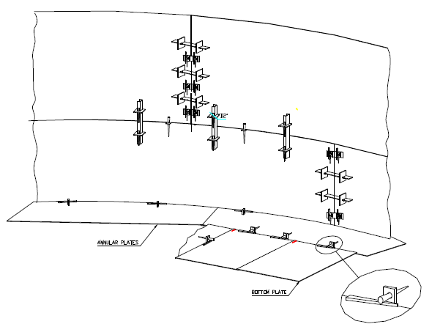

* + - 1. **Third and upper courses**
* 3rd and upper courses shall be assembled in the same manner as the 2nd course. The temporary assembling of each course shall be completed in the day.
* In 3rd and upper courses, the exceed length considered for adjust plate (one of the plates less than 6-meter length) that must be adjusted after fit-up by cutting.
  + 1. **Welding** 
       1. Welding will start after fit-up of course 1 and 2 & 3.
       2. Welding of vertical joints of 1st course:

the vertical joints shall be tack welded from inside and the key plates and strong back (channel) shall be used for fit-up.

* + - 1. Continues welding shall be made on the outside first. the strong back (channel) shall be installed at right angle with the weld line to prevent plate distortion during welding.
      2. Welding of vertical joints of second course:

Welding of vertical joints of 2nd course shall be made in the same manner as the 1st course.

* + - 1. Welding of horizontal joints between 1st course and 2nd course:

The welding of horizontal joints between 1st course and 2nd course shall be made the outside first and being the stiffeners removed. If there were some defects at 1st layer which shall be hindrance to welding from inside, it shall be removed by grinding from inside.

* + - 1. After fit-up of fourth course the back weld of vertical joints for first and second shell course and horizontal joints between course 1 and 2 will be done.

Note: before welding the strong back (channel) shall be removed and welded joints shall be cleaned thoroughly in a manner that will leave the exposed surface satisfactory for fusion of the weld metal to be added. This cleaning shall be made from inside by grinding too evenly smoothly.

* + - 1. Welding of vertical joints of third course shall be made the outside first.
      2. Welding of horizontal joints between 2nd course and 3rd course:

Welding of horizontal joints of between 2nd course and 3rd course shall be made in the same manner as horizontal joints between 1st course and 2nd course.

* + - 1. After fit-up of fifth course the back weld of vertical joints for 3rd shell course and horizontal joints between course 2 and 3 will be done.

Note: before welding the strong back(channel) shall be removed and welded joints shall be cleaned thoroughly in a manner that will leave the exposed surface satisfactory for fusion of the weld metal to be added. This cleaning shall be made from inside by grinding too evenly smoothly.

* + - 1. Welding joints of 4th course and other upper courses:

Assembling and welding of other upper courses shall be made as the same manner as stated before.

* + - 1. After completed welding the rest of annular-to-annular plates and confirmed radiography test of 1st shell course vertical joints, the welding of shell course 1 to annular plates will be done.
      2. Welding sequence for vertical and horizontal joints:
* Vertical joints:

the vertical joints welding sequence shall be made as per below figure.

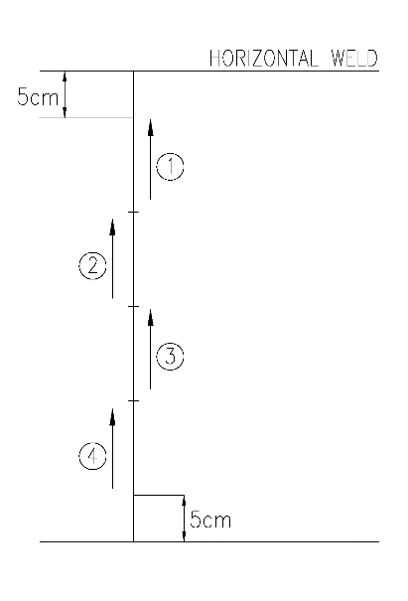

Welding sequence of vertical seams

**Note**: the parts of incomplete vertical joint (5 cm) shall be made with horizontal joint welding.

* Horizontal joints:

The welding of horizontal joints shall be made by even quantity of welder and Proportion work. the Circumference of horizontal joints is divided to 0.5 meter and welding sequence will be done as per below figure. please be noted that all welders should be welding in one direction for each circumferential weld. (clock wise or counter clock wise).

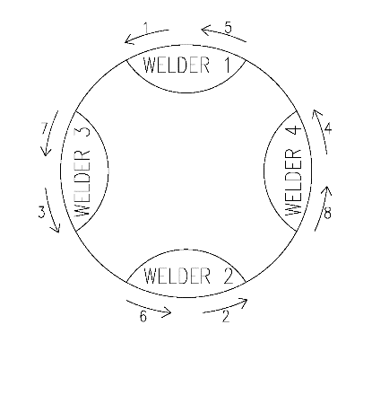

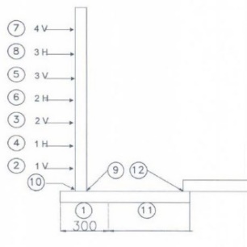

Sequence of welding

Example of welding sequence with 4 welders for horizontal joints of tank wall

* + - 1. The accomplished welds will be inspected as per API.650 (7.3) and Spec.
      2. Plates to be joined by butt welding shall be matched accurately and retained in position during the welding operation. Misalignment in completed vertical joints for plates less than or equal to 16 mm (5/8 in.) thick shall not exceed 1.5 mm (1/16 in.).
      3. Permanent and temporary attachments (see 7.2.1.10 API 650 for information on shell-to-bottom welds) shall be welded with low-hydrogen electrodes. Both permanent and temporary attachments shall be welded in accordance with a procedure that minimizes the potential for under bead cracking. The welds of permanent attachments (not including shell-to-bottom welds) and areas where temporary attachments are removed, shall be examined visually and by either the magnetic particle method or by the liquid penetrant method.
      4. Flush-type connections shall be inspected according to 5.7.8.11(API 650).
      5. Manhole and shell Nozzles can be installed as per shop drawing after that the below tasks were accomplished:
      6. The exact location of manhole and Nozzles on each course must be marked by subcontractor after welding of vertical joints and horizontal upper course and confirmed by Q.C supervisor of client. After that marking was confirmed shell plate is cut by using manual air/gas torch.
      7. After cutting, the edges are finished and prepared for weld as per the relevant DWG.
      8. Manhole and Nozzles reinforce pad have been attached before, will be installed in the correct place as per the drawing and will be welded after approval as per the relevant W.P.S. after fabrication is completed the reinforcing plates shall be soap tested by the manufacture before the tank is filled with test water.
    1. **DIMENSIONAL TOLERANCES** 
       1. **General**

The tolerance for peaking of shell plates using a horizontal sweep board 915 mm (36in.) long is 10 mm (2/5 in.). Occasional peaking up to 12 mm (1/2 in.) shall not be cause for removal of a sound weld.

* The tolerances for banding of shell plates using a vertical sweep board 915 mm (36in.) long is 10 mm (2/5 in.). Occasional banding up to 12 mm (1/2 in.) shall not be cause for removal of a sound weld.
* The radius of the shell measured at 300 mm (12 in.) above the bottom corner weld shall be 12 mm (1/2 inch) or less.
* The maximum permissible out-of-plumb of any single shell course, exclusive of banding effects, shall be 6 mm (1/4 in.).
  + - 1. **Nozzle**

Nozzles (excluding manholes) shall be installed within the following tolerances:

a. Specified projection from outside of tank shell to extreme face of flange: ±5 mm (3/16 in.)

b. Elevation of shell nozzle or radial location of a roof nozzle: ±6 mm (1/4 in.)

c. Flange tilt in any plane, measured on the flange face:

±1/2 degree for nozzles greater than NPS 12 in nominal diameter

±3 mm (1/8 in.) at the outside flange diameter for nozzles NPS 12 and smaller

d. Flange bolt hole orientation: ±3 mm (1/8 in.)

* + - 1. **Shell Manholes**

Manholes shall be installed within the following tolerances:

a. Specified projection from outside of shell to extreme face of flange, ±13 mm (1/2 in.)

b. Elevation and angular location, ±13 mm (1/2 in.)

c. Flange tilt in any plane, measured across the flange diameter, ±13 mm (1/2 in.)

* + 1. **Installing Top Angles**

1. Top angle shall be assembled and tack weld at the end of shell erection after completion of welding vertical joints of top course.
2. The horizontal joints between top angle and top course shall be welded finally.
   * 1. **Installing Wind Grinder**

After erection of shell course 8, fit-up will be done and welding to be performed after welding of vertical joint shell course 8 and horizontal joint between shell course 7 and 8.

* + 1. **Protecting Against Wind**

In cases of stormy weather in order to prevent deforming, shell must be stiffened by using metal cables with clips in minimum 6 points the upper edge of the shell course 4 and upper. Care must be taken that the angle between cable and shell must be less than 35º (if applicable).

* + 1. **Installing Sump**

After erection and welding of bottom plates (except welding annular to bottom and annular to shell) the exact location of sump according to drawing will be marked and cutting after approval , then the parts of sump that prior fabricate , will be done fit-up and welding in place of sump.

* + 1. **Installing Roof Structure**

Installation of roof structure will be done after forming parts in a factory and shipped to the site with one of three ways:

* + - 1. **fabrication of Partial structure near the tank and construction of remain structure on location**

1. Assembly of four or six rafters to the central ring (preferably symmetrical) in a location near the tank (with the agreement of the client at site) according to drawing.
2. Then reinforcement of this set by temporary profile under rafters at a distance of 4 meters from the central ring to prevent distortion during lifting and then installing at their location on the shell, according to the drawing by crane.

Note1: roof structure pad support on shell must be installed on location according to the drawing before the above stage.

1. Installation of remain rafters (opposite each other) in their places according to the drawing.
2. Installation of remain structure parts as symmetrically according to the drawing.

Note2: rafter length must be adjusted on location.

* + - 1. **Construction of roof structure in radial section and Installation with temporary columns at location**

1. Temporary column shall be installed on the bottom plate.
2. The structure shall be assembled part by part between temporary column and shell.
   * + 1. **Construction of roof structure Integrally and Installation by crane**
3. Roof structure constructed Integrally near the tank (with the agreement of the client at site) and will be Install by one or two cranes at location.

Note: Tonnage and the number of cranes will be determined in the time of installation due to the availability of cranes in the region.

* + 1. **Installing Roof Plates**
* After installation of roof structure, erected roof plate from circumferential to center of tank (with considering weight balance).
* Roof plate arrangement may be performed during the water filling of tank, but it shall be finished before the water reaches hydrostatic test level.
* weld will be start from welding cross lines at first with alternate sequence 300 mm for each weld line and the remain steps will be down same as bottom plate welding sequence.

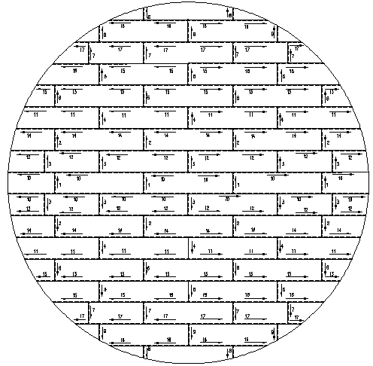

* + 1. **Installing Roof Nozzles and Manhole**

* + - 1. After complete welding of roof plates, roof nozzles and manhole can be fabricated as per drawing and installed after passing stages below:
      2. The exact location of nozzles and manhole must be marked and after approval, the next stages will be done.
      3. Plate should be cut by manual air / gas torch considering suitable distance for cleaning and edge preparation by grinder.
      4. The final edge preparation for weld will be done by grinder as per relevant DWG.
      5. Nozzles are attached as per relevant drawing in the location and after approval, will be welded.
      6. To prevent buckling plates during the weld, edge of plates must be harnessed by using installation instruments, and then welding will be done.
      7. After fabrication is completed but before the tank is filled with test water, the reinforcing plates shall be tested by the manufacture.
      8. After that installation of roof was done, welding annular plates to bottom plates will be performed, this stage can also be done after completing erection of shell.
      9. After welding bottom plates to each other, vacuum test will be done.
    1. **Installing** **Anchor Chair**

All parts cutting by C.N.C machine and after grinding montage and welding separately. Fabricated Anchor Chair fit-up around of tank, but welding to tank will be done after welding of shell plate to annular plate.

* + 1. **Installing Spiral Stairway**

After completion fit-up of 7th course first station installed in their places according to drawing.

Stairway support from the floor to the first station to be installed in their place according to drawing.

Stair supports (flat bar) installed at location according to drawing.

Installing the remaining parts will be done.

After completion welding of roof plates, roof handrail and end station are installed on location according to drawing.

Stair supports (flat bar) between two stations installed at location.

Installation of remaining parts between two stations will be done.

Gratings installed in the last stage after completion painting of storage tank.

* + 1. **Final Visual Check**

All parts of the erected tank must be checked up visually. In case of observing any defection,

such as surface damages, troubles raised from misassembling, etc. must be eliminated. After elimination all troubles, approval will be taken.

* + 1. **Important Note**

All of activity performance by iDrill Middle East team at site shall be coordinate with client mechanical department and client Q.C department deep seated at site.

* + 1. **Final Cleaning**

All available regions of the tank must be cleaned so that no trouble exists on surface.

For final cleaning, approval should also be taken.

* + 1. **Hydrostatic Test**

Hydrostatic test shall be carried, according to Project specification and Hydrostatic Test Procedure.

* + 1. **Painting**

Sand blast and painting shall be carried, according to Project specification and painting Procedure.

1. **CONSTRUCTION OF POTABLE TANK BASED ON AWWA D100 (TAG NO.TK-2209)**
   1. **FABRICATION**
      1. **Workmanship:**

Work performed on tanks built under the provisions of this standard shall be quality

workmanship.

* + 1. **Straightening:**

Any required straightening of material shall be done using methods that will not harm the

Steel. Minor cold straightening is permitted. Cold straightening may be performed by hammering or, preferably, by rolling or pressing. Heat may be used in straightening more severe deformations, unless otherwise specified. The steel temperature shall not exceed 1,200° F (649° C)

For as-rolled and normalizes steel, and 1,100 °F (600°C) for quenched and tempered steel.

* + 1. **Finish of Plate Edges _ Welded Work:**

The plate edges to be welded may be universal mill edges or they may be prepared by shearing, machining, chipping, or by mechanically guided oxyfuel gas or plasma arc cutting. Edges of irregular contours may be prepared by manually guided oxyfuel gas or plasma arc cutting.

1. **Oxyfuel gas or plasma arc cutting:**

When edges of plates are oxyfuel gas or plasma arc cut, the surface obtained shall be uniform and smooth and shall be cleaned of slag accumulation before welding. All cutting shall follow closely the lines prescribed.

1. **Shearing:**

Shearing may be used for material $1/2$ in.(13mm) or less in thickness to be joined by butt joint and for all thicknesses of material permitted to be joined by lap joints. Burrs shall be removed.

* + 1. **Rolling:**

Table 19 provides rolling requirements for shell plates for elevated tanks. Shell plates do not require rolling for tanks having a diameter larger than the minimum diameter indicated in Table 19 and for the plate thicknesses given therein.

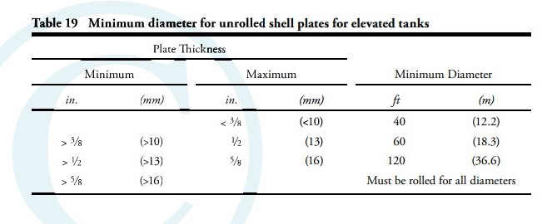

* + 1. **Double-Curved Plates:**

Plates that are curved in two directions may be pressed either cold or hot or may be dished with a “mortar and pestle” die by repeated applications.

* + 1. **Columns:**

1. **Milling of columns.** The ends of columns shall be milled to provide a satisfactory bearing unless the design calls for sufficient welding to resist the total calculated loads.
2. **Column fabrication tolerances.** The column axis shall not deviate from a straight line by more than 0.1 percent of the laterally unsupported length. At no cross section shall the difference between the maximum and minimum outside diameter of a tubular column exceed 2 percent of the nomina outside diameter. Local dents in tubular columns shall be no deeper than the thickness of the column shell.
   * 1. **Tank Assembly:**

Shell, Bottom, and Roof plates subjected to stress by the weight of pressure of the contained liquid shall be assembled and welded in such a manner that the proper curvature of the plates in both direction is maintained.

* + - 1. **Clips, Jigs and lugs:** Any clips, Jigs or lug welded to the shell plates for erection purpose shall be removed without damaging the plates, and any portion of weld beads remaining shall be chipped or ground smooth.
      2. Bottom Plate Bottom plate for elevated tanks: The bottom plate for elevated tanks shall be assembled and welded together by a procedure that will result in a minimum of distortion from weld shrinkage.
      3. Bottom plate for flat-bottom tanks.: The bottom plate for flat-bottom tanks, after being laid out and tacked, shall be joined by welding the joints in a sequence that results in the least distortion caused by shrinkage of the weld. Out-of-plant distortion equal to 1% of the tank radius is considered acceptable.
      4. For welding in the vertical position, the progression of welding shall be either upward or downward, according to the direction specified in the welding procedure and used for welder performance qualification. The shell plates shall be joined by welding the joints in a sequence that results in the least distortion caused by shrinkage of the weld and that will avoid kinks at the longitudinal joints.
      5. Ground-supported standpipe and reservoir cylindrical shell tolerance: Shell tolerances may be waived if the structural adequacy of the shell is substantiated by a rational analysis.
      6. Plumbness: The maximum out-of-plumbness of the top of the shell relative to the bottom of the shell shall not exceed 1/200 of the total shell height.

The out-of-plumbness of one shell plate shall not exceed the permissible variation for flatness and waviness as specified in ASTM A6 or in ASTM A20, whichever is applicable.

* + - 1. Roundness: Radii measured at 1ft (0.3m) above the bottom corner well shall not exceed the tolerance as given in Table 21.
      2. 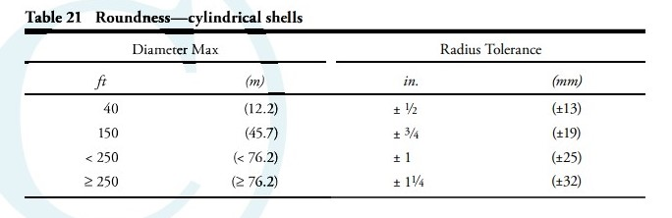Piping and banding at well joint: Banding is the out-of-plane distortion across a vertical well seam. Banding is the out-of-plumb distortion across a circumferential weld seam.
  1. **WELDING:**

Welding will be done based on Approved WPS & PQR and Section 10 of AWWA D100:

* 1. All welds in the tank and structural attachments shall be made in a manner to ensure complete fusion with the base metal, within the limits specified for each joint, and in strict accordance with the qualified welding procedure specifications.

1. **Weather and temperature conditions.** Welding shall not be performed when the surfaces of the parts to be welded are wet from rain, snow, or ice; when rain or snow is falling on such surfaces; or during periods of high winds, unless the welder or welding operator and the work are properly protected. See Sec. 10.3 for preheat requirements and Sec. 10.4 for low-hydrogen requirements.

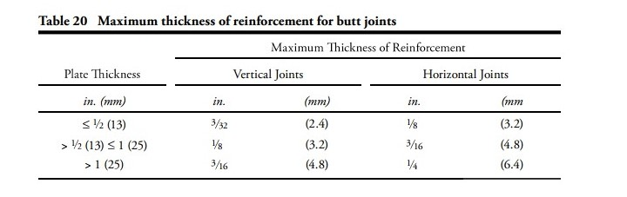

1. **Peening.** Peening of weld layers may be used to prevent undue distortion. Surface layers shall not be peened. Peening shall be performed with light blow from a power hammer with a blunt-nosed tool.
2. **Contour.** The surface beads shall merge smoothly into each other in all weld.
3. **Undercut.** Undercutting of base metal in the plate adjoining the weld shall be repaired, except as permitted in Sec. 11
4. **Craters.** All Craters shall be filled to the full cross section of the weld
5. **Reinforcement.** The thickness of reinforcement of the weld all butt joint shall not exceed the thicknesses the in the table 20.the reinforcement need not be removed except to the extent that it exceeds the maximum acceptable thickness or when require for radiography inspection.in no case shall the face of the weld line below the surface of the plates being joint.
6. **Gouging.** Gouging at the roof of welds and gouging of weld to remove defects maybe performed with a round – nosed tool or by arc or oxygen gouging.
7. **Cleaning between beads.** Each bead of multiple-pass weld shall be cleaned of slag and other loose the deposits before the next bead applied.
   1. **Tack Welds**

Tack weld used in the assembly of joints subject to primary stress from the weight or pressure of tank contents shall be made by qualified welders and shall be thoroughly cleaned of all welding slag, but need not be removed, provided they are visually inspected for soundness (no crack, complete fusion, fill crater and acceptable profiles) and are thoroughly fused into the subsequently deposited weld metal. Tack weld used in the assembly of joint subject to secondary stress, such as those uses in flat bottom, roofs, circumferential seems of cylindrical tank shell, need not be remove, provided that they are sound , cleaned of all welding slag, and that the subsequently applied weld thoroughly fused into the weld tack welds.

* 1. **SURFACE PREPARATION &PAINTING:**

Surface Preparation and painting will be done based on approved Surface Preparation and painting Procedure

1. **Quality Control plane & tolerance**

All of the fabrication tolerances shall not exceed those specified in project specifications and API codes.

## 20.1 Material Receiving Inspection

**20.1.1**Material Certificate: All material used in the manufacture of Storage tank will be covered by mill certificates showing chemical analysis, mechanical tests and additional tests required by the applicable material specification.

**20.1.2** Receiving inspection section of QC Sec. shall be performed according to Purchase Order Requisition, and the applicable code/standard for the following as minimum:

1. Check mill certificates and other inspection/test reports.
2. Check identification marking on the material or parts.
3. Visual check for lamination, crack and other injurious defects.
4. Thickness & Dimension check
5. Others

**20.1.3** When materials cannot be traceable with identification marking, chemical and mechanical test shall be verified that the materials meet the requirements of the applicable code/standard.

When non-conformance has been found during receiving inspection, Q.C inspector shall be personnel attach a hold tag to the non-conformance item and the material cannot be issued for fabrication, until the non-conformance is cleared.

## Material Traceability

After issuing the MTO in the latest furbished form by the project manager and the engineering department, the above-mentioned form will be signed by exporter and corroborant and will be sent to the material control department. Immediately, after receiving the MTO, the material control department will take action against coding and registering the MTO.

## Material Storage Condition

1. **Paint & Electrode:**

All of paints and electrodes have to preserve in the indoor area and the storage man have to control and record the temperature and humidity some times during the day.

1. **Flange & Fitting:**

The Flanges & Fittings are place in the indoor storage and they sort by kind of material and size in shelf. It is necessary that each Flange or Fitting have to be recognizable by identification cards that are prepared.

1. **Plates & Pipes:**

All of plates shall be place on the vertical or horizontal position and they have to separate by pieces of wood and distance between each plate shall be at least 100mm.

The pipes have to place on the stand or saddle that are prepared and they have not to contact with each other and they have to sorted by kind of materials.

## Edge preparation and fit-up inspection

**20.4.1** Edge preparation and fit-up shall be referred to the relevant Welding Procedure Specification (WPS) and approved drawings.

The edges of plates may be sheared, machined, chipped, or machine gas cut. Shearing shall be limited to plates less than or equal

to 10 mm (3/8 in.) thick used for butt-welded joints and to plates less than or equal to 16 mm (5/8 in.) thick used for lap-welded joints.

Note: With the Purchaser’s approval, the shearing limitation on plates used for butt-welded joints may be increased to a thickness less than or equal to 16 mm (5/8 in.).

When edges of plates are gas cut, the resulting surfaces shall be uniform and smooth and shall be freed from scale and slag accumulations before welding. After cut or sheared edges are wire brushed, the fine film of rust adhering to the edges need not be removed before welding. Circumferential edges of roof and bottom plates may be manually gas cut.

**20.4.2** Inspection shall be performed mainly on the followings;

1) Root gap and beveled angle.

2) Cracks, notches, flaws or other injurious defects on the edges

3) Tack welding and alignment of parts to be joined.

4) Cleanliness.

**20.4.3** The following dimensional tolerances shall apply.

1) Offset in butt welding.

2) Root gap and beveled angle to be within the range specified on WPS or Drawing.

## Welding & Visual Inspection

**20.5.1** All welding shall be performed by qualified welders or welding operators in accordance with adequately qualified welding procedure.

**20.5.2** It shall be confirmed visually that the dimensions, shape and finish of edges after back chipping have good condition and no defects.

**20.5.3** A weld shall be acceptable by visual inspection if the inspection shows the following:

a. There are no crater cracks, other surface cracks or arc strikes in or adjacent to the welded joints.

b. Maximum permissible undercut is 0.4 mm (1/64 in.) in depth for vertical butt joints, vertically oriented permanent attachments,

attachment welds for nozzles, manholes, flush-type openings, and the inside shell-to-bottom welds. For horizontal butt joints, horizontally

oriented permanent attachments, and annular-ring butt joints, the maximum permissible undercut is 0.8 mm

(1/32 in.) in depth.

c. The frequency of surface porosity in the weld does not exceed one cluster (one or more pores) in any 100 mm (4 in.) of length,

and the diameter of each cluster does not exceed 2.5 mm (3/32 in.).

d. The reinforcement of the welds on all butt joints on each side of the plate shall not exceed the following thicknesses:

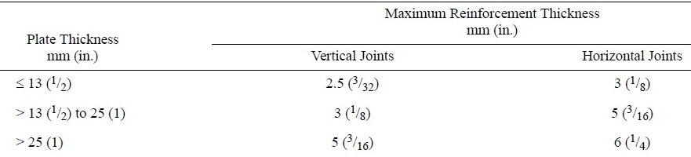

The reinforcement need not be removed except to the extent that it exceeds the maximum acceptable thickness or unless its removal is required by API 650 Para. 8.1.3.4 for radiographic examination.

## Nondestructive Examination (NDE)

After visual inspection, the following nondestructive examination shall be performed as appropriate.

**20.6.1 General**

1) All welds shall be inspected by NDE such as RT, UT, PT and MT in accordance with code and specification.

2) Final NDE (RT, UT, etc) shall be carried out after PWHT, if required PWHT.

**20.6.2 Radiographic Examination (RT)**

1)Butt weld seam where so specified in the relevant drawing shall be radio-graphically examined in accordance with API 650 Section 8 Para. 8.1 and NDE procedures.

2) Ultrasonic Examination in Lieu of Radiography.

Acceptance – rejection standards shall be in accordance with ASME Sec. VIII, Div.1 UW-51 and UW-52.

3)Spot radiography shall mean at least 10% coverage of length of each weld and all ‘T’ joints.

**20.6.3 Ultrasonic Examination (UT)**

Ultrasonic Examination in Lieu of Radiography.

When the radiographic method is applied in order to fulfill the requirement of API 650 Para. 7.3.2.1, then any ultrasonic examination specified shall be in accordance with this section.

The method of examination shall be in accordance with Section V, Article 4, of the ASME Code.

Ultrasonic examination performed in accordance with a written procedure that is certified by iDrill Middle East Co.

to be in compliance with the applicable requirements of Section V of the ASME Code.

**20.6.4 Liquid Penetration Examination (PT)**

1) When liquid penetrant examination is specified, the method of examination shall be in accordance with Section V, Article 6, of the ASME Code.

Liquid penetrant examination performed in accordance with a written procedure that is certified by iDrill Middle East Co. to be in compliance with the applicable requirements of Section V of the ASME Code.

2) Acceptance standards and the removal and repair of defects shall be in accordance with Section VIII, Appendix8, Paragraphs 8-3, 8-4, and 8-5, of the ASME Code.

## Dimensional Inspection

1)All outward and inward dimensions shall be checked in accordance with applicable.

2) Actual wall thickness shall be checked by Ultrasonic thickness gauge after formed and bending.

3) Direction and orientation of nozzles and other fittings of tanks shall be checked.

4) Deformation of tanks shall be checked.

8.1 DIMENSIONAL TOLERANCES

**20.7.1 General**

The purpose of the tolerances given in 8.1.2 through 7.5.7 is to produce a tank of acceptable appearance and to permit proper functioning of floating roofs. Measurements shall be taken prior to the hydrostatic water test. Unless waived or modified by the Purchaser on Data Sheet, Line 15, or established separately by agreement between the Purchaser and the Manufacturer, the following tolerances apply:

**20.7.2 Plumbness**

a. The maximum out-of-plumbness of the top of the shell relative to the bottom of the shell shall not exceed 1/200 of the total

tank height. The out-of-plumbness in one shell course shall not exceed the permissible variations for flatness and waviness as

specified in ASTM A 6M/A 6, ASTM A 20M/A 20, or ASTM A 480M/A 480, whichever is applicable.

b. The maximum out-of-plumbness of roof columns, guide poles, or other vertical internal components shall not exceed 1/200 of

the total height. The 1/200 criteria shall also apply to fixed roof columns. For tanks with internal floating roofs, apply the criteria

of this section or Appendix H, whichever is more stringent.

**20.7.3 Roundness**

Radii measured at 0.3 m (1 ft) above the bottom corner weld shall not exceed the following tolerances:

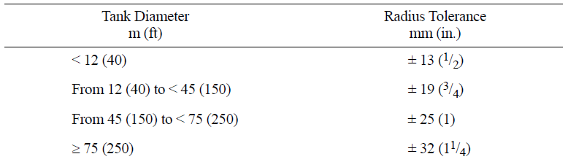

**20.7.4 Local Deviations**

Local deviations from the theoretical shape (for example, weld discontinuities and flat spots) shall be limited as follows:

a. Deviations (peaking) at vertical weld joints shall not exceed 13 mm (1/2 in.). Peaking at vertical weld joints

shall be determined

using a horizontal sweep board 900 mm (36 in.) long. The sweep board shall be made to the nominal radius of the tank.

b. Deviations (banding) at horizontal weld joints shall not exceed 13 mm (1/2 in.). Banding at horizontal weld joints shall be determined using a straight edge vertical sweep board 900 mm (36 in.) long.

c. Flat spots measured in the vertical plane shall not exceed the appropriate plate flatness and waviness requirements given in 8.1.2.

**20.7.5 Nozzles**

Nozzles (excluding manholes) shall be installed within the following tolerances:

a. Specified projection from outside of tank shell to extreme face of flange: ±5 mm (3/16 in.)

b. Elevation of shell nozzle or radial location of a roof nozzle: ±6 mm (1/4 in.)

c. Flange tilt in any plane, measured on the flange face:

±1/2 degree for nozzles greater than NPS 12 in nominal diameter

±3 mm (1/8 in.) at the outside flange diameter for nozzles NPS 12 and smaller

d. Flange bolt hole orientation: ±3 mm (1/8 in.)

## Pressure Test

**20.8.1 Hydrostatic Testing Requirements**

This hydrostatic test of the tank shall be conducted before permanent external piping is connected to the tank. Attachments to the shell defined in API 650 Para. 5.8.1.1, located at least 1 m (3 ft) above the water level, and roof appurtenances may be welded during the filling of the tank. After completion of the hydro-test, only non-structural small attachments may be welded to the tank in accordance

with API 650 Para. 7.2.1.11. Any welded joints above the test-water level shall be examined for leakage by one of the following methods:

1. coating all of the joints on the inside with a highly penetrating oil, such as automobile spring oil, and carefully examining the outside of the joints for leakage;

2. applying vacuum to either side of the joints or applying internal air pressure as specified for the roof test in API 650 Para. 7.3.7 and carefully examining the joints for leakage; or

3. using any combination of the methods stipulated in Sub items 1 and 2.

The Manufacturer shall be responsible for:

1. Preparing the tank for testing. This shall include removal of all trash, debris, grease, oil, weld scale, weld spatter, and any other foreign matter from the interior and the roof(s) of the tank.

2. Furnishing, laying, and removing all lines from the water source tie-in location and to the water disposal point as prescribed on the Data Sheet, Line 14.

3. Filling and emptying the tank. (See 1.3 for Purchaser responsibility to obtain any required permits for disposal of water.)

4. Cleaning, rinsing, drying, or other prescribed activity, if specified on Data Sheet, Line 14, following the hydro-test to make the tank ready for operation.

5. Taking settlement measurements (unless explicitly waived by the Purchaser on the Data Sheet, Line 14).

6. Furnishing all other test materials and facilities, including blinds, bolting, and gaskets (see 4.9).

7. Checking the wind girders for proper drainage during or following the hydro-test. If water is retained, additional drainage shall be provided subject to the Purchaser’s approval.

7.3.6.3 The Purchaser shall be responsible for:

1. Furnishing and disposing of the water for hydro-testing the tank from the water source tie-in location as designated on the Data Sheet, Line 14. If biocide or caustic additions are specified to the Manufacturer, the Purchaser is responsible for determining or identifying disposal restrictions on the treated water.

2. Specifying the test water quality. Potable water is preferred for hydro-testing. This does not preclude the use of condensate, reverse osmosis water, well water, river water, or sea water. The Purchaser shall consider issues such as low temperature brittle fracture, freeze damage, amount of suspended solids, sanitation issues, animal/plant incubation and/or growth, acidity, general corrosion, pitting, protecting against cathodic cells, microbiologically-induced corrosion, material dependent sensitivity to trace chemical attack, disposal, rinsing, and residuals left in the tank after emptying. If the Purchaser-supplied test water causes corrosion, the Purchaser is responsible for the required repairs.

For carbon and low-alloy steel tanks, the tank metal temperature during hydrostatic testing shall not be colder than the design metal temperature per Figure 4-1, as long as the water is prevented from freezing. The Manufacturer is responsible for heating the test water, if heating is required, unless stated otherwise on the Data Sheet, Line 14. 7.3.6.5 The minimum fill and discharge rate, if any, shall be specified by the Purchaser on the Data Sheet, Line 23. When settlement measurements are specified by the Purchaser, the maximum filling rates shall be as follows, unless otherwise restricted by the requirements in 5.8.5:

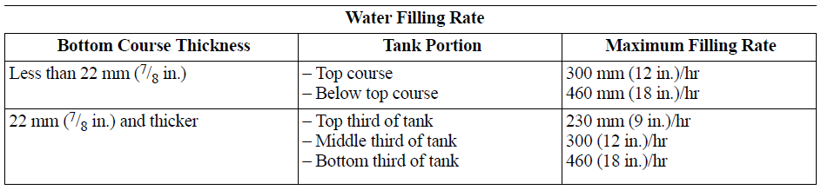 Filling may continue while elevation measurements are being made as long as the change in water elevation for a set of readings does not exceed 300 mm (12 in.). Unless waived on the Data Sheet, the Manufacturer shall make shell elevation measurements in accordance with the following:

1. Shell elevation measurements shall be made at equally-spaced intervals around the tank circumference not exceeding 10 m (32 ft). The minimum number of shell measurement points shall be eight.

2. Observed elevations shall be referred to a permanent benchmark. The level instrument shall be set up at least 11/2 times tank diameter away from the tank when tank elevation readings are taken. Six sets of settlement readings are required:

a. Before start of the hydrostatic test

b. With tank filled to 1/4 test height (±600 mm [2 ft])

c. With tank filled to 1/2 test height (±600 mm [2 ft])

d. With tank filled to 3/4 test height (±600 mm [2 ft])

e. At least 24 hours after the tank has been filled to the maximum test height. This 24-hour period may be increased to duration specified on the data sheet if the Purchaser so requires for conditions such as:

i. The tank is the first one in the area.

ii. The tank has a larger capacity than any other existing tank in the area.

iii. The tank has a higher unit bearing load than any other existing tank in the area.

iv. There is a question regarding the rate or magnitude of settlement that will take place.

f. After tank has been emptied of test water

Note: The three sets of settlement readings described in paragraphs b, c, and d above may be omitted if specified by the Purchaser.

If settlement measurements are specified by the Purchaser, any differential settlement greater than 13 mm per 10 m (1/2 in. per 32 ft) of circumference or a uniform settlement over 50 mm (2 in.) shall be reported to the Purchaser for evaluation. Filling of the tank shall be stopped until cleared by the Purchaser.

Internal bottom elevation measurements shall be made before and after hydrostatic testing. Measurements shall be made at maximum intervals of 3 m (10 ft) measured on diametrical lines across the tank. The diametrical lines shall be spaced at equal angles, with a maximum separation measured at the tank circumference of 10 m (32 ft). A minimum of four diametrical lines shall be used.

## Rust Prevention / Painting Inspection.

Surface preparation & painting for carbon steel part shall be done in accordance with customer's painting specification and instructed in detail manufacturer’s Painting and Rust Prevention procedure approved by purchaser.

Surface preparation shall be visually inspected after shot blasting or other mechanical rescaling to the reference standard required.

The surface prior to application of primer or any coat shall be clean, free of dust and dry.

Dry film thickness shall be checked with coating thickness gauge.

## Packing Inspection

* + 1. Prior to packing, all equipment shall be cleaned and rust prevented completely shall be performe
    2. Packing style, criteria, outline sketch of packing shall be in accordance with job specification.

## Documentation

**20.11.1** The results of inspection or test shall be recorded on the applicable supplier's form at the time of each inspection or test required through fabrication.

**20.11.2** The inspection and test reports shall be properly complied upon completion of fabrication and submitted to purchaser after final inspection acceptance which will be submitted to purchaser within two (2) weeks

**20.11.3** This shall include, but not be limited to, the followings:

* Manufacturer’s Certificate of Compliance.
* Dimensional inspection records of major and critical parts
* List of materials.
* Material certificates
* Heat treatment charts (if PWHT required)
* Non-Destructive test reports.
* Leak Test Reports.
* Production test plate results (if any)
* Photos or Pencil rubbing of Name-plate
* Pressure test report
* Inspection Release Note
* Packing inspection report
* Painting inspection report
* Welding records
* Others

1. **Health, safety & environment**

* Compliance with laws and regulation of client HSE is mandatory.
* Cell phone use is prohibited during work.
* Safety inspector immediately report unsafe behavior.
* Use personal protective equipment is mandatory at all hours worked.
* No smoking.
* In the event of an accident, immediately inform subject to safety inspector.
* It is forbidden to problem dangerous pranks.
* When climbing use the ladder with safety .
* When welding, please use safety mask.
* After finishing work , please put equipment in own place