طرح نگهداشت و افزایش تولید 27 مخزن
HYDROSTATIC TEST PROCEDURE

نگهداشت و افزایش تولید میدان نفتی بینک
V01 | Jan.2025 | IFA | IDrill M.E. | M.Fakharian | S.Faramarzpour
V00 | Nov.2024 | IFA | IDrill M.E. | M.Fakharian | M.Sadeghian
Rev. | Date | Purpose of Issue/Status | Prepared by: | Checked by: | Approved by: | CLIENT Approval
Status: | IFA: Issued For Approval  IFI: Issued For Information  AFC: Approved For Construction

REVISION RECORD SHEET
PAGE | V00 | V01 | V02 | V03 | V04 |  | PAGE | V00 | V01 | V02 | V03 | V04
1 | X |  |  |  |  |  | 66
2 | X |  |  |  |  |  | 67
3 | X |  |  |  |  |  | 68
4 | X |  |  |  |  |  | 69
5 | X |  |  |  |  |  | 70
6 | X | X |  |  |  |  | 71
7 | X |  |  |  |  |  | 72
8 | X |  |  |  |  |  | 73
9 | X |  |  |  |  |  | 74
10 | X |  |  |  |  |  | 75
11 | X | X |  |  |  |  | 76
12 | X |  |  |  |  |  | 77
13 | X |  |  |  |  |  | 78
14 |  |  |  |  |  |  | 79
15 |  |  |  |  |  |  | 80
16 |  |  |  |  |  |  | 81
17 |  |  |  |  |  |  | 82
18 |  |  |  |  |  |  | 83
19 |  |  |  |  |  |  | 84
20 |  |  |  |  |  |  | 85
21 |  |  |  |  |  |  | 86
22 |  |  |  |  |  |  | 87
23 |  |  |  |  |  |  | 88
24 |  |  |  |  |  |  | 89
25 |  |  |  |  |  |  | 90
26 |  |  |  |  |  |  | 91
27 |  |  |  |  |  |  | 92
28 |  |  |  |  |  |  | 93
29 |  |  |  |  |  |  | 94
30 |  |  |  |  |  |  | 95
31 |  |  |  |  |  |  | 96
32 |  |  |  |  |  |  | 97
33 |  |  |  |  |  |  | 98
34 |  |  |  |  |  |  | 99
35 |  |  |  |  |  |  | 100
36 |  |  |  |  |  |  | 101
37 |  |  |  |  |  |  | 102
38 |  |  |  |  |  |  | 103
39 |  |  |  |  |  |  | 104
40 |  |  |  |  |  |  | 105
41 |  |  |  |  |  |  | 106
42 |  |  |  |  |  |  | 107
43 |  |  |  |  |  |  | 108
44 |  |  |  |  |  |  | 109
45 |  |  |  |  |  |  | 110
46 |  |  |  |  |  |  | 111
47 |  |  |  |  |  |  | 112
48 |  |  |  |  |  |  | 113
49 |  |  |  |  |  |  | 114
50 |  |  |  |  |  |  | 115
51 |  |  |  |  |  |  | 116
52 |  |  |  |  |  |  | 117
53 |  |  |  |  |  |  | 118
54 |  |  |  |  |  |  | 119
55 |  |  |  |  |  |  | 120
56 |  |  |  |  |  |  | 121
57 |  |  |  |  |  |  | 122
58 |  |  |  |  |  |  | 123
59 |  |  |  |  |  |  | 124
60 |  |  |  |  |  |  | 125
61 |  |  |  |  |  |  | 126
62 |  |  |  |  |  |  | 127
63 |  |  |  |  |  |  | 128
64 |  |  |  |  |  |  | 129
65 |  |  |  |  |  |  | 130

CONTENTS
1.0 INTRODUCTION 4
2.0 SCOPE 5
3.0 REFERENCES CODE AND STANDARD 5
4.0 Responsibility 5
5.0 Reinforcing Pad test: 5
6.0 Test Procedure of Tag No. TK-2209 based on awwa d100 6
7.0 Test Procedure of Tag No. TK-2102 and TK-2301 A/B 6
8.0 EMPTY AND CLEANING 12
9.0 Attachment 12

- INTRODUCTION
Binak oilfield in Bushehr province is a part of the southern oilfields of Iran, is located 20 km northwest of Genaveh city.
With the aim of increasing production of oil from Binak oilfield, an EPC/EPD Project has been defined by NIOC/NISOC and awarded to Petro Iran Development Company (PEDCO). Also, PEDCO (as General Contractor) has assigned the EPC-packages of the Project to "Hirgan Energy - Design and Inspection" JV.
GENERAL DEFINITION
The following terms shall be used in this document.
CLIENT: | National Iranian South Oilfields Company (NISOC)
PROJECT: | Binak Oilfield Development – Manufacturing (w/Engineering & Material Supply) of Gas Dehydration Package.
EPD/EPC CONTRACTOR (GC): | Petro Iran Development Company (PEDCO)
EPC CONTRACTOR/PURCAHSER: | Joint Venture of: Hirgan Energy – Design &  Inspection Companies (HE/DI)
VENDOR: | iDrill Middle East (iDrill M.E)
EXECUTOR: | Executor is the party which carries out all or part of  construction and/or commissioning for the project.
TPI: | Third-Party Inspector
SHALL: | Is used where a provision is mandatory.
SHOULD: | Is used where a provision is advisory only.
MAY: | Is used where a provision is completely discretionary.

- SCOPE
This procedure describes the minimum requirements to be followed for conducting the Hydrostatic Test of site erected Storage Tanks Tag No. TK-2102 and TK-2301 A/B and shop storage tank Tag No.TK-2209, which are manufactured by iDrill MIDDLE EAST Company for HIRGAN ENERGY.
- REFERENCES CODE AND STANDARD
- API 650.
- IPS-G-ME-100
- AWWA D-100
- Project Specification
- Responsibility

Contractor constriction team shall be responsible to prepare and carry out all the necessary arrangements for conduction hydrostatic test as described in this procedure, after completion of all erection activities, welding and all non-destructive testing.

The construction manager shall be overall responsible for providing adequate resources or the implementation of this procedure and to ensure all safety precautions are taken and that HSE requirements are met.
- Reinforcing Pad test:
All reinforcing pads shall be pneumatically tested with air at 0.5kg/cm2 and tested with soap from outside and inside of Tank.
- Test Procedure of Tag No. TK-2209 based on awwa d100
V01

Test preparation: Ensure all construction and painting are completed before testing.

Filling: Fill the tank with potable water to the Top Capacity Level (TCL) or as otherwise specified by design requirements.

Duration: Maintain the water level for at least 24 hours to identify potential leaks or deformation.

Inspection: Conduct visual inspection for leaks at all seams and struct rural parts.

Repairs: Any leaks in the Shell, Bottom shall be repaired by chipping, gouging, or oxygen gouging to remove any defective welds, and rewelded. No repair work shall be done on any joints unless the water in the tank is at least 2 ft (0.6 m) below the point being repaired.

7.0 Test Procedure of Tag No. TK-2102 and TK-2301 A/B

PREPARATION

    - To confirm mechanical completion Report/Test Pack has been prepared and approved by client prior to start any hydro test activity. shall close all NCRs (if any), site observation and audit findings.
    - complete all QA /QC documents and submit to the client for their approval prior carry out the hydro test.
    - Ensure all punch lists, check list, for filling/draining are cleared prior to hydro test.
    - The tank internal shall be cleaned and free of dirt, weld slag, oil, grease, debris, etc.
    - All welding and grinding work shall be completed.
    - Tank shall be clean and all debris, tools, etc. shall be removed from tank.
    - All the relevant QA/QC documents shall be reviewed and approved by contractor and their client. Completion all NDT and vacuum box test, leak test of RF pads, leak test of weld between last shell courses to Annular plate prior to test.
    - All temporary supports ring damage area shall be removed before hydro test.
    - Instruments have been removed and connections blanked.
    - Before Hydrotest, safety officers shall prepare a check list and will check and verify.
    - Inspection for box up carried out in presence of the contractor and client representatives.
    - All the punch list points shall be attended and Hydrotest package to be prepared.
    - Adequate safety measures e.g. checking of vent, isolation of electricity, signs, barricading, etc. shall be done.
    - Checking the wind girders for proper drainage during or following the hydro-test. If water is retained, additional drainage shall be provided subject to the Purchaser’s approval.
    - Roof manholes and all roof nozzles shall be kept open during water filling and draining and remain open during test.
    - Ensure all attachments are of correct pressure rating.
    - Proper arrangement shall be made to monitor the water level during hydrostatic test by meter and calculation. Transparent polythene tube may be used to check the level. Level making for the settlement measurements shall be marked on the tank shell at a suitable elevation above the tank bottom.
    - One reference point will be transferred to the tank which is to be Hydrotested. The elevation of reference point on the tank shall be 1 meter from top of the annular plate for easy access and checking of the level during Hydrotest.
    - Location for the tank settlement elevation will be in accordance with the drawings.

TEST MEDIUM

Potable water shall be used as medium.

The temperature of the test water shall be not below 50°C.

WATER FILLING

The tank shall be filled with water up to 2 inch above the weld connecting the roof plate to the top angle or maximum design level.

During the filling operation, the tank shall be inspected frequently to detect if any major defects are showing. The maximum filling rate must be followed as indicated in table 1.

The holding time shall be 24 hours for final settlement.

After 24 hours, all joints and surface area of the tank shall be carefully examined and free from any harmful defects and leakages.

Roof testing will be carried out in accordance with the API 650 class 7.3.7

During the water filling operation, the tank shall be frequently inspected for any major settlements.

During the water filling operation, the tank shall be frequently inspected for any major settlements.

The settlement reading shall be recorded in applicable form.

SHELL SETTLEMENT

Water filling shall be continued while the settlement level does not exceed 300 mm (12 inch)

The shell settlement measuring point shall be checked at the top face of the jack-up brackets or marking at equally spaced intervals around the tank circumference, not exceeding 10 meters (32 ft), with minimum 8 measuring points at 0°, 45°, 90°, 135°, 180°, 225°, 270° and 315°.

A permanent bench mark shall be established in a location unaffected by tank loading.

The level instrument shall be set up at least 1.5 times diameter away from the tank when the shell settlement readings are taken.

Measurement must be taken in a clockwise direction with a reference to the north direction.

The frequency of shell settlement measurements shall be performed and recorded.

Tank filled to 20% height (+600 min) and the liquid level filled for a period of 8 hours reading shall be noted at the beginning and end of the 8-hour holding period.

Tank filled to 50% height (+600 min) and the liquid level filled for a period of 8 hours reading shall be noted at the beginning and end of the 8-hour holding period.

Tank filled to 75% height (+600 min) and the liquid level held for a period of 8 hours reading shall be noted at the beginning and end of the 8-hour holding period.

Final test level, the liquid shall be held for 24 hours and the readings noted in every 8 hours.

During discharge, fill half of the tank, the liquid level held for a period of 8 hours and the readings shall be noted at the beginning and end of the 8-hour holding period.

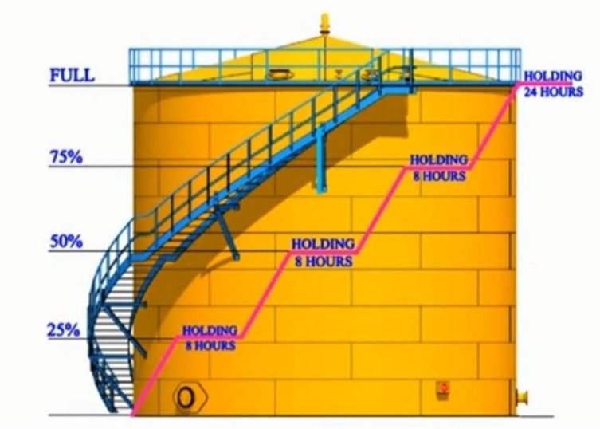 | 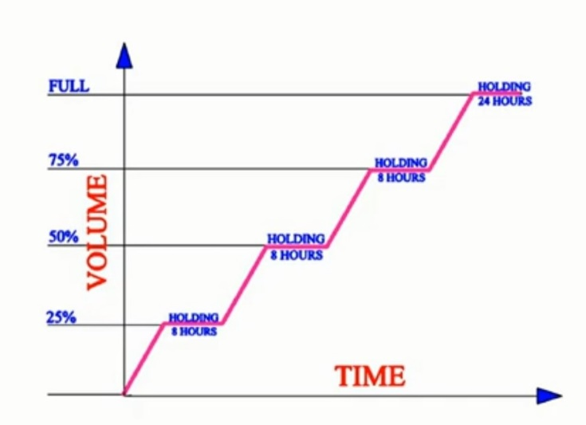

Completely discharge of water.

Readings are taken at each stage shall be reported to the client. Settlement time can be reduced upon mutual agreement between the client and the contractor.

Any part of the tank shell or the foundation exhibit excessive distortion or uneven excessive settlement Noticed during the tank hydrostatic test shall immediately informed to the client representative and the filling shall be stopped until further clearance obtained.

Remedial action including holding at the current water level or discharge of water in the tank shall be agreed by the contractor and the client.

Acceptance

Any leak found shall be corrected in accordance with API 650. The tank shall be pressure tested again in accordance with this procedure.

For settlement measurements, any differential settlement greater than 13 mm per 10m (1/2 in. per 32 ft) of circumference or a uniform settlement over 50m(2 in.) shall be reported to the client for evaluation.

Repair

Repairs shall be carried out according to the approval weld repair procedure and shall be referenced adequately.

Pinhole leaks or porosity in a tank joint may be repaired by re-welding after removal of weld bead on or near the defective area.

Repairs of the defects detected after the tank has been filled with water for testing shall be made with the water level at least one foot below any point being repaired.

If the repairs have to be made on or near the tank bottom, the tank shall be completely emptied prior to repairing.

Repaired weld parts shall be re-examined in accordance with the inspection and test plan.
V01

Certification

The test report shall be duly signed by both the contractor QC and the client TPI.

Safety

Only authorized personnel shall be allowed near the test area.

No work of any sort shall be carried out on the site during hydrostatic tests unless such work is essential to performance of the testing operation.

An emergency drain-off point shall be identified and manned in case of an overpressure.

All other safety measures related to site construction work shall be strictly adhered to.

Adequate signage and barricading shall be provided in the hydrostatic test area.

PREVENTIVES MEASURES

To ensure the integrity of the weldment by visual inspection and other testing methods in accordance with API 650 standards.

All gaskets’ ratings shall meet their standard requirements.

Stud bolt and heavy nut for nozzle shall be provided for nozzle tightening.

Bolt torquing shall be performed according to the method of statements.

Temporary blind flange for nozzle tightening shall be provided for each nozzle size and type

Ensure the inspection clearance from contractor QC department.
- EMPTY AND CLEANING

  - Prior to starting water discharging, confirm that the roof manholes and / or some nozzles are opened to vent the tank.
  - After finishing the hydrostatic test, water shall be drawn off in at least 1 day.
- Attachment
Report Format

 | Project Name: Binak Oilfield Development of Gas Dehydration Package. |  | 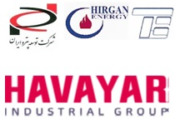  
 | HYDROSTATIC Test Report
Client: | Vendor: | Purchaser: | Date:
NISOC | iDrill Middle East | Hirgan Energy – Design & Inspection Companies | …. . .. . ..
P.O. No.: | Procedure No.: | Report No.: | Page No.:
………………… | ………………… | ………………… | Page 1 of 1

Equipment Name: |  | Tag No.:

Test Data
Fluid Type: |  | Holding Time:
Fluid Temperature: |  | Ambient Temperature:
Design Pressure: |  | Design Temperature:
Test Pressure: |  | Test Temperature:

Detail of Filling Water stage: | Rate of Filling: | Start of Test: |  | End Time: | Holding Time:
Diagram of Test |  |  | Sketch of Tank
Result: |  |  | Settlement Elevation:
Cleaning With: |  |  | Drying with:
IdRILL M. E | HIRGAN / DI | PEDCO | TPI | NISOC
Name: | Name: | Name: | Name: | Name:
Date: | Date: | Date: | Date: | Date:
Signature: | Signature: | Signature: | Signature: | Signature:

