|  |  |  |  |  |  |  |
| --- | --- | --- | --- | --- | --- | --- |
| **طرح نگهداشت و افزایش تولید 27 مخزن** | | | | | | |
| **MECHANICAL RUNNING TEST PROCEDURE**  **نگهداشت و افزایش تولید میدان نفتی بینک** | | | | | | |
|  |  |  |  |  |  |  |
|  |  |  |  |  |  |  |
|  |  |  |  |  |  |  |
| V01 | FEB. 2025 | AFC | Kalaye Pump | M.Fakharian | S.Faramarzpour |  |
| V00 | NOV. 2024 | IFA | Kalaye Pump | M.Fakharian | M.Sadeghian |  |
| **Rev.** | **Date** | **Purpose of Issue/Status** | **Prepared by:** | **Checked by:** | **Approved by:** | **CLIENT Approval** |
|  | | | | | | |
| **Status:** | **IFA: Issued for Approval**  **IFI: Issued for Information**  **AFC: Approved for Construction** | | | | | |

**REVISION RECORD SHEET**

|  |  |  |  |  |  |  |  |  |  |  |  |  |
| --- | --- | --- | --- | --- | --- | --- | --- | --- | --- | --- | --- | --- |
| **PAGE** | **V00** | **V01** | **V02** | **V03** | **V04** |  | **PAGE** | **V00** | **V01** | **V02** | **V03** | **V04** |
| **1** | X | X |  |  |  | **66** |  |  |  |  |  |
| **2** | X | X |  |  |  | **67** |  |  |  |  |  |
| **3** | X |  |  |  |  | **68** |  |  |  |  |  |
| **4** | X |  |  |  |  | **69** |  |  |  |  |  |
| **5** | X | X |  |  |  | **70** |  |  |  |  |  |
| **6** |  | X |  |  |  | **71** |  |  |  |  |  |
| **7** |  | X |  |  |  | **72** |  |  |  |  |  |
| **8** |  |  |  |  |  | **73** |  |  |  |  |  |
| **9** |  |  |  |  |  | **74** |  |  |  |  |  |
| **10** |  |  |  |  |  | **75** |  |  |  |  |  |
| **11** |  |  |  |  |  | **76** |  |  |  |  |  |
| **12** |  |  |  |  |  | **77** |  |  |  |  |  |
| **13** |  |  |  |  |  | **78** |  |  |  |  |  |
| **14** |  |  |  |  |  | **79** |  |  |  |  |  |
| **15** |  |  |  |  |  | **80** |  |  |  |  |  |
| **16** |  |  |  |  |  | **81** |  |  |  |  |  |
| **17** |  |  |  |  |  | **82** |  |  |  |  |  |
| **18** |  |  |  |  |  | **83** |  |  |  |  |  |
| **19** |  |  |  |  |  | **84** |  |  |  |  |  |
| **20** |  |  |  |  |  | **85** |  |  |  |  |  |
| **21** |  |  |  |  |  | **86** |  |  |  |  |  |
| **22** |  |  |  |  |  | **87** |  |  |  |  |  |
| **23** |  |  |  |  |  | **88** |  |  |  |  |  |
| **24** |  |  |  |  |  | **89** |  |  |  |  |  |
| **25** |  |  |  |  |  | **90** |  |  |  |  |  |
| **26** |  |  |  |  |  | **91** |  |  |  |  |  |
| **27** |  |  |  |  |  | **92** |  |  |  |  |  |
| **28** |  |  |  |  |  | **93** |  |  |  |  |  |
| **29** |  |  |  |  |  | **94** |  |  |  |  |  |
| **30** |  |  |  |  |  | **95** |  |  |  |  |  |
| **31** |  |  |  |  |  | **96** |  |  |  |  |  |
| **32** |  |  |  |  |  | **97** |  |  |  |  |  |
| **33** |  |  |  |  |  | **98** |  |  |  |  |  |
| **34** |  |  |  |  |  | **99** |  |  |  |  |  |
| **35** |  |  |  |  |  | **100** |  |  |  |  |  |
| **36** |  |  |  |  |  | **101** |  |  |  |  |  |
| **37** |  |  |  |  |  | **102** |  |  |  |  |  |
| **38** |  |  |  |  |  | **103** |  |  |  |  |  |
| **39** |  |  |  |  |  | **104** |  |  |  |  |  |
| **40** |  |  |  |  |  | **105** |  |  |  |  |  |
| **41** |  |  |  |  |  | **106** |  |  |  |  |  |
| **42** |  |  |  |  |  | **107** |  |  |  |  |  |
| **43** |  |  |  |  |  | **108** |  |  |  |  |  |
| **44** |  |  |  |  |  | **109** |  |  |  |  |  |
| **45** |  |  |  |  |  | **110** |  |  |  |  |  |
| **46** |  |  |  |  |  | **111** |  |  |  |  |  |
| **47** |  |  |  |  |  | **112** |  |  |  |  |  |
| **48** |  |  |  |  |  | **113** |  |  |  |  |  |
| **49** |  |  |  |  |  | **114** |  |  |  |  |  |
| **50** |  |  |  |  |  | **115** |  |  |  |  |  |
| **51** |  |  |  |  |  | **116** |  |  |  |  |  |
| **52** |  |  |  |  |  | **117** |  |  |  |  |  |
| **53** |  |  |  |  |  | **118** |  |  |  |  |  |
| **54** |  |  |  |  |  | **119** |  |  |  |  |  |
| **55** |  |  |  |  |  | **120** |  |  |  |  |  |
| **56** |  |  |  |  |  | **121** |  |  |  |  |  |
| **57** |  |  |  |  |  | **122** |  |  |  |  |  |
| **58** |  |  |  |  |  | **123** |  |  |  |  |  |
| **59** |  |  |  |  |  | **124** |  |  |  |  |  |
| **60** |  |  |  |  |  | **125** |  |  |  |  |  |
| **61** |  |  |  |  |  | **126** |  |  |  |  |  |
| **62** |  |  |  |  |  | **127** |  |  |  |  |  |
| **63** |  |  |  |  |  | **128** |  |  |  |  |  |
| **64** |  |  |  |  |  | **129** |  |  |  |  |  |
| **65** |  |  |  |  |  | **130** |  |  |  |  |  |

1. **INTRODUCTION**

Binak oilfield in Bushehr province is a part of the southern oilfields of Iran, is located 20 km northwest of Genaveh city.

With the aim of increasing production of oil from Binak oilfield, an EPC/EPD Project has been defined by NIOC/NISOC and awarded to Petro Iran Development Company (PEDCO). Also, PEDCO (as General Contractor) has assigned the EPC-packages of the Project to "Hirgan Energy - Design and Inspection" JV.

1. **GENERAL DEFINITION**

The following terms shall be used in this document.

|  |  |
| --- | --- |
| CLIENT: | National Iranian South Oilfields Company (NISOC) |
| PROJECT: | Binak Oilfield Development – Supply Of Fire Water Pumps |
| EPD/EPC CONTRACTOR (GC): | Petro Iran Development Company (PEDCO) |
| EPC CONTRACTOR/PURCHASER: | Joint Venture of: Hirgan Energy – Design & Inspection (D&I) Companies |
| VENDOR: | Kalaye Pump Company |
| EXECUTOR: | Executor is the party which carries out all or part of construction and/or commissioning for the project. |
| TPI: | Third Party Inspector. |
| SHALL: | Is used where a provision is mandatory. |
| SHOULD: | Is used where a provision is advisory only. |
| WILL: | Is normally used in connection with the action by CLIENT rather than by an EPC/EPD CONTRACTOR, supplier or VENDOR. |
| MAY: | Is used where a provision is completely discretionary. |

1. **Scope**

This executive method aims to illustrate the way of the test and testing manufactured/repaired pumps in the factory to achieve assurance about their alignment to those determined characteristics as well as their quality.

1. **Usage domain**

The usage domain of this executive instruction includes all projects of Kalay-E-Pump Company and other common productions.

1. **Liabilities**

The quality control director is responsible for executing this instruction, furthermore product supervisor and technical office representative are present in the examination (Test) steps entirely, as auditors.

1. **References**

The testing operation of pumps/Electro pumps/Diesel Pumps belonging to Kalay-E-Pump Company is accomplished based on derivate tests of creditable global collected standards for centrifugal and firefighting pumps and gathered movements. (API 610, NFPA 20)

* ISO 10816

1. **Proceeding description**

The running test (including bearing temperature test, vibration test, noise level test) for all project pumps is carried out according to API 610 and this procedure as well as customer project documents”.

1. **MECHANICAL RUNNING TEST**

This provides a unified test procedure for each mechanical running test. After the test, a report shall be issued by the testbed and controlled by this procedure.

8.1.1. The pump shall be mechanically run for 4 hours , this run shall be performed at rated flow.

8.1.2. The pump shall be run on the test stand until oil temperature stabilization has been achieved.

8.1.3. Test Condition

8.1.3.1. Test fluid is clean water.

8.1.3.2. The following meters can be used for testing:

Flowmeter, laser thermometer, digital photo-optical speed counter, vibration meter in mm/s RMS unit, photometer for noise level.

8.1.3.3. The seal specified in the contract shall be used in the pump for testing. (for mechanical seal pumps)

8.1.4. Test items are:

8.1.4.1. Vibration of pump bearing in horizontal & vertical direction. Vibration must be according to Table 8 of API 610, 11th edition.

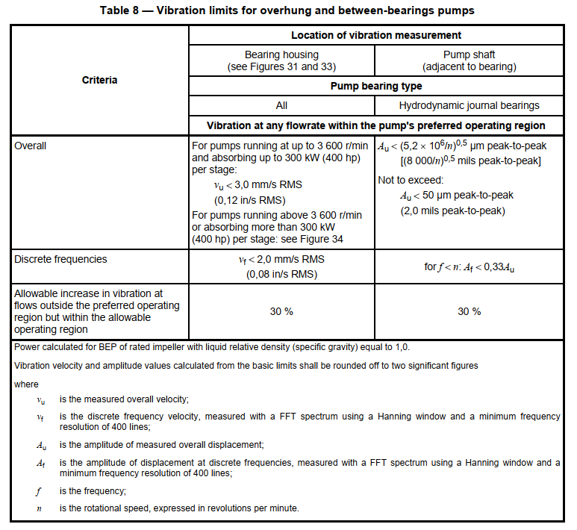

8.1.4.2. Temperature of pump bearings.

8.1.4.3. Speed of pump shaft.

8.1.4.4. Noise level at 1meter distance around of package.

8.1.4.5. Leakage by visual checking from the mechanical seal.

Mentioned items shall be recorded each 1 hour.

Note: Acceptance criteria for noise level of diesel will be according to Diesel Engine Specification.

8.1.5. Acceptable Factors

8.1.5.1. If it is no leakage by visual checking, a mechanical seal is acceptable. Dripping leakage is acceptable for a soft packing seal.

8.1.5.2. Noise level of pump set shall be lower than 85dB under rated flow in 1 meter distance and 1.5 m above ground.

8.1.5.3.Vibration must be according to table 8 of API 610 11th edition.

8.1.5.4. For ring-oiled or splash systems and grease lubricated bearings, an oil temperature below 82ºC (180ºF) during shop testing is acceptable. The sump oil temperature rise shall not exceed 40ºK (70ºR) above the ambient temperature in the test cell measured at the time of each reading and if bearing temperature sensors are supplied outer ring temperature shall not exceed 93ºC (200º F).

Note:

Test fluid is clean water at the temperature less than 40ºC.

The following meters can be used for testing:Electromagnetic or orifice or venture flow meter, optical temperature meter, digital photo- optical speed counter, vibration measuring meter in mm/s RMS unit, phonometer for noise level.

Unless otherwise specified, seal specified in contract shall be used in pump for testing.

4 hours mechanical running test, with job motor if power is right for water.

Test items are:

1- Vibration of pump and electromotor bearing at Horizontal & Vertical & Axial direction.

2- Temperature of pump and electromotor bearing.

3- Speed of pump shaft.

4- Noise level at 1meter distance around of package.

5- leakage by visual checking from mechanical seal

running test shall be done under the rated flow (if power is right for water), running for 4 hours and the above items shall be recorded ever 1 hours.

Note: For diesel pumps, vibration classification numbers and guide values for reciprocating machines are given in Table A.1. (ISO 10816-6)

-Pump vibration values to be limited to class 3 machine, acceptance criteria 11.2 mm/s (rms) is given in table A.1.

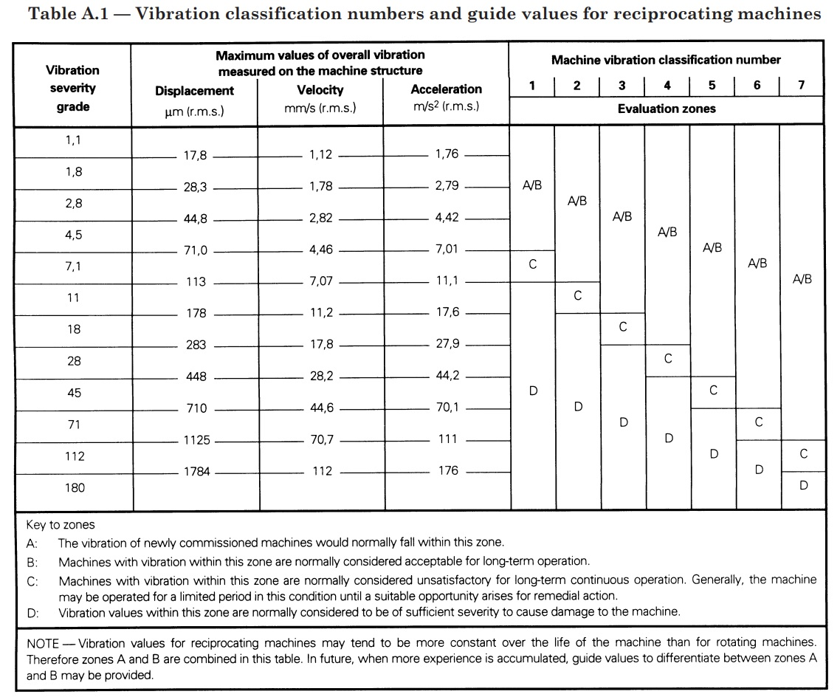

Noise Level

|  |  |  |
| --- | --- | --- |
| Model Pump | Tag No. | Noise level criteria |
| KPSPF 150-570 | P-2301 B | 117.9 |
| KPSPF 150-570 | P-2301 A | 85 |
| KP 2532 | P-2302 A/B | 85 |