|  |  |  |  |  |  |  |  |
| --- | --- | --- | --- | --- | --- | --- | --- |
| **طرح نگهداشت و افزایش تولید 27 مخزن** | | | | | | | |
| **POSTWELD HEAT TREATMENT PROCEDURE (TOWER, COLUMNS, REBOILER, DRUMS, FILTERS & EXCHANGERS)**  **نگهداشت و افزایش تولید میدان نفتی بینک** | | | | | | | |
|  |  |  |  |  |  |  |
|  |  |  |  |  |  |  |
|  |  |  |  |  |  |  |
|  |  |  |  |  |  |  |
| V00 | APR. 2025 | IFA | MFS | M.Fakharian | S.Faramarzpour |  |
| **Rev.** | **Date** | **Purpose of Issue/Status** | **Prepared by:** | **Checked by:** | **Approved by:** | **CLIENT Approval** |
|  | | | | | | |
| **Status:** | **IFA: Issued For Approval**  **IFI: Issued For Information**  **AFC: Approved For Construction** | | | | | |

**REVISION RECORD SHEET**

|  |  |  |  |  |  |  |  |  |  |  |  |  |
| --- | --- | --- | --- | --- | --- | --- | --- | --- | --- | --- | --- | --- |
| **PAGE** | **V00** | **V01** | **V02** | **V03** | **V04** |  | **PAGE** | **V00** | **V01** | **V02** | **V03** | **V04** |
| **1** | X |  |  |  |  | **66** |  |  |  |  |  |
| **2** | X |  |  |  |  | **67** |  |  |  |  |  |
| **3** | X |  |  |  |  | **68** |  |  |  |  |  |
| **4** | X |  |  |  |  | **69** |  |  |  |  |  |
| **5** | X |  |  |  |  | **70** |  |  |  |  |  |
| **6** | X |  |  |  |  | **71** |  |  |  |  |  |
| **7** | X |  |  |  |  | **72** |  |  |  |  |  |
| **8** | X |  |  |  |  | **73** |  |  |  |  |  |
| **9** |  |  |  |  |  | **74** |  |  |  |  |  |
| **10** |  |  |  |  |  | **75** |  |  |  |  |  |
| **11** |  |  |  |  |  | **76** |  |  |  |  |  |
| **12** |  |  |  |  |  | **77** |  |  |  |  |  |
| **13** |  |  |  |  |  | **78** |  |  |  |  |  |
| **14** |  |  |  |  |  | **79** |  |  |  |  |  |
| **15** |  |  |  |  |  | **80** |  |  |  |  |  |
| **16** |  |  |  |  |  | **81** |  |  |  |  |  |
| **17** |  |  |  |  |  | **82** |  |  |  |  |  |
| **18** |  |  |  |  |  | **83** |  |  |  |  |  |
| **19** |  |  |  |  |  | **84** |  |  |  |  |  |
| **20** |  |  |  |  |  | **85** |  |  |  |  |  |
| **21** |  |  |  |  |  | **86** |  |  |  |  |  |
| **22** |  |  |  |  |  | **87** |  |  |  |  |  |
| **23** |  |  |  |  |  | **88** |  |  |  |  |  |
| **24** |  |  |  |  |  | **89** |  |  |  |  |  |
| **25** |  |  |  |  |  | **90** |  |  |  |  |  |
| **26** |  |  |  |  |  | **91** |  |  |  |  |  |
| **27** |  |  |  |  |  | **92** |  |  |  |  |  |
| **28** |  |  |  |  |  | **93** |  |  |  |  |  |
| **29** |  |  |  |  |  | **94** |  |  |  |  |  |
| **30** |  |  |  |  |  | **95** |  |  |  |  |  |
| **31** |  |  |  |  |  | **96** |  |  |  |  |  |
| **32** |  |  |  |  |  | **97** |  |  |  |  |  |
| **33** |  |  |  |  |  | **98** |  |  |  |  |  |
| **34** |  |  |  |  |  | **99** |  |  |  |  |  |
| **35** |  |  |  |  |  | **100** |  |  |  |  |  |
| **36** |  |  |  |  |  | **101** |  |  |  |  |  |
| **37** |  |  |  |  |  | **102** |  |  |  |  |  |
| **38** |  |  |  |  |  | **103** |  |  |  |  |  |
| **39** |  |  |  |  |  | **104** |  |  |  |  |  |
| **40** |  |  |  |  |  | **105** |  |  |  |  |  |
| **41** |  |  |  |  |  | **106** |  |  |  |  |  |
| **42** |  |  |  |  |  | **107** |  |  |  |  |  |
| **43** |  |  |  |  |  | **108** |  |  |  |  |  |
| **44** |  |  |  |  |  | **109** |  |  |  |  |  |
| **45** |  |  |  |  |  | **110** |  |  |  |  |  |
| **46** |  |  |  |  |  | **111** |  |  |  |  |  |
| **47** |  |  |  |  |  | **112** |  |  |  |  |  |
| **48** |  |  |  |  |  | **113** |  |  |  |  |  |
| **49** |  |  |  |  |  | **114** |  |  |  |  |  |
| **50** |  |  |  |  |  | **115** |  |  |  |  |  |
| **51** |  |  |  |  |  | **116** |  |  |  |  |  |
| **52** |  |  |  |  |  | **117** |  |  |  |  |  |
| **53** |  |  |  |  |  | **118** |  |  |  |  |  |
| **54** |  |  |  |  |  | **119** |  |  |  |  |  |
| **55** |  |  |  |  |  | **120** |  |  |  |  |  |
| **56** |  |  |  |  |  | **121** |  |  |  |  |  |
| **57** |  |  |  |  |  | **122** |  |  |  |  |  |
| **58** |  |  |  |  |  | **123** |  |  |  |  |  |
| **59** |  |  |  |  |  | **124** |  |  |  |  |  |
| **60** |  |  |  |  |  | **125** |  |  |  |  |  |
| **61** |  |  |  |  |  | **126** |  |  |  |  |  |
| **62** |  |  |  |  |  | **127** |  |  |  |  |  |
| **63** |  |  |  |  |  | **128** |  |  |  |  |  |
| **64** |  |  |  |  |  | **129** |  |  |  |  |  |
| **65** |  |  |  |  |  | **130** |  |  |  |  |  |

***Table of Contents***

|  |  |  |
| --- | --- | --- |
|  | **index** | **Page** |
| **1.** | **GENERAL** | **4** |
| **2.** | **DEFINITION OF TERMS** | **4** |
| **3.** | **REFERENCE DOCUMENT** | **4** |
| **4.** | **EQUIPMENT** | **4** |
| **5.** | **REQUIREMENTS** | **5** |
| **6.** | **THE OPERATION OF POST WELD HEAT TREATMENT** | **6** |
| **7.** | **MANDATORY APPENDIX** | **6** |
| **8.** | **PWHT Report** | **7** |
| **9.** | **Heat Treatment Report** | **7** |

1. **GENERAL:**
   1. **SCOPE:**

This procedure covers requirements of Post Weld Heat Treatment for carbon steel parts, which will be applied by Masnouat Felezi Sangin Co.

* 1. **PURPOSE:**

Post weld heat treatment is used to release, locked up and residual stresses which are result of mechanical treatment and welding process for carbon steel parts. Stress-relive is done by heating a vessel to a sufficient temperature.

1. **DEFINITION OF TERMS**

In this specification the following definitions shall apply:

|  |  |
| --- | --- |
| **CLIENT:** | National Iranian South Oilfields Company (NISOC) |
| **PROJECT:** | Binak Oilfield Development – General Facilities |
| **EPD/EPC CONTRACTOR (GC):** | Petro Iran Development Company (PEDCO) |
| **EPC CONTRACTOR:** | Joint Venture of: Hirgan Energy – Design & Inspection(D&I) Companies |
| **VENDOR:** | MFS Co. |

1. **REFERENCE DOCUMENT**
   1. ASME SECTION VIII- DIV.I Edition 2021
2. **EQUIPMENT**

Post weld heat treatment carried out by using furnace and thermocouples, whenever is required.

* 1. **Furnace**

During the operation, furnace chart should be checked for determining the rate of heating, holding time and cooling time.

The furnace fuel is usually diesel.

Heat treatment is performed in furnace with indirect heating to ensure a uniform temperature distribution and the furnace temperature and atmosphere shall be so controlled as to avoid excessive surface oxidation. Machined surfaces such as flange faces shall be suitably protected against oxidation during heat treatment.

* 1. **Thermocouple**
* Thermocouple install at Top, Center & Bottom of the equipment or whichever is necessary to determining and controlling the temperature.
* Thermocouples are “Type K”, Nickel – chromium. The mentioned thermocouple can measure the temperature of -270 °C to 1300 °C.
* Maximum distance between two adjacent thermocouples on the equipment is equal to 4.6 meter (according to the ASME Sec. VIII, Para. UCS-56). Depending on the vessel shape and volume, numbers of thermocouples are varied.
* During the heating period there shall not be a greater variation in temperature throughout the portion of the vessel being heated than 140 °C within any 4.6 m interval of length.
* Thermocouples may be attached into steel block or insulation to avoid temperature misreading caused by the effect of radiation.
* Contacted area of thermocouples shall be ground flush to ensure the soundness of metals surfaces.

1. **REQUIREMENTS**
   1. PWHT when required shall be done before hydrostatic test and after any repairs to welding. Prior to heat treatment, all oil, grease, seal, weld spatter, dirt and other foreign matters shall be removed.
   2. The heat-treated part or item shall be held at or above the temperature Specified in Table UCS-56 or UCS-56.1 of ASME Code Section VIII Div.1 and project specifications.
   3. Post weld heat treatment will be performed on welding plate with thickness over 38 mm (1 1/2"). For welded joints over (1 ¼") through (1½") post weld heat treatment will be done unless preheat is applied at a minimum temp. Of 200°F (95°C) during welding. In any case table no. UCS-56 and any enclosure here to & its foot notes is governed.
   4. The carbon and low alloy steel vessels, which the minimum design temperatures are below – 55oF (-48oC) must be post weld heat treated, unless exempted from impact tests. (Code Par.UCS-68)
   5. It will be considered all items of ASME Sec VIII UW-2 and Spec requirements as well.
   6. Documents on calibration of furnace recorders will be presented to client inspector.
   7. The heat-treated part or item shall be held at or above the temperature specified in Table in UCS-56 or UCS-56.1 of ASME code section VIII div 1. Unless otherwise any temperature which specified by client or its authorized parties here to.
   8. When pressure parts of two different P-Numbers are joined by welding, the post weld heat treatment done according to the standard. When non-pressure parts are welded to pressure parts, the post weld heat treatment temperature of the pressure part will be controlled.
   9. The temperature of the furnace shall not exceed 800°F (425°C) at the time the vessel or part is placed in it.
   10. Above 800 oF (425 oC) the rate of heating will not be more than 400 oF/hr. (222 oC/hr.) divided by the maximum metal thickness of the shell or head plate in inches but in no case more than 400 oF/hr. (222oC/hr.) During the heating period there will not be a greater variation in temperature throughout the portion of the vessel being heated than 250 oF (140 oC) within any 15 ft (4.6m) interval of length.
   11. Above 800 oF (425 oC), cooling will be done in a closed furnace or cooling chamber at a rate not greater than 500 oF/hr. (280 oC/h) divided by the maximum metal thickness of the shell or head plate in inches, but in no case more than 500 oF/hr. (280 oC/hr.). From 800 oF (425 oC) the vessel may be cooled in still air.
   12. During the holding time, there shall not be a greater difference than 150°F (83 °C) between the highest and lowest temperature throughout the portion of the item being heated, except where the range is further limited in Table UCS-56.
   13. For accomplishing post weld heat treatment in more than one section, the parts, which are outside of furnace, will be shielded so that the temperature variation is not harmful. The cross section where the vessel projects from the furnace will not intersect a nozzle or other structure discontinues.
   14. When heating the vessel internally, the outside of vessel will be fully protected with insulating material.
   15. In principle, PWHT for the welds joined by dissimilar ferrite materials shall be heat treated to the higher temperature ranges.
2. **THE OPERATION OF POST WELD HEAT TREATMENT**
   1. Heating the complete vessel in a closed furnace.
   2. Heating the vessel in more than 1 part: For this purpose, two sections will be overlapped for at least 5 ft. (1.5m).
   3. When heating the vessel in longitudinal joint or complicated welded details are not practicable and P.W.H.T is compulsive, heat treatment done in more than one part (when heating the complete vessel is not possible).
   4. When P.W.H.T is necessary for circumferential joints containing Nozzles or other welded attachments, heating entire bend, up to reach uniform required temperature and held for the specific time.
   5. The furnace atmosphere must be controlled during the heating and maintenance time as to avoid excessive oxidation by experimental controlling of relativity between gas and air of the surface of the vessel.
   6. The heat treatment graph which depicts temperature fluctuation (min/◦C) on the piece inside the furnace (Quench & Tempering rate), will be printed by digital recorder (PWHT Curve).
   7. The gasket faces of nozzle flanges will be protected against oxidation with a suitable material during PWHT.
3. **MANDATORY APPENDIX**
   1. Stress relieving and/or tempering will be carried out whenever laid down in codes in compliance with which the vessel is designed and fabricated or if the Client specifically requests this. The supplier will specifically request the above treatments if he considers them advisable.
   2. Final heat treatment will be carried out after having completed welding operations and after NDTs and repairs on the shell (including connections and appurtenances) and head.
   3. Final heat treatment after welding will be carried out at a temperature of not less than 600°C for Cr-Mo Steels.
   4. Any differences between the temperature recorded and the actual temperature of the various parts of the vessel shall be taken into account (thermocouples in contact with the part and/or test recordings are recommended).
   5. All test pieces as production weld that may be required, will be treated together with the vessel and not separately
   6. Hardness test will be done after PWHT. Minimum one set hardness test including 3 specimens for any process and welding operatories required.
4. **PWHT Curve**

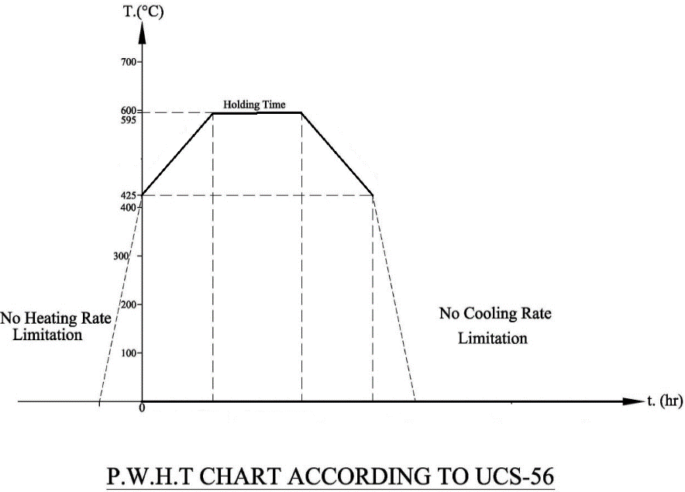

1. **Heat Treatment Report**

Sample of PWHT report is attached on the next page.

PWHT chart which recorded during the test, shall be attached to the below report sheet for each equipment.

